Class of 2020
Doris Russell
Chad Thomason
Michelle Tortora
JoAnn Wahala

Class of 2021
Denise Edmonds
Robert Gordon
Lee McCaskill
Geraldine Moore

Class of 2022
Keith Hardin
Elizabeth Martindale
Helen McDonald
Marie Monroe

Non-Profit
Organization
U.S. Postage
PAID
CARTHAGE, NC
28327
Permit No. 35
FIRST PRESBYTERIAN CHURCH
POST OFFICE BOX 397
CARTHAGE, NORTH CAROLINA 28327
(910) 947-2924
fpccarthage.com (website)
infofpc397@gmail.com (email)
FpcCarthage (facebook)



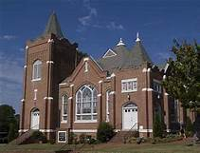
FIRST PRESBYTERIAN CHURCH September 2020

The Reverend Rick Martindale Pastor
Ali Wadsworth Choir Director
Elizabeth Williams Organist
Shelley Hammond Administrative Assistant
Andie Hyman Nursery Attendant
Ann Key Sexton
Marie Monroe Treasurer

Ruth Craig Interim Pianist




When was the last time you went outside and just listened? Listened to the birds, the insects, the wind blowing, and the quiet presence of God? Our being patient and enjoying the peace and quiet of God is more of a requirement now, than ever before. We tend to be surrounded by a never-ending noise that consumes us. It consumes our busy lives. The noise of life challenges us and we get sidetracked from what is important. Even when we relax, we are devoted to the busyness of life around us. Our down time has very little to do with our relationship with Jesus, who is supposed to be the Lord and Savior of our daily lives.

We are in a busy, noisy time of the year. School has begun and it looks so different than any other year. It is taxing for students, teachers, parents, and many others. We are in a presidential year…do I need to say more? COVID-19 still confounds us and tries our understanding of what we should or shouldn’t be doing.

The days of peaceful protests from the likes of Martin Luther King, Jr. are rare today. There is too much hatred and not enough love. We all see it. Outside groups have wrongly highjacked the good intentions of many. We encounter the noise of media, social platforms, and groups that further challenge our lives.

God is aware of the endless noise that consumes us. It is important for us to hear the noise but not be consumed by it. Consider Romans 12:2 (yes, open your app or Bible and read it). God is calling us to walk, hike, paddle, bike, read, and acknowledge the importance of making time to embrace God’s quietness.

We are not called to hate and belittle others. We are called to follow in Jesus’ footsteps and walk where He walked. We are called to take time from our “noisy” lives and embrace the peace of God. We might just discover it is the most important thing we do.

Grace and Peace Be with You,

Rick

In Our Prayers . . .
Please remember our sisters and brothers in your prayers as they face difficult times.

If you would like to add someone or take yourself off this list,
please call the church office at 947-2924.

Debbie Albright Jean Bennett, Quail Haven Jimmy Bibey
Anna Belle Campbell John Currie, Tara Plantation Betty Elliott
Gail Hardin Keith Hardin Sheree Kelly
Margaret Leonard Carol Lucas Linda McCaskill
Nancy McKenzie Ina Sue Parks Kay Patterson
Judy Phillips Bonnie Scott Phillip Warmbrod

Karen Bryant, friend of JoAnn Wahala Olivia Bryant, Karen Bryant’s granddaughter
Carl Greeson, Susan Cole’s brother June Greeson, Susan Cole’s mother
Ann Herndon, Kay Patterson’s sister Sean Kennally, Angie Provost’s son-in-law
Jane Medlin, Carol Lucas’ daughter Parker Megs, Union Pines student
Jonah Monk, Sarah and Jonathan Monk’s son Tommy Walton, Diane Pangborn’s brother

All of our military men and women and their families, especially the following:
Michael Abercrombie, Jonathan Baker, Kyle Bryant, Chris Mohan, Patrick Mohan,
Michael Schwartz, Will Strickland, and Quinn Wicker.

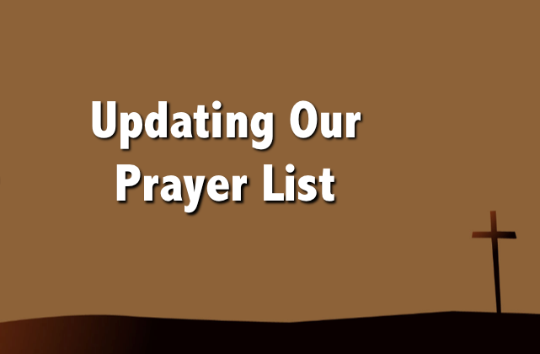
We have attempted to clean-up our prayer list.
Please take a moment and see if your name is on there and you would like it removed.
If someone’s name has been removed by accident, or if you would like to add a name, please email or call Rev. Martindale. Please remember that we should pray for each other regularly. Those on the prayer list are there because they are going through an
especially difficult time and need our fervent prayers.

JULY FINANCIAL REPORT
(No physical church attendance during the month due to Covid-19.)
OPERATING FUNDS:
Balance in checking account as of July 1, 2020 |  | 85,386.60
Tithes and Offerings Received |  | +12,031.00
Sub-Total |  | 97,417.60
Expenditures |  | -16,524.54
Balance in checking account as of July 31, 2020 |  | 80,893.06
RESTRICTED FUNDS:
(Funds designated for specific projects, etc.)
Restricted Funds held in checking account as of July 1, 2020  Employee FICA & w/holding taxes for July 2020  Donations/offerings received (2ȼ a Meal $0.00; RACM $500) |  | 93,873.83  +562.37  +500.00
Sub-Total |  | 94,936.20
Expenditures:  2nd Quarter 2020 Employer taxes: IRS $1,624.55; NCDR $45 |  | -1,669.55
Balance in Restricted Funds as of July 31, 2020 |  | 93,266.65
RECAP:
Operating Funds Balance | 80,893.06
Building Fund: Equip etc. 93.54 + Other 60,328.62 | +60,422.16
 | +32,844.49
Restricted Funds Balance | 174,159.71
July '20 Payroll Taxes on hand  (FICA 494.37; FW/H 53.00; SW/H 15.00; Adj +.02) | -562.39
7/31/2020 Checkbook Balance | 173,597.32
OTHER REVENUES ON HAND:
Scholarship C/D with BB&T  BB&T Investments Brokerage Acc. #JAL-059738, Estimated value (4 shs) | 23,635.62  +150.64
Total Other Revenues on hand | 23,786.26



Come out and volunteer at the
Robbins’ Food Bank on
Saturday, September 5th.
Arrive at 7:30 a.m. to fill and pass out bags of essential food items to our hungry neighbors between the hours of 8 and 10 a.m.

Thank you to those who help from home by continuing to provide a food bank necessity,
double-bagged grocery bags!
Keep up the good work FPC!


Thursday, September 3rd
10 a.m. Morning Circle
Bring a lawn-chair, wear a mask, and enjoy fellowship outside (weather-permitting) as we cover Lesson 7 of our current study.
Circle members, please remember to bring much-needed school supplies for Carthage Elementary.



September Birthdays

1 John (Buddy) Baker, Jr.
5 Diane Pangborn
9 Jean Bennett
10 Justin Edmonds
13 Ali Wadsworth
15 Nathan Phillips
16 Bobby Wallace
17 Catherine Monroe Collins
17 Judy Phillips
18 Nancy McClendon
21 Tracy Ingold
22 Ian Estep
23 Lisa Baker
27 Carly Monroe
30 Gail Hardin

Update us with church-family
birthdays anytime
by calling (910) 947-2924,
or emailing the church office at infofpc397@gmail.com.


Thursday, September 3rd 10:00 a.m. PW Morning Circle (outside, weather permitting)
Saturday, September 5th 7:30 a.m. Robbins’ Food Bank
Sunday, September 6th 9:00 a.m. Outdoor/Virtual Worship Service
2:00 p.m. Session Meeting – FLC/virtual
Monday, September 7th Labor Day, Church Office closed
Wednesday, September 9th 6:30 p.m. Christian Education Meeting – FLC/virtual
Sunday, September 13th 9:00 a.m. Worship Service – Outdoors/Virtual
Sunday, September 20th 9:00 a.m. Worship Service –
Employee Evaluations due
Thursday, Sept. 24th 6:00 p.m. Building and Grounds Committee
Sunday, September 27th 9:00 a.m. Worship Service –

FLOWERS USHERS
6 Outside Service (no flowers) Lee McCaskill, lead usher
13 Outside Service (no flowers) Michelle Tortora
20 Gail and Keith Hardin Elizabeth Martindale
27 Helen and CJ McDonald Denise Edmonds

The Administrative Committee is currently conducting FPC’s annual employee performance reviews.

Any beneficial feedback you have is appreciated!

Responses are due by September 20th,
and may be turned in by mailing them to the church,
or by placing them in the offering plate to the attention of the Administrative Committee.
If you prefer, you may also email your feedback to jwahala@embarqmail.com.

All responses are confidential
and will assist the committee in the review process.

Thank you for your dedication to God’s work and to FPC!

FEEDBACK

PLEASE!


