FIRST PRESBYTERIAN CHURCH
Non-Profit
Organization
U.S. Postage
PAID
CARTHAGE, NC
28327
Permit No. 35
POST OFFICE BOX 397
CARTHAGE, NORTH CAROLINA 28327
(910) 947-2924
fpccarthage.com (website)

infofpc397@gmail.com (email)
Fpc Carthage (facebook)



Class of 2020
Doris Russell
Chad Thomason
Michelle Tortora
JoAnn Wahala

Class of 2021
Denise Edmonds
Robert Gordon
Lee McCaskill
Geraldine Moore

Class of 2022
Keith Hardin
Elizabeth Martindale
Helen McDonald
Marie Monroe


The Reverend Rick Martindale Pastor
Ali Wadsworth Choir Director
Elizabeth Williams Organist
Shelley Hammond Administrative Assistant
Andie Hyman Nursery Attendant
Ann Key Sexton
Marie Monroe Treasurer



First Presbyterian
Church News
December 2020
Hope

Hope is alive and well. We might need to be reminded of that reality this year. Our way of life has changed dramatically. We miss seeing so many people and worshipping with one another. We are a family that has been told to quarantine from our normal way of life. As we learn of friends and even family who have been diagnosed with COVID-19, we are reminded of the importance of hope. Many will recover, but some won’t. As we enter the season of Advent, we are reminded of hope played out in the upcoming birth of the Christ Child. Hope is alive, even if we struggle to see it, and Him.

Celebrating the birth of Christ might be a challenge for us, especially since our normal Advent activities are missing this year. It causes us to pause and hopefully ponder our lives and our relationships with God. How do we make hope a reality in our lives?

Hope in 2020 requires us to be willing to change our perspective and reality. It requires us to try something new and different. So here are a couple of options to consider. Depression seems very present through the, “I’m doing fine” or “things are good” comments. Try a “praise” journal. Each day write a few lines (or more) about things in which you are thankful. You may write down gratitude for your family or friends (explain why). After a couple of weeks, you will start seeing God in your midst, even as you include challenges that you viewed in a new way. Then when you are down, go back and start reading. God will use your own words to lift you up.

Another option might be to simply light a candle. As you work on a project, cooking a meal, or on your computer… light a candle as a reminder that God is with you. There is something comforting with that physical reminder that God is the light that ushers in comfort and peace. When we are alone, especially, it is nice to be reminded that we aren’t.

May we discover the joy, peace, love, and hope of this Advent season that guides us. Yes, this year is different but God’s love and care for us isn’t.


Grace and Peace,

Rick

In Our Prayers
Remembering our sisters and brothers as they face difficult times.



Debbie Albright Jean Bennett, Quail Haven Jimmy Bibey
Anna Belle Campbell John Currie, Tara Plantation Lee Edmonds
Betty Elliott Keith Hardin Sheree Kelly
Margaret Leonard Carol Lucas John McCaskill
Linda McCaskill Nancy McKenzie Ina Sue Parks Kay Patterson Otis Patterson Judy Phillips Bonnie Scott Mary Thomas Phillip Warmbrod
Elizabeth Williams

Karen Bryant, friend of JoAnn Wahala Brian Casey, Lucinda and David’s son
Judy Claterbos, Mary Thomas’ sister Barbara Gomez Family
Carl Greeson, Susan Cole’s brother June Greeson, Susan Cole’s mother
Callie Hayes, friend of the Riyevskis Ann Herndon, Kay Patterson’s sister Sean Kennally, Angie Provost’s son-in-law Barbara May, friend of Debbie Gordon Jane Medlin, Carol Lucas’ daughter Jonah Monk, Sarah and Jonathan Monk’s son
Tommy Walton, Diane Pangborn’s brother

All of our military men and women and their families, especially the following:
Michael Abercrombie, Jonathan Baker, Kyle Bryant, Chris Mohan,
Patrick Mohan, Michael Schwartz, Will Strickland, and Quinn Wicker.

If you would like to add someone or take yourself off our Prayer List,
please call the church office at 947-2924,
or email infoFPC397@gmail.com.

ATTENDANCE
CHURCH SUNDAY SCHOOL
10/4 32 --
10/11 Rain --
10/18 32 20
10/25 Rain, no outside service 17
Indoor service, 17
Average 27 19
Outdoor service on the lawn continued in October.
Children’s Sunday School and an Indoor Service began October 18th.


OCTOBER 2020 FINANCIAL REPORT

OPERATING FUNDS:
Balance in checking account as of October 1, 2020 | 90,378.87
Tithes and Offerings Received | +8,947.00
Sub-Total | 99,325.87
Expenditures (includes $.02 Employee tax adjustment) | -20,298.72
Balance in checking account as of October 31, 2020 | 79,027.15
RESTRICTED FUNDS: (Funds designated for specific projects, etc.)
Restricted Funds held in checking account as of October 1, 2020  Employee FICA & w/holding taxes for October 2020  Donations/offerings received (2ȼ a Meal $5.00; Bldg Fd $250; Memorials $150; PW 2020 Thank Offering $272.86) | 89,719.54  +554.48  +677.86
Sub-Total | 90,951.88
Expenditures: 3rd Qtr Employee taxes $1,677.44 + adj $.02; 2 Cents as Meal $55 | -1,732.46
Balance in Restricted Funds as of October 31, 2020 | 89,219.42
RECAP:
Operating Funds Balance | 79,027.15
Building Fund: Equip etc 93.54 + Other 60,561.42 + $250.00 = | +60,904.96
Restricted Funds Balance | +28,314.46
 | 168,246.57
Oct '20 Payroll Taxes on hand (FICA 486.48; FW/H 53.00; SW/H 15.00) | -554.48
10/31/2020 Checkbook Balance | 167,692.09
OTHER REVENUES ON HAND:
Scholarship C/D with BB&T  BB&T Investments Brokerage Acc. #JAL-059738, Estimated value (4 shs) | 23,635.62  +171.96
Total Other Revenues on hand | 23,807.58



Ladies Morning Bible Study
is now ordering their new 2021 Bible Study!
Next month we hope to begin the new study
“Into the Light: Finding Hope through Prayers & Lament.” Books may be purchased for $10 this month for group or independent study by contacting Helen at 690-2463.
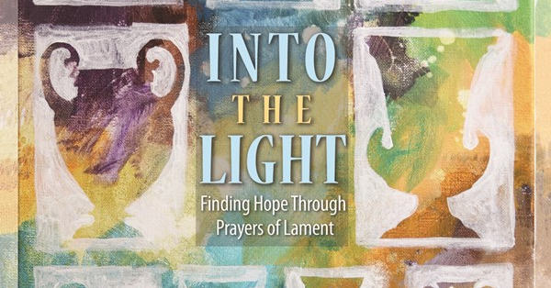
This nine-lesson study revives lament as a theological response to the difficult situations of our world. One of the foundational points of the study is that, in scripture, lament usually leads to hope. After crying out to God, the one who laments remembers God. And while that doesn’t fix things in the moment—the injustice, the loss still exists—the lamenter is strengthened to face the world and to hope. Recovering lament may be one of the church’s most timely gifts to the world. www.PresbyterianWomen.org
Happy Birthday!

5 Kelly Martindale
7 Nicolas Carter
12 Herman Seawell, Sr.
14 Abby Phillips
16 Linda Myrick
19 Tanya Adelman
19 Jackson Smith
22 Brandon Kelly
24 Pat Burt
24 Tom Pangborn
31 John McCaskill

Ushers
Michelle Tortora (Lead Usher)
Elizabeth Martindale
Denise Edmonds
Lee McCaskill



At the November 8th meeting, the session took the following action:
- Discussed the new roof for the Currie/Education Building and the sanctuary which had been approved earlier. Both projects should be starting very soon.
- Discussed repair work to the inside of the sanctuary.
- A new list of members for elders to call was requested.
- Approved budget for 2021. Rev. Martindale’s terms of call will be decided at our next congregational meeting.
- Applied for an equipment grant offered by the presbytery.





Since we are unable to gather for our annual Christmas Dinner
this year, FPC is collecting a
special offering on Sunday,
Dec. 6th for the Carthage Food Pantry to help local, hungry families in need of food during this difficult time. Due to COVID, special envelopes will not be provided. If using a regular offering envelope, please designate your “special offering” on the outside. You may also use a separate envelope labeled Carthage Food Pantry.
Thank you for choosing all the angels off our annual Angel Tree in the Family Life Center. Two local families will be blessed this Christmas from your generosity!
Be sure to wrap your gifts, attach the angel to the OUTSIDE of each package, and place gifts under the tree no later than Monday, December 7th.

Questions?
Contact Doris at 690-1511,
russell_doris@hotmail.com,
or Geraldine at 947-5363.


ADVENT SUNDAYS
10 a.m. Indoor/Virtual Worship 11 a.m. Outdoor Worship
Masks required. Social distance seating provided. Weather permitting.
Watch live on our facebook page, Fpc Carthage. Please wear a mask until seated,
View later on our website, www.fpccarthage.com. and bring a lawn chair for seating.

Tuesday, December 1st 6:15 p.m. Men’s Group (FLC)
Saturday, December 5th 7:30 a.m. Robbins’ Food Bank
To carpool, meet at FPC at 7 a.m.
Sunday, December 6th 2nd Sunday of Advent
Carthage Food Pantry Special Offering
10:00 a.m. Children’s Sunday School, ages 3-12th grade
10:00 a.m. Indoor/Virtual Worship (FLC)
11:00 a.m. Outdoor Worship
5:00 p.m. Youth Group
Monday, December 7th Angel Tree Gifts Due
2:00 p.m. Christian Faith Yoga, floor class (FLC)
3:15 p.m. Christian Faith Yoga, chair class (FLC)
Sunday, December 13th 3rd Sunday of Advent
10:00 a.m. Children’s Sunday School, ages 3-12th grade
10:00 a.m. Indoor/Virtual Worship (FLC)
11:00 a.m. Outdoor Worship
2:00 p.m. Session Meeting (FLC)
5:00 p.m. Youth Group
Monday, December 14th 2:00 p.m. Christian Faith Yoga, floor class (FLC)
3:15 p.m. Christian Faith Yoga, chair class (FLC)
Tuesday, December 15th Deadline for Church Mouse Newsletter
6:15 p.m. Men’s Group (FLC)
Sunday, December 20th 4th Sunday of Advent / Communion
10:00 a.m. Children’s Sunday School, ages 3-12th grade
10:00 a.m. Indoor/Virtual Worship (FLC)
11:00 a.m. Outdoor Worship
5:00 p.m. Youth Group
Thursday, December 24th 5:00 p.m. Christmas Eve Service (tentative time)
Friday, December 25th Christmas Day
Sunday, December 27th 10:00 a.m. Children’s Sunday School, ages 3-12th grade
10:00 a.m. Indoor/Virtual Worship (FLC)
11:00 a.m. Outdoor Worship

Thank you Church Family
for your generosity with
all of our projects!
Stay well and stay safe this
holiday season.
Fellowship & Mission

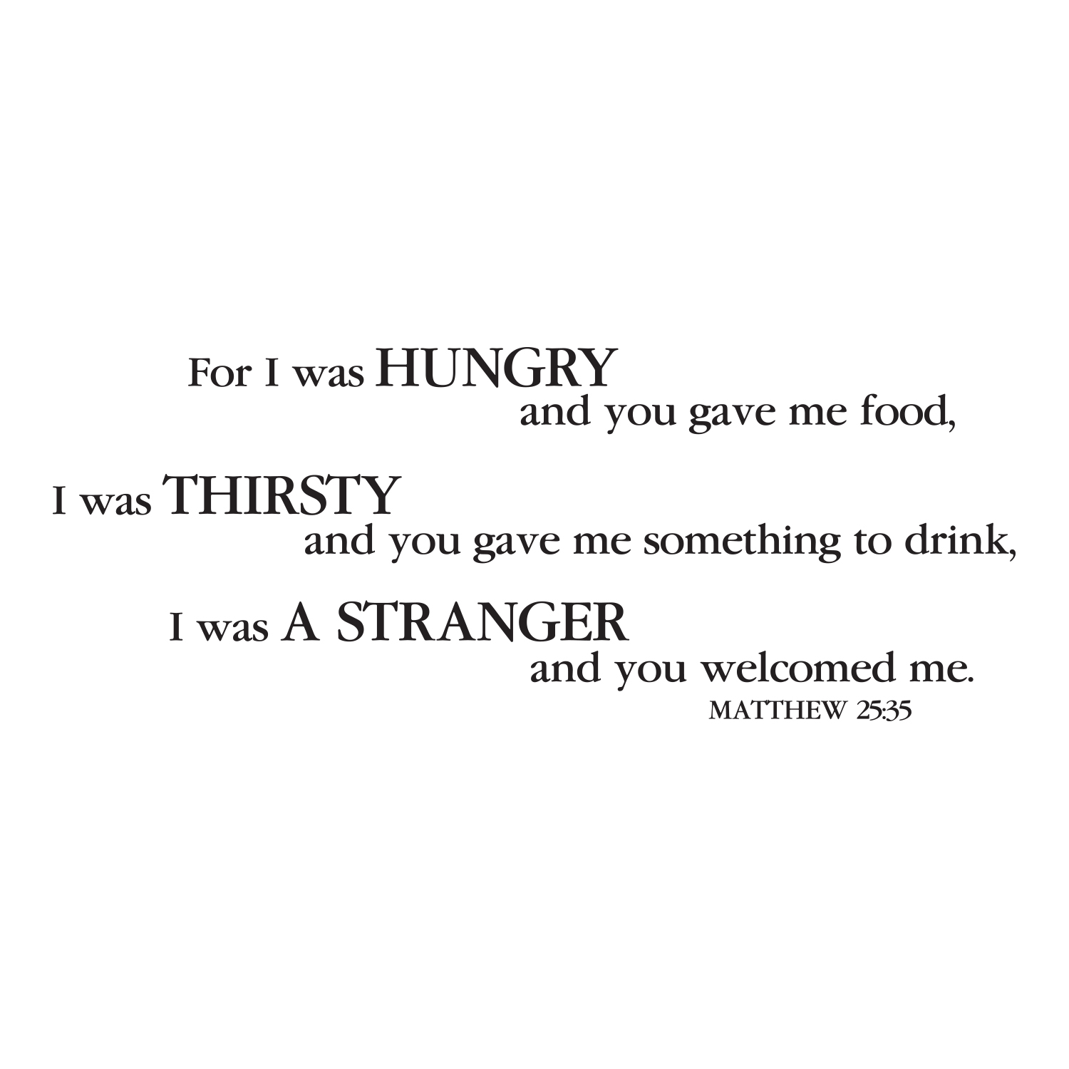
The hands and feet of Jesus…
Thank you for continuing to be the hands and feet of Jesus
by serving our Robbins’ Food Bank friends and neighbors.
Providing double-bagged plastic grocery bags and volunteering
at our Food Bank First Saturdays helps stabilize this long-term ministry.
Recently, a lower number of Saturday volunteers have attended.
If possible, please plan to serve others in need this holiday season at the food bank
on the morning of Saturday, December 5th. If you’d like to carpool, meet at FPC at 7 a.m. And as always, thank you for being the hands and feet of our Savior!

Advent Poinsettias are given
In Honor Of
Geraldine Moore, by Your Loving Family
Our Pastor, by Geraldine Moore
My Family, by Geraldine Moore

In Memory Of
Earl Moore, Bill Moore, and Heather Kelly, by Your Loving Family
Michelle Cottrell, by the Martindale Family
Jim Lucas, by the Martindale Family
Buddy Baker, by the Martindale Family

