Non-Profit
Organization
U.S. Postage
PAID
CARTHAGE, NC
28327
Permit No. 35

FIRST PRESBYTERIAN CHURCH
POST OFFICE BOX 397
CARTHAGE, NORTH CAROLINA 28327
(910) 947-2924
fpccarthage.com (web site)
infofpc@yahoo.com (e-mail)

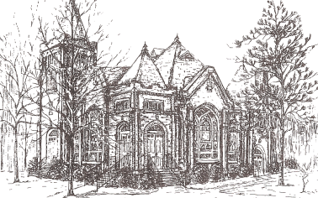THE CHURCH MOUSE

The Reverend Rick Martindale Pastor
Elizabeth Williams Organist & Choir Director
Shanon Venable Administrative Assistant
Sarah Frick Nursery Attendant
Ann Key Sexton
Marie Monroe Treasurer
Class of 2017
John Baker
Robert Gordon
Margaret Leonard
Bill Russell

Class of 2018
Angie Medlin
J.D. Monroe
Susan Phillips
Marlene Riyevski

Class of 2019
Lucinda Casey
Cristy Dean
Scott Phillips
Paul White

FIRST PRESBYTERIAN CHURCH
July 2017

Summer Schedule

Summer is now officially upon us. In other words, it’s hot not just in the morning but also in the middle of the night (Oliver doesn’t always sleep through the night before needing to go outside 😊). But fear not, Fall is only 114 days away!

For those of us who love this time of year, it is filled with vacations, time at the pool or favorite lake, traveling to the beach or the mountains (to escape the heat), eating watermelon, watching baseball, and lots of other activities.

For us in the life of the church it means that we don’t get to see each other as often because of all those activities listed above and many more. As you are busy this summer, know that you will be missed. We are a family. And like all families, we miss one another when we are not around even if it is just to flash a smile or see you from across the room. There is a feeling of contentment when everyone is together.

The Martindale family will be gone some this summer as well. We have a trip planned to Lancaster, PA to see a great production of Jonah. We will head to Topsail Beach with all my family from Iowa. The girls are looking forward to seeing all their Iowa cousins!

FPC will be on our summer schedule beginning in July and going through August 13th. This means that our children, youth, and young adult Sunday school classes will not be meeting. This gives our teachers a break after teaching for the last 10 months. But fear not, our adult class that meets in the library will be meeting at 9 a.m. Everyone is invited to come and be a part of this class.

During the summer schedule, our worship time changes as well. We will be meeting at 10 a.m. instead of 11 a.m. I know some of you love this schedule and some of you don’t. For those who love the extra time this provides…enjoy! I’m looking forward to heading to the Pik-N-Pig ahead of all the crazy Sunday crowd! For those of you who don’t like the time change, remember…you get your time for worship roughly 90% of the time. Growing up in Burlington, Iowa our worship time was 10:15 a.m. except for in the summer when it was even earlier!

Please make the most of your summer! Appreciate all that God has given you! Be safe! We do not close our doors during the summer. We are a family that gains strength from our Lord and Savior and our ability to gather together. You are not forgotten and your participation in worship and the life of the church is important!

Grace and Peace,
Rick
July Calendar Page

Birthdays

1 Debbie Gordon
4 Gracen Bennett
4 CJ McDonald
7 JoAnn Wahala
8 Jason Myrick
11 Sarah Lucas
17 Geraldine Moore
18 Greg Riyevski
18 Marc Stromko
22 Carol White
22 Gavin Parker
24 Scott Tortora
26 Sawyer Dean
27 Scott McLeod
29 J.D. Monroe
31 Ina Sue Parks

If we do not have your correct birthday or if it is missing please let the church office know. Thanks.

USHERS
Margaret Leonard*
Youth
J.D. Monroe
Scott Phillips

*Lead Usher

FLOWERS
2 Ruby Ingold
9 Jeannie & Max Muse
16 Ann Key
23 Debbie & Robert Gordon
30 Elizabeth Barringer

If you would like to place flowers in the sanctuary, please contact Susan Cole (947-5764).

GREETERS
2 Ashley & Jimmy Bibey
9
16
23
30

In Our Prayers . . .

Bette Allen Jean Bennett - Quail Haven
Linda Busch John Currie – Tara Plantation
Damon Dean Sheree Kelly
Margaret Leonard Jim Lucas
Joan MacLean Nancy McKenzie
Garin Parker Dennis Parks
Ina Sue Parks Kay Patterson
Jim Phillips – St. Joseph’s Bonnie Scott
Phillip Warmbrod



Linda Ammons – Jim Phillips’ sister Tony Bibey – Jimmy’s son
Cheryl Bowman Karen Bryant – Friend of JoAnn Wahala
Dean Cameron Libby Craven
Family and Friends of Ginny Cumbee Lee Cunningham – Marlene Riyevski’s Uncle
Robert Davis Judy Durham
Christopher Freeman – Maria Bigger’s Grandson Wendy Horne- Linda Myrick’s Niece
Bo Houff – Elizabeth Barringer’s Son-in-Law Aaron Ladmin
Vince Mann – Friend of the Leonards David Moore – Geraldine’s son Ann Parker – Barbara Danley’s cousin
Megan Sanchez – Marlene Riyevski Niece Hunter Smith
William Stutts – Bonnie Scott’s Brother-in-Law Skip Vann – Jim Phillips’ brother
Linda Ray Winslow – Friend of Pat Jackson

All of our military men and women especially the following: Jonathan Baker,
Chris Mohan, Patrick Mohan, Gregory Riyevski, Will Strickland, and Quinn Wicker.

JULY CALENDAR

1 8:30 Robbins Food Bank (meet at FPC)
2 9:00 Adult Sunday School Class (library)
10:00 Worship
11:00 Lemonade on the Lawn
4 Independence Day (church office closed)
5 8:45 Christian Yoga
10:15 Christian Chair Yoga
11:00 Grief Share
6 7:00 Christian Yoga
7:00 Boy Scouts
9 9:00 Adult Sunday School Class (library)
10:00 Worship
12 8:45 Christian Yoga
10:15 Christian Chair Yoga
11:00 Grief Share
13 7:00 Christian Yoga
15 9:00 Genealogical Society Conference
16 9:00 Adult Sunday School Class (library)
10:00 Worship/Communion/Homebound Communion
19 8:45 Christian Yoga
10:15 Christian Chair Yoga
11:00 Grief Share
21 Mouse Articles Due
23 9:00 Adult Sunday School Class
10:00 Worship
26 8:45 Christian Yoga
10:15 Christian Chair Yoga
25 1:00 Mouse Deadline
30 9:00 Sunday School Class
10:00 Worship

FINANCIAL REPORT
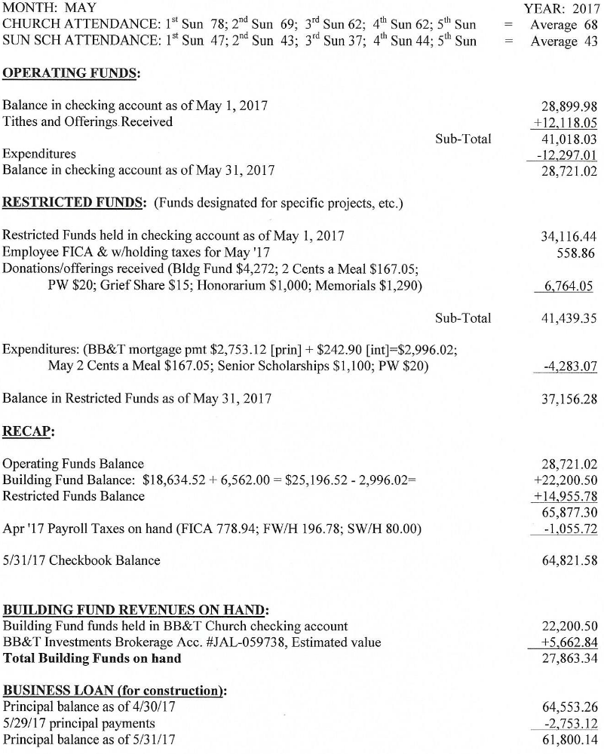
Fall Festival

Fall Festival Chairpersons are:

Silent Auction— Susan Phillips/Angie Medlin
Arts & Crafts— Gail Meeks
Plants— Bill Russell
Boutique— Lucinda Casey/Nancy Carter
Bakery— Susan Cole
Advertising/Flyers— Lucinda Casey
50/50 Raffle— Hal Meeks
Culinary— JoAnn Wahala
Doll House Raffle — Kay Grimm
Popcorn— Debbie and Laura Gordon
White Elephant— Tom Pangborn/Steve Ingold
Decorations— Joan MacLean, Marlene Riyevski and JoAnn Wahala

If you are a Fall Festival chairperson, please contact Doris Russell with anything you would like included in future church bulletins or The Mouse. Doris would like to put all Fall Festival news together for easy access.
Email: russell_doris@hotmail.com or phone 949-6549. She will respond or meet in person to discuss any of your questions. Doris will hold a group meeting for all chairpersons at a later date, closer to festival time.

There are several of you who have not yet placed your name under one of the categories, please contact one of the above chairpersons to let them know you can help either before Oct. 28th’s festival, or on the festival day to help in the booth. Thank you.

With the Women

Circle will not meet this month. We will meet in July to preview the dvd option to the Horizons Bible study, “Cloud of Witnesses: The Community of Christ in Hebrews” as well as a couple of other studies.
We will kick off our 2017-2018 year on August 7th at 6:00 pm at our annual Salad Supper. All are invited to bring your favorite salad and join us for an evening of good food and fellowship.
Ladies Lunch will not meet in July. We will meet again in August at Mrs. Lacy’s in Sanford.

Grief Share

Grief Share will continue to meet through July 19th. You can begin this weekly video, personal workbook, and group discussion at any time. Each week is self-contained. Sessions begin at 11:00 a.m. and finish by 1:00 p.m. If you have dealt with the death of a family member or friend you will discover that this study is very helpful. Please contact the church office (947-2924) or the Russell’s (949-6549) to learn more.

Remaining lessons:
11th lesson — Wed, July 5 Lessons of Grief; Part 2
12th lesson — Wed. July 12 Heaven
13th lesson — Wed. July 19 What Do I Live for Now & Grief Share Celebration

Christian Faith Yoga
Our Christian Faith Yoga classes will continue throughout the summer! Christian Faith Yoga is taught by Lynda Lea Goodall (trained in Christian yoga, recognized by the yoga alliance, the national certifying agency). Lynda Lea will read Bible verses and play Christ centered worship music and classical church music during the yoga sessions.

Christian Faith Yoga will take place three times a week! We will meet on Wednesdays from 8:45 – 9:45 a.m. using mats and 10:15 – 11:15 a.m. for chair yoga. On Thursdays the class meets from 7:00 – 8:00 p.m. using mats.

This is a great way to care for your whole being! It is $5.00 per session. Come and bring a friend!

