First Presbyterian Church

Located in the heart of Carthage, NC
near the Post Office at 110 South Ray Street,
First Presbyterian welcomes you!
(910) 947-2924
infofpc397@gmail.com

www.FpcCarthage.com


Fpc Carthage


#fpcbethelight

The Reverend Rick Martindale Pastor
Ali Wadsworth Choir Director
Elizabeth Williams Organist
Shelley Hammond Administrative Assistant
Andie Hyman Nursery Attendant
Ann Key Sexton
Marie Monroe Treasurer



The Reverend Rick Martindale, Pastor
Shelley Hammond, Administrative Assistant
Andie Hyman, Nursery Attendant
Ann Key, Sexton
Marie Monroe, Treasurer
Ali Wadsworth, Choir Director
Robert Wilson, Interim Organist

FPC Session
Session Class of 2021 Denise Edmonds, Robert Gordon, Lee McCaskill, Geraldine Moore
Session Class of 2022 Keith Hardin, Elizabeth Martindale, Helen McDonald, Marie Monroe
Session Class of 2023 Lucinda Casey, Tom Leonard, Scott Phillips, Jennifer Thomason

Non-Profit
Organization
U.S. Postage
PAID
CARTHAGE, NC
28327
Permit No. 35
First Presbyterian Church
PO Box 397
Carthage, NC 28327




First Presbyterian Church
A Cornerstone for Christ since 1850.

June 2021 Church News

Congregational Meeting and Summer Schedule

We have a congregational meeting scheduled for June 13th. Our meeting will be a little different than approving my terms of call, electing a nominating committee, or electing those to serve as an elder or on the cemetery committee. Instead, a motion is coming before you dealing with the session itself. A group of elders composed of Robert Gordon, as chair, Keith Hardin, Helen McDonald, Scott Phillips, Jennifer Thomason, JoAnn Wahala, and myself have been exploring what is best for the church moving forward.

Our current policy is that we have 12 Ruling Elders who serve for three years. After the third year they must take one year off.

The motion that will come before the congregation will be to keep the session at 12 Ruling Elders but change the term of office from three to two years. An elder may be asked, if willing, to serve a second term (2 more years for a total of 4 years) before having to take a year off.

The Elder Committee had discussed changing the number on the session but ultimately decided that having 12 members makes the work of the committees much easier. We have six standing committees, thus providing two elders to remain on each committee.

I’m sharing this information so everyone is in the know and can be informed before the congregational meeting. The session has approved the changes that are coming before the congregation.

Changing gears, our summer schedule will begin June 6th and run through August 15th. Worship will be at 10:00 a.m. We are planning on having a speaker outside the multi-purpose room for those who want to worship outside. We are also hoping to move back to the sanctuary soon. During the summer schedule, our children will have a short lesson each week during part of the worship time. The adult class in the library may begin meeting at 9:00 a.m. if they so choose. Stay tuned for details.

I sense that it’s going to be an exciting summer as we start engaging again in the life of our church family. May we discover again the joy of being together worshipping God!

Grace and Peace, Rick

PRAYER CONCERNS

First Pres prays for you.

Remember
our brothers and sisters
in Christ through prayer and petition
as they face difficult times.
Debbie Albright Jean Bennett, Quail Haven
Anna Belle Campbell Benny Cole John Currie, Tara Plantation Justin & Sarah Edmonds
Lee Edmonds Gail Hardin
Margaret Leonard Carol Lucas
Linda McCaskill, Quail Haven Nancy McKenzie
Gail Meeks Ina Sue Parks
Kay Patterson Otis Patterson
Tom Stewart Bonnie Scott
Phillip Warmbrod

Bo, friend of Geraldine Moore
Karen Bryant, friend of JoAnn Wahala
Brian Casey, Lucinda and David Casey’s son
Judy Claterbos, Mary Thomas’ sister
Jack Denniston, Lucinda and David’s daughter-in-law’s father
Carl Greeson, Susan Cole’s brother
June Greeson, Susan Cole’s mother
Ann Herndon, Kay Patterson’s sister
Sean Kennally, Angie Provost’s son-in-law
Barbara May, friend of Debbie Gordon
Noah Matthews, Kayla Carter’s brother
Jane Medlin, Carol Lucas’ daughter
Lisa Muller, Cousin of Ina Sue Parks
Tommy Walton, Diane Pangborn’s brother

All of our military men and women and their families, especially the following:
Michael Abercrombie, Jonathan Baker, Kyle Bryant, Chris Mohan,
Patrick Mohan, Greg Riyevski, Michael Schwartz, Will Strickland, and Quinn Wicker.

FPC Stewardship & Finance

April 2021
OPERATING FUNDS:
Balance in checking account as of April 1, 2021 | 92,688.74
Tithes and Offerings Received | +17,876.79
Sub-Total | 110,565.53
Expenditures | -12,428.49
Balance in checking account as of April 30, 2021 | 98,137.04
RESTRICTED FUNDS: (Funds designated for specific projects, etc.)
Restricted Funds held in checking account as of April 1, 2021  Employee FICA & w/holding taxes for April 2021  Donations/offerings received (2ȼ a Meal $61.80; Bldg Fd $50; BF Memorials $75;  Cemetery Fund $90; Cemetery Fd Memorials $75; Music Fund $40;  PW donation $100; PW B'day $185; Love offering $1,415; Presbyterian  Men (new organization) $100; Regular Memorials $1,275 | 134,109.99  +296.37  +3,466.80
Sub-Total | 137,873.16
Expenditures: Souper Bowl donations to Carthage Food Pantry & RACM $377;  US Treasury, 1st qtr '21 employee taxes $562.41 | -939.41
Balance in Restricted Funds as of April 30, 2021 | 136,933.75
RECAP:
Operating Funds Balance | 98,137.04
Building Fund: Equip etc.. 93.54 + Grant $500.00 + Other 107,510.17 + 125.00= | +108,228.71
Restricted Funds Balance | +28,705.04
 | 235,070.79
Apr '21 Payroll Taxes on hand (FICA 273.37; FW/H 23.00; SW/H 0.00; + $.04 excess) | -296.41
4/30/2021 Checkbook Balance | 234,774.38
OTHER REVENUES ON HAND:
Scholarship C/D with BB&T  Truist Financial Corp, Estimated value (4 shs)  Total Other Revenues on hand | 23,639.20  +246.56 23,885.76

FPC Calendar June 2021 Family Life Center (FLC) Conference Room (CR)

Tuesday, June 1st 6:30 p.m. Fellowship and Mission Committee

Thursday, June 3rd 11:00 a.m. Ladies Bible Study, final study until September (CR)

Saturday, June 5th 7:30 a.m. Robbins’ Food Bank, meet 7 a.m. at FPC to carpool

Sunday, June 6th 9:00 a.m. Building and Grounds Committee
10:00 a.m. Indoor/Outdoor/Virtual Worship (FLC) and
Children’s Church – Summer Schedule Begins

Monday, June 7th 6:30 p.m. Worship Committee

Saturday, June 12th West Community Presbytery Meeting
Spring Clean-Up at FPC

Sunday, June 13th 10:00 a.m. Indoor/Outdoor/Virtual Worship (FLC) and
Children’s Church
10:45 a.m. Congregational Meeting
2:00 p.m. Session Meeting

Sunday, June 20th Father’s Day
10:00 a.m. Indoor/Outdoor/Virtual Worship/Communion and
Children’s Church (FLC)
2:00 p.m. Session Meeting

Monday, June 21st Deadline for July Church Mouse Newsletter

Sunday, June 27th 10:00 a.m. Indoor/Outdoor/Virtual Worship (FLC) and
Children’s Church

Thursday, June 3rd 11:00 a.m. FPC Conference Room
During this last meeting before breaking for the summer, we’ll complete our current Bible study,
lessons 8 and 9. For a copy of our fall study that is scheduled to begin in August –
“What My Grandmothers Taught Me: Learning from the Women in Matthew's Genealogy of Jesus” –
please call Helen McDonald at (910) 690-2463.

____ ____ FPC Connect News & Announcements_______
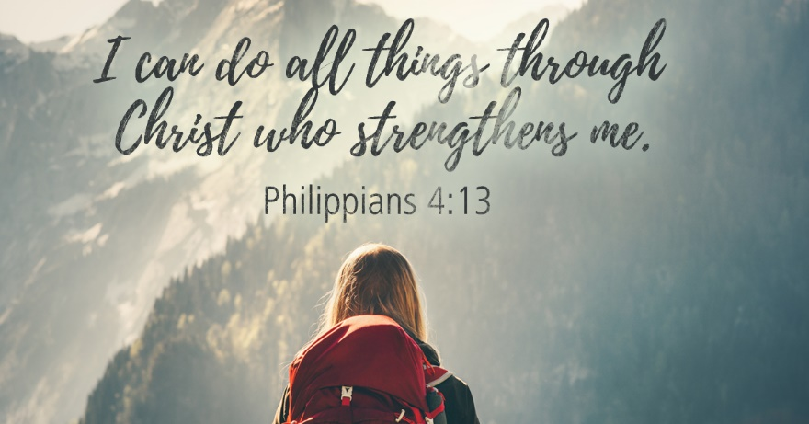

Congratulations to our graduating high school seniors!

Riley Medlin graduates from Pinecrest High School June 5th
and will attend Clemson University in the Fall.
Emily Tortora graduates from Union Pines High School June 4th
and will attend Virginia Tech in the Fall.



July 18th – 21st
Ages 4 through 6th grade 6-7:30 p.m.
Preschool VBS for ages 2 & 3 will be on July 18th from 2 to 4 p.m.



For a registration form, please email
Jennifer Thomason at
mrs.jenniferthomason@gmail.com.


FPC is updating our website and visitors packet,
and we need new photos! Please email your recent and upcoming church fellowship & worship photos to us! infofpc397@gmail.com

Happy Birthday!

1 Silas Stromko
3 Doris Russell
6 Carol Lucas
6 Bryan Monroe
8 John Currie
11 Ginny Buie
12 Benny Cole
14 Joanna Monroe
17 Jonathan Baker
20 Sandra Pearson
22 Brenda Smith
24 Cristy Dean
29 Philip Warmbrod
30 Matthew Leonard

To update or add a birthday,
please contact the church office.
(910) 947-2924
infofpc397@gmail.com



FIRST PRESBYTERIAN.
A cornerstone for Christ in the Carthage community since 1850.

Led by God and sustained by the Holy Spirit, FPC supports God’s children they grow
in their faith, strengthens their relationship with Jesus Christ,
and are challenged to be God’s servants and disciples.

10 a.m. Children’s & Youth 10 a.m. Worship 11 a.m. Worship
Sunday School Indoor Outdoor
4/4 -- 62 5
4/11 8 29 0
4/18 10 29 11
4/25 18 37 0
Average 12 39 5

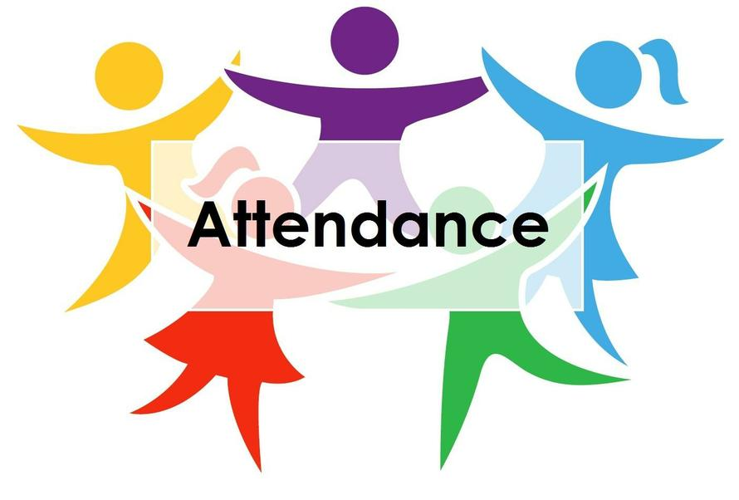

#fpcbethelight


This summer, Presbyterian Women are
“Spreading A Little Sunshine!”
Join the fun by sending cards and other activities
to our church family.

FPC Basket Ministries & Missions
JUNE FOCUS: Sandhills/Moore Coalition & Robbins Food Pantry

Please donate simple items to show God’s love to our neighbors!

Sandhills/Moore Coalition for Human Care
instant potatoes

Robbins Food Pantry
food and plastic bags

Nursing Home Ministry:
Pinelake Nursing Home & First Health Hospice and Palliative Care
puzzles, word searches, crosswords, adult coloring books, pens,
colored pencils, crayons and snacks (Little Debbie Cakes, Lance crackers, etc.)

Carthage Food Pantry
Please hold children’s books donations at this time.

Back Pack Pals
While school is out for the summer, crackers and raisins already purchased
for Back Pack Pals may be donated to our Nursing Home Ministry,
where there is also a need.

"For I was hungry and you gave me food, I was thirsty and you gave me something to drink,
I was a stranger and you welcomed me, I was naked and you gave me clothing, I was sick and you took care of me, I was in prison and you visited me." Matthew 25:35-36 NRSV

