Non-Profit
Organization
U.S. Postage
PAID
CARTHAGE, NC
28327
Permit No. 35

FIRST PRESBYTERIAN CHURCH
POST OFFICE BOX 397
CARTHAGE, NORTH CAROLINA 28327
(910) 947-2924
fpccarthage.com (web site)
infofpc397@gmail.com (e-mail)

THE CHURCH MOUSE

The Reverend Rick Martindale Pastor
Ali Wadsworth Choir Director
Elizabeth Williams Organist
Shelley Hammond Administrative Assistant
Andie Hyman Nursery Attendant
Ann Key Sexton
Marie Monroe Treasurer

Ruth Craig Interim Pianist
Class of 2019
Lucinda Casey
Cristy Dean
Scott Phillips
Paul White

Class of 2020
Doris Russell
Chad Thomason
Michelle Tortora
JoAnn Wahala

Class of 2021
Denise Edmonds
Robert Gordon
Lee McCaskill
Geraldine Moore
FIRST PRESBYTERIAN CHURCH
April 2019

Are You Ready for Easter?

We only have three more weeks to prepare for the joy of Easter morning. Why do we have to prepare for Easter? If we don’t prepare, Easter is just another Sunday. It’s just another day. Easter is neither of these things.

We must prepare ourselves for the turmoil that comes as we walk with Jesus during His last days. Easter is not simply celebrating that Christ is risen, and that He has conquered sin so that we might be able to relish in the joy of everlasting forgiveness and eternity with God. Easter is the culmination of joy after a grueling marathon. Jesus ran a very demanding race and endured great challenges as He led His disciples, and us, toward a future that is full of hope and promise.

He perseveres against the religious leaders and countless others who ignore who He is, and instead try to destroy Him and His ministry. His struggles are real, just as our struggles are real. His pain on the cross is real, just as our pain is real.

The short-lived celebration of Palm Sunday is clouded with more and more rebellion and treachery, even coming within His own trusted twelve. It leads to betrayal, torture, and the Son of God hanging on the cross.

The joy of Easter morning enables us to look back and see the cross not as a symbol of death but as defiant symbol of hope. Jesus has transformed a sign of torture, pain, and death into a sign of hope and love. The empty tomb affirms that Jesus is not dead but alive!

We can’t cross the finish line of a marathon without embracing all the work and miles of running to get to that point. Crossing the finish line is a shallow act if we haven’t done the work. Easter is far from shallow and meaningless if we have journeyed through this season of lent. Jesus has done the work, and we in our preparation begin to understand and appreciate all that He has done for us.

It is never too late to start the race and embrace the joy of Easter as God intends. We have three weeks to prepare ourselves for one of the pinnacle events of our Christian faith. Spend this time wisely and be ready to celebrate Easter as God intends!

Grace and Peace,

Rick
April Calendar Page
USHERS

Scott Phillips*
Doris Russell
Michelle Tortora
Robert Gordon

*Lead Usher

Birthdays

4 David Casey
5 Cindy Monroe
6 Katie Campbell
7 Shane Medlin
9 Judi Kelly
10 Reid Marshburn
11 Kayden Dean
11 Betty Elliot
11 Katie Kelly Crenshaw
11 Sharon McDonald
14 Michelle Tortora
16 Regena Nugent
18 Kelly Gordon
19 Ann Key
21 Lee McCaskill
26 Denise Bennett
26 Shirley Moore
30 Coy Oakley
30 Tina Stromko
If we do not have your correct birthday or if it is missing please let the church office know. Thanks.

FLOWERS

7 Pat Jackson
14 Carol and Paul White
21 Easter Lilies
28 Diane and Tom Pangborn
To place an Easter Lily in the sanctuary on Easter Sunday (April 21st) in memory or in honor of someone special, please email or call the church office by April 17th.
(947-2924) infofpc397@gmail.com

If you would like to place flowers in the sanctuary, please contact Susan Cole
(947-5764).

GREETERS

7 Jimmy Bibey

14 Otis Patterson

21 Judi and Archie Kelly

28 Debbie Albright

In Our Prayers . . .

The thoughts and prayers of the congregation are extended to Scott Rives, and all of
Joan MacLean’s family, in her death on March 15th.

Jean Bennett – Quail Haven Jimmy Bibey John Currie – Tara Plantation
Betty Elliott Sheree Kelly Carol Lucas Jim Lucas Nancy McKenzie Pat Nugent
Dennis Parks Ina Sue Parks Phillip Warmbrod
Kay Patterson Jim Phillips – St. Joseph’s Scott Rives
Bonnie Scott



Linda Ammons – Jim Phillip’s sister Dean Cameron
James Cox – Friend of Kelly Martindale Robert Davis
Christopher Freeman – Maria Bigger’s grandson Jimmie Garner – Joan Power’s father
Carl Greeson – Susan Cole’s brother June Greeson – Susan Cole’s mother
Aaron Ladmin Vince Mann – Friend of the Leonards
Garin Parker – Barbara Danley’s Nephew Kimberly Sanders and Family
William Stutts – Bonnie Scott’s Brother-in-Law Hunter Smith
Skip Vann – Jim Phillip’s brother

All of our military men and women and their families especially the following:
Jonathan Baker, Chris Mohan, Patrick Mohan, Gregory Riyevski, Tim Shiflet,
Will Strickland, and Quinn Wicker.

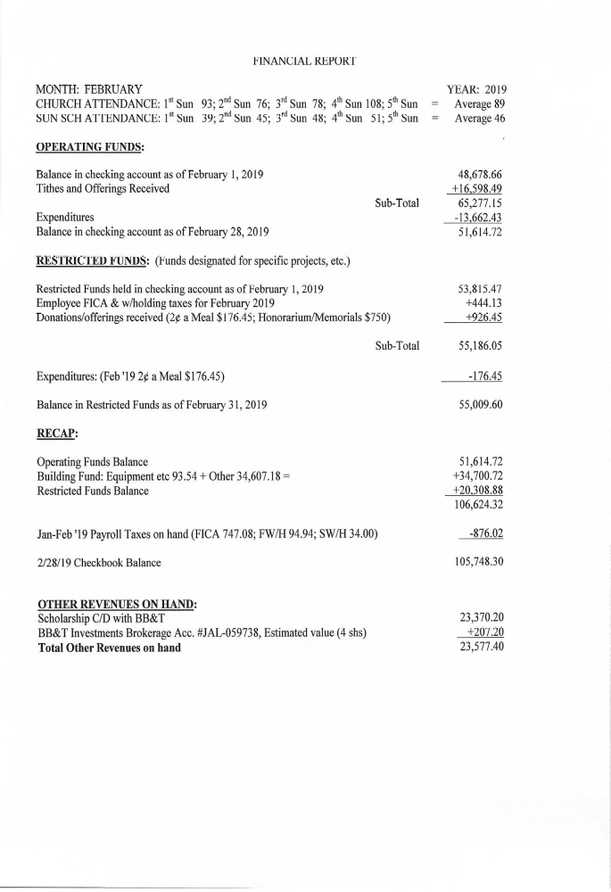

APRIL CALENDAR
1 8:45 Christian Yoga
10:15 Christian Chair Yoga
3 8:45 Christian Yoga
10:15 Christian Chair Yoga
12:00 Community Lenten Service (Mt. Olive AME Zion Church)
5:30 What’s Up Wednesday (Family Life Center)
4 11:00 Presbyterian Women’s Circle (conference room)
7:00 Praise Team practice
6 7:30 Robbins’ Food Bank
10:00 PW Annual Spring Gathering (College Heights Pres, Fayetteville)
7 9:00 Fellowship and Mission Committee (conference room)
9:45 Sunday School
11:00 Contemporary Worship Service (Family Life Center)
2:00 Crop Hunger Walk
8 8:45 Christian Yoga
10:15 Christian Chair Yoga
6:30 Homebound Outreach Easter Bunny making (Family Life Center)
10 8:45 Christian Yoga
10:15 Christian Chair Yoga
12:00 Community Lenten Service (First Missionary Baptist Church)
5:30 What’s Up Wednesday (Family Life Center)
7:00 Choir practice
11 7:00 Praise Team practice
14 Palm Sunday
9:00 Worship Committee (conference room)
9:45 Sunday School
11:00 Worship
2:00 Session Meeting (conference room)
6:00 Robbins Community Service
15 8:45 Christian Yoga
10:15 Christian Chair Yoga
17 8:45 Christian Yoga
10:15 Christian Chair Yoga
7:00 Choir Practice
18 11:30 PW Ladies’ Lunch at Mrs. Lacy’s Magnolia House, Sanford
7:00 Maundy Thursday/Tenebrae Service

(The rest of April is on the next page)

All articles/information for the Mouse and the weekly bulletins should be emailed
to the church’s email address: infofpc397@gmail.com

April Calendar Continued
19 Good Friday
21 7:00 Easter Sunrise Service (FPC Cemetery) and church breakfast
9:45 Sunday School
11:00 Easter Communion Worship Service
22 Easter Monday (Church Office Closed)
8:45 Christian Yoga
10:15 Christian Chair Yoga
23 Deadline for May Mouse
24 8:45 Christian Yoga
10:15 Christian Chair Yoga
5:30 What’s Up Wednesday (Family Life Center)
7:00 Choir practice
25 7:00 Praise Team practice
27 8:00 Church Clean-up Day
4:00 Coalition Pack-the-Pick-Up, Youth Participating
28 9:45 Sunday School
11:00 Worship
29 8:45 Christian Yoga
9:45 Christian Chair Yoga
30 1:00 Fold Mouse (conference room)

One Great Hour of Sharing


On Easter Sunday, April 21st, our congregation will join fellow Presbyterians and Christians from around the world to give to One Great Hour of Sharing. In its 70th year, this offering continues to provide support and help those in need of food, families who have suffered loss due to terrible disasters, and those tangled in a life of poverty with little hope to improve their conditions. Some of the offering remains in our presbytery, while some of the offering funds return to other areas in North Carolina. Regardless of the geographical area, your generosity goes to help humans in need. This is part of God’s ministry to reach out to others, even if we do not know them or where they live. Let God’s love for all people guide you in supporting this special offering!

Fellowship and Mission
- We will meet at 9:00 a.m. Sunday, April 7th in the conference room.
- Crop Hunger Walk is scheduled for 2 p.m., Sunday, April 7th. Let’s walk to help end hunger!
- Easter Sunrise Service will be 7 a.m. at FPC Cemetery on Sunday, April 21st, followed by a church breakfast. If you would like to volunteer to help with the Easter Sunrise breakfast, please contact Geraldine Moore (947-5363).
- Mark your calendars now. We will be taking pictures for our new pictorial directory on Thursday, May 2nd from 4 – 9 p.m.; Friday, May 3rd from 2 – 9 p.m.; and Saturday, May 4th from 10 a.m. – 5 p.m. Stay tuned for more details. Also, if you would like to join Bill Russell and Ann Currie on the new pictorial directory committee, contact Bill (949-6549).
- Fellowship and Missions Committee is seeking donations for residents of Carthage’s Peak Resources Pinelake nursing home who do not have close by family or loved ones. Items needed: toiletries – lotion, chapstick, body wash, shampoo, toothpaste, back scratchers, and hair accessories; men’s and women’s items – blankets, socks, pajamas, and sweats (various sizes); activities – bird feeders, small radios, coloring supplies, word searches, crosswords, games, and puzzles.
With the Women
A special thank you from Presbyterian Women for all of your support!
-Thank you for the wonderful response for food and help for funerals and other events at the church. -Money collected for lunch after the Lenten Service will be donated to the Carthage Food Pantry.
-With the money we collected at our Soup Lunch in January we contributed to the Interfaith Prison Ministry to provide a Hope Bag for women leaving minimum security prison, contributed to Children’s Hope Alliance (combined Barium Springs and Grandfather Homes), can continue to provide These Days devotionals, and will make a donation to the Thank Offering in the fall.
-Thank you for your donations to the Birthday Offering which benefits multiple recipients –
one of whom is from NC!

Circle will meet on Thursday, April 4th at 11:00 a.m. in the conference room.

Mark your calendar!! PW Annual Spring Gathering will be at College Heights Presbyterian Church in Fayetteville on Saturday, April 6th. Debbie Gordon will be installed to the PW Coastal Carolina Coordinating Team as our Facilitator of Mission/Celebration Giving. Registration is from 8:30 - 9:30 a.m. Plenary begins at 10:00 a.m. Hope you can attend.

All are invited – young and old – to make Easter bunnies to take to those who are homebound. Meet on Monday, April 8th at 6:30 p.m. in the Family Life Center fellowship hall. If you are unable to help make one, and would like to deliver, please let us know. Thank you to Marie Monroe for organizing!

Ladies Lunch will meet on April 18th at 11:30 a.m. at Mrs. Lacy’s Magnolia House, 405 Carthage St., Sanford. Please RSVP by April 15th to Helen if you plan to attend. Carpool from FPC at 11:00 a.m.

We will be decorating pillow cases to send to children in Puerto Rico. More details to come.

If you would like be added Presbyterian Women’s email, or receive a call to help in times of need, please let Helen McDonald know at hmcd2946@gmail.com, or call/text (910) 690-2463.

