Non-Profit
Organization
U.S. Postage
PAID
CARTHAGE, NC
28327
Permit No. 35

FIRST PRESBYTERIAN CHURCH
POST OFFICE BOX 397
CARTHAGE, NORTH CAROLINA 28327
(910) 947-2924
fpccarthage.com (web site)
infofpc@yahoo.com (e-mail)

THE CHURCH MOUSE
The Reverend Rick Martindale Pastor
Elizabeth Williams Organist & Choir Director
Ann Key Sexton
Marie Monroe Treasurer
Shanon Venable Administrative Assistant
Sarah Frick Nursery Attendant

Class of 2018
Angie Medlin
J.D. Monroe
Susan Phillips
Marlene Riyevski

Class of 2019
Lucinda Casey
Cristy Dean
Scott Phillips
Paul White

Class of 2020
Doris Russell
Chad Thomason
Michelle Tortora
JoAnn Wahala

FIRST PRESBYTERIAN CHURCH
June 2018

Quickly Approaching Deadlines:

Thank you to everyone who has contributed to Back Pack Pals this school year. It is a wonderful program to help feed the children in Moore County that might otherwise go hungry. This coming Sunday, June 3rd is the last day to contribute to this ministry until the fall.

On a regular basis the staff at FPC gets requests asking for food and assistance in paying for utility bills. With your giving we are able to help many throughout the year. The PW assist with bags that help individuals with a day’s worth of food. Now, with your help, we are providing frozen family meals to help entire families. This coming Sunday, June 3rd, is the last day to contribute for this season. See the article inside for more details. Thanks for assisting with this new ministry.

Summer Schedule:

During the month of July, we will again be on our summer schedule meaning that worship will be at 10:00 a.m. instead of 11:00 a.m. There will not be any Sunday School except for the adult class which meets in the library. They will meet at 9:00 a.m. and everyone is invited to join them.

June Calendar Page
GREETERS

3 JD Monroe

10 Denise Edmonds

17 Dennis Parks

24 Justin Edmonds

Birthdays

1 Silas Stromko
3 Doris Russell
6 Carol Lucas
6 Bryan Monroe
8 John Currie
11 Ginny Buie
12 Benny Cole
14 Joanna Monroe
17 Jonathan Baker
20 Sandra Pearson
22 Brenda Smith
24 Christy Dean
29 Philip Warmbrod
30 Matthew Leonard
30 Jim Lucas

If we do not have your correct birthday or if it is missing please let the church office know. Thanks.

USHERS

3 Angie Medlin*

10 Susan Phillips

17 Cristy Dean

24 Paul White

*Head Usher

FLOWERS

3 Sarah McLeod

10 Carol & Jim Lucas

17 Joan MacLean & Scott Rives

24 Judi & Archie Kelly

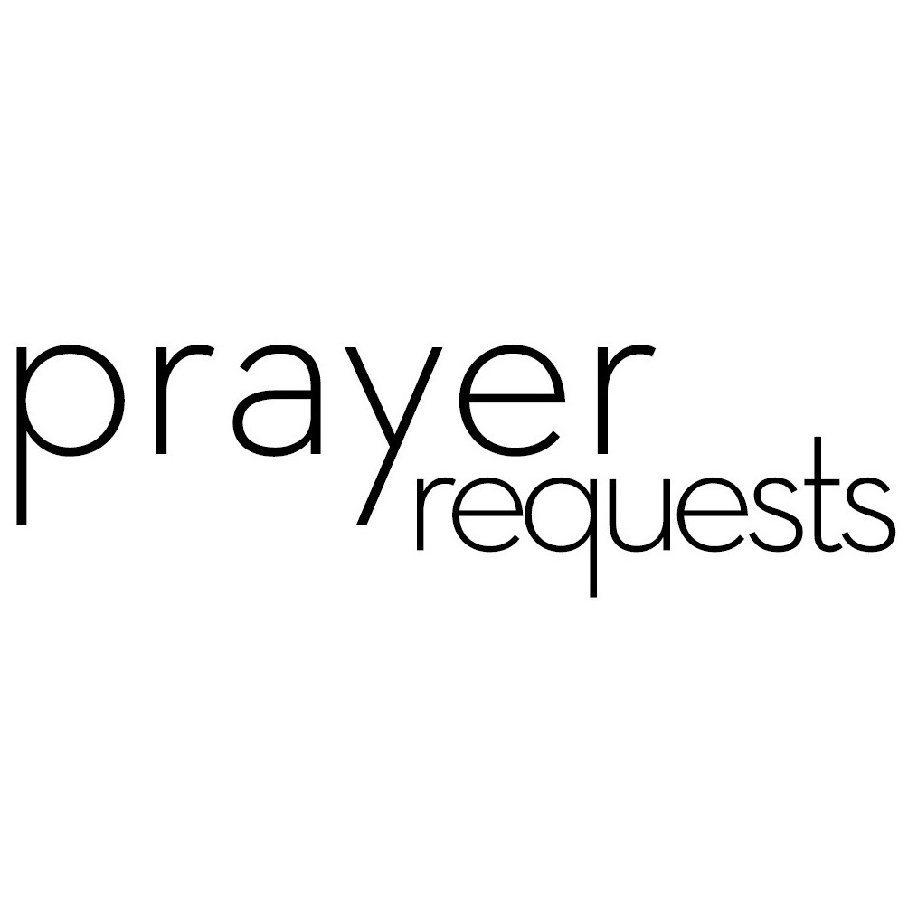Please remember our sisters and brothers in your prayers as they face difficult times. If you would like to add someone or take yourself off this list, please call the church office at 947-2924.

Bette Allen Jim Lucas Kay Patterson
Jean Bennett – Quail Haven Joan MacLean Jim Phillips – St. Joseph’s
Linda Busch Nancy McKenzie Scott Rives
John Currie – Tara Plantation Pat Nugent Bonnie Scott
Betty Elliot Garin Parker Ali Wadsworth
Sheree Kelly Dennis Parks Philip Warmbrod
Margaret Leonard Ina Sue Parks



Linda Ammons – Jim Phillip’s sister Tony Bibey – Jimmy’s son
Karen Bryant – Friend of JoAnn Wahala Alice Byrd – Bonnie Scott’s daughter
Dean Cameron Libby Craven
Robert Davis Christopher Freeman – Maria Bigger’s Grandson
Jimmie Garner – Joan Power’s Father Diamond Garnett – Youth at John Hall Church
Barbara Gomez and Family Aaron Ladmin
Vince Mann – Friend of the Leonard’s David Moore – Geraldine’s son
Ann Parker – Barbara Danley’s cousin Kim and Anthony Sanders– Friends of Ashley Bibey Hunter Smith William Stutts – Bonnie Scott’s Brother-in-Law Skip Vann – Jim Phillip’s brother Linda Ray Winslow – Friend of Pat Jackson

All of our military men and women especially the following: Jonathan Baker,
Chris Mohan, Patrick Mohan, Gregory Riyevski, Will Strickland, and Quinn Wicker

JUNE CALENDAR

3 9:00 Fellowship and Missions Meeting (conference room)
9:45 Sunday School
11:00 Worship
5:00 Youth Group (last meeting)
4 8:45 Christian Yoga
10:15 Christian Chair Yoga
6 8:45 Christian Yoga
10:15 Christian Chair Yoga
7:00 Choir Practice
7 11:00 PW Circle
8 Last Day of School
7:00 Movie Night (Family Life Center)
9 9:00 West Community Presbytery Meeting (Camp Monroe)
10 9:45 Sunday School
11:00 Worship
2:00 Session Meeting (conference room)
13 12:00 Grief Share Leaders Meeting
7:00 Choir Practice
14 10:00 PW Bible Study (Aroma Café)
17 Father’s Day
9:45 Sunday School
11:00 Worship
18 8:45 Christian Yoga
10:15 Christian Chair Yoga
19 Mouse Articles Due
20 8:45 Christian Yoga
10:15 Christian Chair Yoga
7:00 Choir Practice
21 10:00 PW Bible Study (Aroma Café)
24 9:45 Sunday School
11:00 Worship
26 1:00 Fold the Mouse
27 8:45 Christian Yoga
10:15 Christian Chair Yoga
7:00 Choir Practice
28 10:00 PW Bible Study (Aroma Café)

FINANCIAL REPORT

MONTH: APRIL YEAR: 2018
CHURCH ATTENDANCE: 1st Sun 114; 2nd Sun 55; 3rd Sun 91; 4th Sun 78; 5th Sun 80 =Average 84
SUN SCH ATTENDANCE: 1st Sun 46; 2nd Sun 28; 3rd Sun 52; 4th Sun 38; 5th Sun 38=Average 40
OPERATING FUNDS:

Balance in checking account as of April 1, 2018 | 18,141.84
Tithes and Offerings Received | +18,924.58
Sub-Total | 37,066.42
Expenditures | -14,084.45
Balance in checking account as of April 30, 2018 | 22,981.97
RESTRICTED FUNDS: (Funds designated for specific projects, etc.)

Restricted Funds held in checking account as of April 1, 2018  Employee FICA & w/holding taxes for April '18  Donations/offerings received (Bldg Fund $100; 2 Cents a Meal $163.89; Grief  Share $30; Due Pres. Women $120; Frozen Meal Ministry $20; One  Great Hour of Sharing $415.30) | 27,814.33  +538.65  +849.19
Sub-Total | 29,202.17
Expenditures: (Rose for Carter Reynolds $21.30; Qtrly taxes $1,597.75;  April 2 Cents a Meal $163.89; One Great Hour of Sharing $405.30) | -2,188.24
Balance in Restricted Funds as of April 30, 2018 | 27,013.93
RECAP:

Operating Funds Balance | 22,981.97
Building Fund: Equipment etc 93.54 + Other 9,466.44 + 100= | +9,659.98
Restricted Funds Balance | +17,353.95
 | 49,995.90
Apr '18 Payroll Taxes on hand (FICA 414.70; FW/H 81.95; SW/H 42.00) | -538.65
4/30/18 Checkbook Balance | 49,457.25
OTHER REVENUES ON HAND:
Scholarship C/D with BB&T  BB&T Investments Brokerage Acc. #JAL-059738, Estimated value (4 shs) | 23,346.86  +212.44
Total Other Revenues on hand | 23,559.30


Our first Contemporary Services will begin on Sunday, Oct. 7th at 11:00 a.m.
In the past, many of you have enjoyed our Christmas in the Barn and VBS Celebration services in The Family Life Center and this should prove to be another delightful way for us to all worship together. The Contemporary Service will meet on the first Sunday each month and be evaluated after six months.

The FPC Presbyterian Women will host a summer
Bible Study using, “Jesus Calling” Bible Study Series; Experiencing God’s Presence, by Sarah Young. Books
are $7.00. The Bible Study will meet on Thursdays in June, July and August at 10:00 a.m. at Aroma Cafe and Bakery. Participants will order brunch, and go upstairs to the private dining room for the Bible Study. The PW Summer Bible Study is open to FPC as well as other guests and members from other churches.

Circle will on meet on Thursday, June 7th at 11:00 a.m. in the conference room. This is the last lesson from this study. You can get a study book from PW box in the office.

Ladies lunch will not meet in June or July. We will meet again in August.

Thanks to all who contributed to the annual Birthday Offering. We collected $450.00. If you did not have a chance to give and would like to do so you can give your donation to Marie Monroe. Make checks to Presbyterian Women.
Congregation Request: The Fellowship and Missions Committee is asking you to please provide store bought frozen meals such as; lasagna, mac n’ cheese, waffles, etc. and put in the upright freezer in the church kitchen. If you prefer to give money or have someone do the purchasing for you, please let us know. You can put cash or check in your regular offering envelope and designate under “special offering” as Frozen meal ministry. The final day to bring in meals or contributions for this season will be June 3rd!

The movie, “I’m Not Ashamed” will be shown on our large screen in the Family Life Center on Friday, June 8th from 7:00 - 9:00 p.m. This is the true story of Rachel Scott, the first student that died at the Columbine High School tragedy on April 20th, 1999. The story is from Rachel’s own words, drawn directly from her writings. Please come enjoy the free movie and popcorn.

Vacation Bible School: “Mega Sports Camp, Team Spirit”, will be held on Friday, August 3rd (6:00 p.m. - 8:00 p.m.), and Saturday, August 4th (9:00 a.m. - 3:30 p.m.) with a celebration during worship on Sunday, August 5th. Bring your children ages 2 years old through rising 6th graders and join the fun and celebration of God! Registration is available online at www.fpccarthage.com.

We Are Hiring!
First Presbyterian Church, Carthage is seeking a part time Nursery Attendant. The position will begin in mid-July. CPR certification and prior experience working with young children are preferred. The position requires approximately 2 hours each Sunday. Competitive salary. Mail resume to Administrative Committee, PO Box 397, Carthage, NC 28387 or email resume to infofpc397@gmail.com.

