The Reverend Rick Martindale Pastor
Ali Wadsworth Choir Director
Elizabeth Williams Organist
Shelley Hammond Administrative Assistant
Andie Hyman Nursery Attendant
Ann Key Sexton
Marie Monroe Treasurer

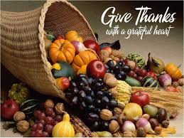
Class of 2019
Lucinda Casey
Cristy Dean
Scott Phillips
Paul White

Class of 2020
Doris Russell
Chad Thomason
Michelle Tortora
JoAnn Wahala

Class of 2021
Denise Edmonds
Robert Gordon
Lee McCaskill
Geraldine Moore
Non-Profit
Organization
U.S. Postage
PAID
CARTHAGE, NC
28327
Permit No. 35

FIRST PRESBYTERIAN CHURCH
POST OFFICE BOX 397
CARTHAGE, NORTH CAROLINA 28327
(910) 947-2924
fpccarthage.com (website)
infofpc397@gmail.com (email)

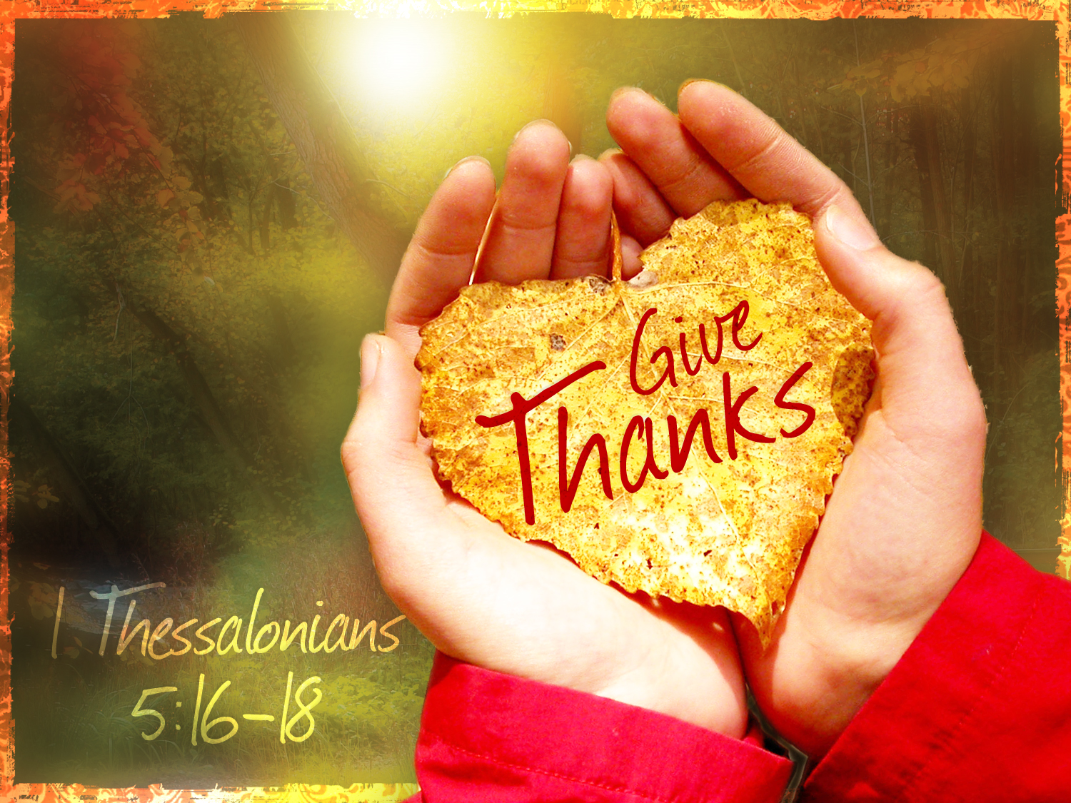 2019 First Presbyterian Church News

Imagine…

We are almost to the “holiday” season, you know, the time from Thanksgiving, through Christmas, and finishing with Epiphany (January 6th). It is a wonderful time of the year. It is a difficult time. It can surely be a stressful time. Often it is all three.

It made me start to think…imagine if everyone, not just Christians, but everyone would practice the love and grace of Jesus Christ. Imagine what our world would look like. Take a moment and imagine it!! Isn’t it beautiful?! We wouldn’t hear an unkind word spoken. We would hear words that lifted us up. We would find kindness shared. We would treat everyone like they were our best friends. We might hear words of truth (which might be hard to hear), but even they would be spoken in love. The words and actions that came from us would be earth shattering. No hurtful jokes, no passive aggressive comments, no rude behavior, no more evil actions. Selfishness was no more. Instead people treating one another as we ought to be treating one another.

Imagine 80 percent of the time people are living lives of love toward one another. This would create a complete transformation of the planet without question. Our hearts would begin to relish in each day, and we might even begin to greater appreciate how God’s kingdom is supposed to be here on earth.

Then we take the last 20 percent who are still struggling and we offer…grace. Grace that truly inspires and rededicates the lives of those who are struggling and more importantly for the times that we still struggle. There will still be those moments, but now grace will be offered. God’s grace is a powerful thing just like God’s love.

Now I know this isn’t realistic. I know that I’m foolish for imagining an earthly realm filled with God’s love and grace beyond the moments we see now. I need to wake up from my foolish dream.

 But what would happen if we embraced the dream this coming holiday season by simply offering love and grace one more time a day – maybe sometimes twice – or even three times? Instead of responding with lies, half-truths, meanness, and downright sin, we try something new – something that makes us not just vulnerable. Something that also helps pave the way for God to be elevated. It doesn’t begin with the world. It begins with you and me. It starts with each interaction we have with one another or at least once a day offering God’s love and grace. Can we start now and pave a brave, new path?

Grace and Peace,

Rick
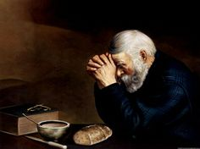

Jean Bennett – Quail Haven Jimmy Bibey
Anna Belle Campbell Benny Cole
John Currie – Tara Plantation Betty Elliott
Sheree Kelly Margaret Leonard
Carol Lucas Jim Lucas
Nancy McKenzie Pat Nugent
Regena Nugent Dennis Parks
Ina Sue Parks Kay Patterson
Scott Rives Bonnie Scott
Phillip Warmbrod

In Our Prayers

Please remember our sisters and brothers in your prayers as they face difficult times.

Michael Abercrombie, Geraldine Moore’s grandson
Donnie Albright Tony Bibey, Jimmy Bibey’s son Mary Brewer Anna Bristow, Debbie Albright’s sister Karen Bryant, friend of JoAnn Wahala Olivia Bryant, Karen Bryant’s granddaughter
Dean Cameron Wife of Larry Cockman, friend of Benny Cole James Cox, friend of Kelly Martindale Robert Davis
Caleb Evans, friend of Elizabeth Martindale Christopher Freeman, Maria Bigger’s grandson Carl Greeson, Susan Cole’s brother June Greeson, Susan Cole’s mother Ann Herndon, Kay Patterson’s sister Mary Hussey
Zack Isom, Diane Pangborn’s son Aaron Ladmin
Maxine Lawson, Elizabeth William’s sister Rexine Lloyd, Kelly Martindale’s mother Vince Mann, friend of the Leonards Garin Parker, Barbara Danley’s nephew Kimberly Sanders and Family Hunter Smith
William Stutts, Bonnie Scott’s brother-in-law JoAnne Thompson, Keith Hardin’s mother Skip Vann, Judy Phillip’s brother-in-law Tommy Walton, Diane Pangborn’s brother

Our military men and women and their families including:
Jonathan Baker Kyle Bryant Chris Mohan Patrick Mohan
Gregory Riyevski Will Strickland Quinn Wicker

To add someone or take yourself off this list, please call the church office at 947-2924.

Attendance Sunday School Worship
September 1st 31 77
September 8th 41 84
September 15th 43 76
September 22nd 37 70
September 29th 33 80
Average 37 77

SEPTEMBER FINANCIAL REPORT

OPERATING FUNDS:
Balance in checking account as of September 1, 2019 | 62,264.87
Tithes and Offerings Received | +19,803.15
Sub-Total | 82,068.02
Expenditures | -12,603.78
Balance in checking account as of September 30, 2019 | 69,464.24
RESTRICTED FUNDS: (Funds designated for specific projects, etc.)
Restricted Funds held in checking account as of September 1, 2019  Employee FICA & w/holding taxes for September 2019  Donations/offerings received (2ȼ a Meal $152.01; Presbyterian Women donation $200; BanCorp dividend $1.80; Habitat for Humanity $120) | 58,190.54  +523.49  +473.81
Sub-Total | 59,187.84
Expenditures: Two Cents a Meal $0.00; BB&T Secutities, annual brokerage  Account fee $19; Cantata music $221.14 | -240.14
Balance in Restricted Funds as of September 30, 2019 | 59,947.70
RECAP:
Operating Funds Balance | 69,464.24
Building Fund: Equipment etc 93.54 + Other 35,240.42 - brokerage fee 19.00= | +35,314.96
Restricted Funds Balance | +23,632.74
 | 128,411.94
Jul-Sep '19 Payroll Taxes on hand (FICA 1,377.65; FW/H 142.41; SW/H 51.00) | -1,571.06
9/30/19 Checkbook Balance | 126,840.88
OTHER REVENUES ON HAND:
Scholarship C/D with BB&T  BB&T Investments Brokerage Acc. #JAL-059738, Estimated value (4 shs) | 23,393.57  +209.36
Total Other Revenues on hand | 23,602.93


Morning Circle
11 a.m.
11/7
(no morning Circle in December)

Evening Circle
6:30 p.m.
11/14 & 12/12
To learn more about our new Evening Circle, call
Tina Stromko,
(910) 639-1695.
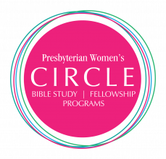




Contact us and stay connected!

Receive Presbyterian Women news.

Help in times of need.

Discover fellowship with purpose.

(910) 690-2463 hmcd2946@gmail.com




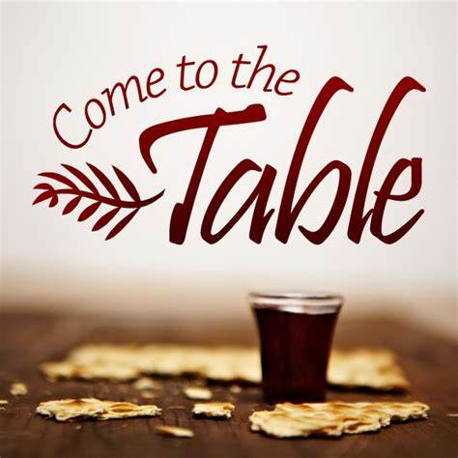

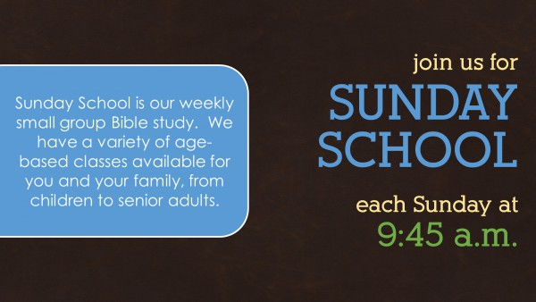

SUNDAY

11 a.m.

1st Sundays
November 3rd
December 1st
Pennies for Hunger
children’s offering.

Noon 11/21 Aroma Café & Bakery

If you need a ride, please contact Helen at (910) 690-2463.

3rd Sundays
November 17th
December 15th
Bread & cup
open invitation.


Meeting 11/10 at 9 a.m.




Sundays
5 p.m.
Grades 7-12

Dinner. Bible. Crafts. Games.
5:30 p.m. Wednesdays
Ages 4-6th grade

Saturday, November 30th


Shoebox Discipleship
Every year, FPC Youth help share the Gospel with children around the globe with a simple gift - Operation Christmas Child shoeboxes. This November, you can help FPC Youth fill shoeboxes for 350 children by simply providing small items for shoeboxes that will be distributed internationally by Samaritan's Purse. Together we can share God’s love.

Drop off Operation Christmas Child items at the FPC Family Life Center Donation Station:
plastic shoebox-size containers with lids, washcloths, toothbrushes,
girls’ hair accessories, and short-sleeved shirts


Saturday, November 2nd 7:30 a.m. Robbins’ Food Bank (meet at FPC to carpool)
Don’t forget to fall back! Daylight Savings ends tonight.
Sunday, November 3rd 9:00 a.m. Fellowship and Mission Committee (conference room)
9:45 a.m. Sunday School
11:00 a.m. Contemporary Worship Service (Family Life Center)
5:00 p.m. Youth Group (grades 7-12)
Monday, November 4th Christian Faith Yoga – 8:45 a.m. Floor, 10:15 a.m. Chair
Wednesday, November 6th Christian Faith Yoga – 8:45 a.m. Floor, 10:15 a.m. Chair 5:30 p.m. What’s Up Wednesday (ages 4-6th grade)
7:00 p.m. Choir practice
Thursday, November 7th 11:00 a.m. Morning Women’s Bible Study & Fellowship Circle
Sunday, November 10th 9:00 a.m. Worship Committee (conference room)
9:45 a.m. Sunday School
11:00 a.m. Worship
2:00 p.m. Session meeting
5:00 p.m. Youth Group (grades 7-12)
Beginning December 1st, the first Sunday of Advent, Christmas Poinsettias will decorate the Sanctuary. To place a poinsettia in honor or in memory of someone, please contact the church office by noon, Tuesday, November 26th. 947-2924 infofpc397@gmail.com
Monday, November 11th Christian Faith Yoga – 8:45 a.m. Floor, 10:15 a.m. Chair
Wednesday, November 13th Christian Faith Yoga – 8:45 a.m. Floor, 10:15 a.m. Chair 5:30 p.m. What’s Up Wednesday (ages 4-6th grade)
7:00 p.m. Choir practice
Thursday, November 14th 6:00 p.m. Praise Team practice
6:30 p.m. Evening Women’s Bible Study & Fellowship Circle
Sunday, November 17th 9:45 a.m. Sunday School

-Pro-Tech came in to give advice on our water leaks and we are going to look
at engineering firms
-Work on the Columbarium in the cemetery should begin soon
-Working on the budget for 2020
-Dates set for December activities:
- Presbyterian Women’s Christmas Lunch on December 8th
- Church wide caroling set for the afternoon of December 8th
- Christmas Cantata will be December 15th
- Christmas in the Barn will be December 22nd at 5 pm at the
- Fairgrounds
-Approved Rev. Martindale taking Continuing Education on October 21-23
-Donated $1,000 to Habitat for Humanity for their new housing project with Pickney School


Help share the meaning of Christmas this year – LOVE!

Stop by the FPC Angel Gift Tree
in the upper narthex to chose an angel (or two) for two families whose children attend Carthage Elementary. Then shop for the gift on the angel, wrap the gift and return it to the tree by the second Sunday in Advent, December 8th.

Thank you! Fellowship & Missions
11:00 a.m. Communion/Stewardship Worship Service
5:00 p.m. Youth Group (grades 7-12)
Monday, November 18th Christian Faith Yoga – 8:45 a.m. Floor, 10:15 a.m. Chair
Tuesday, November 19th Deadline for December Mouse church newsletter
Wednesday, November 20th Christian Faith Yoga – 8:45 a.m. Floor, 10:15 a.m. Chair 5:30 p.m. What’s Up Wednesday (ages 4-6th grade)
7:00 p.m. Choir practice
Thursday, November 21st 12:00 p.m. Ladies’ Lunch, Aroma Café & Bakery
6:00 p.m. Praise Team practice
Sunday, November 24th 9:45 a.m. Sunday School
11:00 a.m. Worship
6:00 p.m. Community Thanksgiving Service (FPC)
Tuesday, November 26th Sanctuary Advent Poinsettia Orders due to church office
1:00 p.m. Fold Mouse Newsletter (conference room)
Wednesday, November 27th 5:30 p.m. What’s Up Wednesday (ages 4-6th grade)
6:00 p.m. Praise Team practice
Thursday, November 28th Thanksgiving Day – Church office closed
Saturday, November 30th Youth trip to Operation Christmas Child, Charlotte
Worship Flowers
3rd Doris & Bill Russell
10th Susan Phillips
17th Kathryn & Dale Buie Family
24th Harvest Table




November Greeters November Ushers
3rd Dennis Parks Geraldine Moore (lead)
10th Denise and Justin Edmonds Lucinda Casey
17th Tom Stewart JoAnn Wahala
24th David and Lucinda Casey Chad Thomason


Happy Birthday!
1 Cody Adelmann
4 Anne Lucas
5 Scott Phillips
8 Jeff Medlin
9 Bill Russell
10 Steve Ingold
12 Emily Tortora
15 Megan Phillips
20 Doreen Little
21 Jane Ritter
24 Hallie Patterson
27 Cathy Campbell
29 Chad Thomason
30 Nancy McKenzie

