Non-Profit
Organization
U.S. Postage
PAID
CARTHAGE, NC
28327
Permit No. 35

FIRST PRESBYTERIAN CHURCH
POST OFFICE BOX 397
CARTHAGE, NORTH CAROLINA 28327
(910) 947-2924
fpccarthage.com (web site)
infofpc@yahoo.com (e-mail)

THE CHURCH MOUSE
The Reverend Rick Martindale Pastor
Elizabeth Williams Organist & Choir Director
Ann Key Sexton
Marie Monroe Treasurer
Shanon Venable Administrative Assistant
Sarah Frick Nursery Attendant
Class of 2018
Angie Medlin
J.D. Monroe
Susan Phillips
Marlene Riyevski

Class of 2019
Lucinda Casey
Cristy Dean
Scott Phillips
Paul White

Class of 2020
Doris Russell
Chad Thomason
Michelle Tortora
JoAnn Wahala

FIRST PRESBYTERIAN CHURCH
May 2018

“Change Is Coming”

The phrase, “Change is coming” typically brings fear to many. Maybe an employer has proclaimed those words before one learned the company was downsizing and one’s job was being eliminated. We tend to view change as a bad thing.

In 1850 change was coming. First Presbyterian Church (it was Carthage Presbyterian Church back then) came into being. I think that was a good change. Starting construction on the Family Life Center was a good change as well. Not all change is bad.

Change is a necessity for any church to remain vibrant and alive. Churches that don’t change, die. If you doubt me, please read “Autopsy of a Deceased Church” by Thom Rainer.

The session has decided to make a change to worship once a month. We are going to change our traditional service into a contemporary service on the first Sunday of the month starting in October. 12 times a year we will be doing this new service while the other 40 weeks will remain the same.

I know some of you are already thinking this is a bad idea while others are thinking, “It’s about time.” Our contemporary service will take place in the Family Life Center. It will continue to be at 11:00 a.m. We will only have one service.

We haven’t finalized many of the details yet. We will probably begin with taped music and hopefully start incorporating people and instruments later. It will probably remain about an hour in length with many elements of our traditional worship service with a few twists.

If you have ever been present for one of our Vacation Bible School’s Celebration Sundays then you will remember the energy and fun that takes place during that worship service. We are hoping our contemporary service will match this in many ways.

If you have questions, please don’t hesitate to ask a session member or myself. Do not be surprised, however, if we don’t have all your answers. We are excited about this new possibility to reach out to our larger community as we worship our Lord and Savior.

Grace and Peace,
Rick

May Calendar Page

GREETERS

6 Carol and Paul White

13 Debbie and Robert Gordon

20 Margaret Leonard and children

27 Dennis Parks

Birthdays
1 Damon Dean
9 John Scott
11 Michelle Cottrell
12 Seth Bennett
12 Miranda Estep
12 Scott Rives
12 MacKenzie Smith
13 Tucker Medlin
16 Ann Currie
22 Evan Ritter
23 Roger Ingold
23 Owen Thomason
24 Andy Marshburn
28 Lee Edmonds
29 Nancy Carter
29 Kay Patterson
30 Ryan Gordon

If we do not have your correct birthday or if it is missing please let the church office know. Thanks.

USHERS

6 JoAnn Wahala (Lead Usher)

13 Chad Thomason

20 Marlene Riyevski

27 Lucinda Casey

FLOWERS

6 The Martindale Family
13 Pat Jackson
20 Susan and Benny Cole
27 Lucinda and David Casey

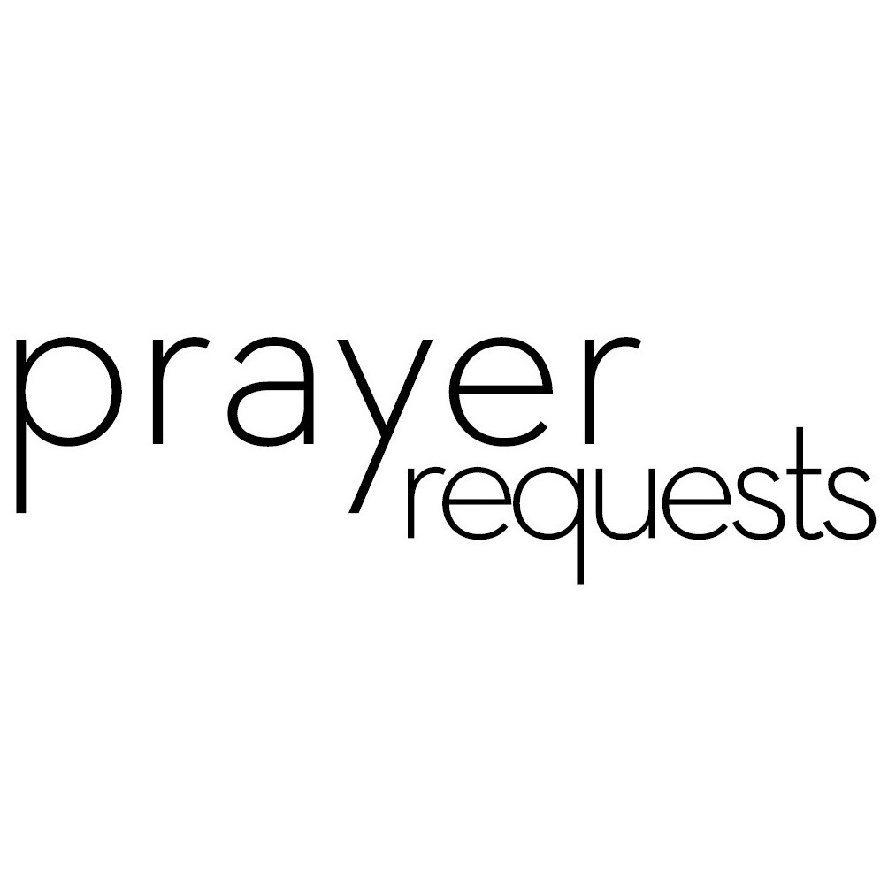Please remember our sisters and brothers in your prayers as they face difficult times. If you would like to add someone or take yourself off this list, please call the church office at 947-2924.

Bette Allen Jim Lucas Kay Patterson
Jean Bennett – Quail Haven Joan MacLean Jim Phillips – St. Joseph’s
Linda Busch Nancy McKenzie Scott Rives
John Currie – Tara Plantation Pat Nugent Bonnie Scott
Betty Elliot Garin Parker Ali Wadsworth
Sheree Kelly Dennis Parks Philip Warmbrod
Margaret Leonard Ina Sue Parks



Linda Ammons – Jim Phillip’s sister Tony Bibey – Jimmy’s son
Karen Bryant – Friend of JoAnn Wahala Alice Byrd – Bonnie Scott’s daughter
Dean Cameron Libby Craven
Robert Davis Christopher Freeman – Maria Bigger’s Grandson
Jimmie Garner – Joan Power’s Father Diamond Garnett – Youth at John Hall Church
Barbara Gomez and Family Aaron Ladmin
Vince Mann – Friend of the Leonard’s David Moore – Geraldine’s son
Ann Parker – Barbara Danley’s cousin Kim and Anthony Sanders– Friends of Ashley Bibey Hunter Smith William Stutts – Bonnie Scott’s Brother-in-Law Skip Vann – Jim Phillip’s brother Linda Ray Winslow – Friend of Pat Jackson

All of our military men and women especially the following: Jonathan Baker,
Chris Mohan, Patrick Mohan, Gregory Riyevski, Will Strickland, and Quinn Wicker

MAY CALENDAR

2 5:30 What’s Up Wednesday
7:00 Choir
3 11:00 PW Meeting
5 7:30 Robbins Food Bank
6 9:00 Fellowship and Mission Committee (conference room)
9:45 Sunday School
11:00 Worship
5:00 Youth Group
7 8:45 Christian Yoga
10:15 Chair Christian Yoga
6:30 Grief Share (conference room)
8 7:00 PWCT (conference room)
9 8:45 Christian Yoga
10:15 Chair Christian Yoga
5:30 What’s Up Wednesday
7:00 Choir
11 7:00 “The Shack” showing in the Family Life Center
13 Mother’s Day
9:45 Sunday School
11:00 Worship
14 6:30 Grief Share (conference room)
16 8:45 Christian Yoga
10:15 Chair Christian Yoga
5:30 What’s Up Wednesday Cookout (last meeting)
7:00 Choir
17 12:00 Ladies Lunch at Mrs. Lacy’s in Sanford
19 7:30 Robbins Food Bank
20 9:45 Sunday School
11:00 Worship/Communion/Pentecost
2:00 Session Meeting (conference room)
5:00 Youth Group
22 Deadline for Church Mouse
23 8:45 Christian Yoga
10:15 Chair Christian Yoga
7:00 Choir
27 9:45 Sunday School
11:00 Worship
5:00 Youth Group
28 Memorial Day (No School and Church Office is Closed)
6:30 Grief Share (conference room)
30 8:45 Christian Yoga
10:15 Chair Christian Yoga
6:30 Grief Share (conference room)

FINANCIAL REPORT

MONTH: MARCH YEAR: 2018
CHURCH ATTENDANCE: 1st Sun 79; 2nd Sun 80; 3rd Sun 68; 4th Sun 95; 5th Sun = Average 81
SUN SCH ATTENDANCE: 1st Sun 49; 2nd Sun 37; 3rd Sun 40; 4th Sun 47; 5th Sun = Average 43
OPERATING FUNDS:

Balance in checking account as of Mar 1, 2018 | 17,548.31
Tithes and Offerings Received | +15,231.26
Sub-Total | 32,779.57
Expenditures | -14,637.73
Balance in checking account as of Mar 31, 2018 | 18,141.84
RESTRICTED FUNDS: (Funds designated for specific projects, etc.)

Restricted Funds held in checking account as of Mar 1, 2018  Employee FICA & w/holding taxes for Mar '18  Donations/offerings received (Bldg Fund $200; 2 Cents a Meal $160; Flower  Fund $45.12) | 27,057.25  +554.21  +405.12
Sub-Total | 28,016.58
Expenditures: (VBS Starter Kit $142.25; Celebration Lunch-Note Burning  $900; March 2 Cents a Meal $160) | -1,202.25
Balance in Restricted Funds as of Mar 31, 2018 | 26,814.33
RECAP:

Operating Funds Balance | 18,141.84
Building Fund: Equipment etc 93.54 + Other 10,166.44 + 200=10,366.44 - 900= | +9,559.98
Restricted Funds Balance | +17,254.35
 | 44,956.17
Jan-Mar '18 Payroll Taxes on hand (FICA 1,225.90; FW/H 245.85; SW/H 126.00) | -1,597.75
3/31/18 Checkbook Balance | 43,358.42
OTHER REVENUES ON HAND:
Scholarship C/D with BB&T  BB&T Investments Brokerage Acc. #JAL-059738, Estimated value (4 shs) | 23,346.86  +208.16
Total Other Revenues on hand | 23,555.02

With the Women

A very special thank you to all who helped with the PW Spring Gathering at our church. We have such a beautiful church and it was nice to share it with others.

It is not too late to join us. Circle will on meet on Thursday, May 3rd at 11:00 a.m. in the conference room. You can get a study book from PW box in the office.

PWCT will meet on Tuesday, May 8th at 7:00 p.m. in the conference room.

Mark your calendar on Thursday, May 17th for lunch at Ms. Lacy’s in Sanford at 11:30 a.m. Hope you can come. We will meet at the church at 11:00 am if you would like to carpool. Please let Helen (690-2463 or hmcd2946@gmail) know if you plan to attend by May 15th for reservations and also if you need a ride.

Thanks to all who contributed to the annual Birthday Offering on Sunday, April 29th. If you did not have a chance to give and would like to do so you can give your donation to Marie Monroe. Make checks payable to Presbyterian Women.

We have replaced the rectangular tablecloths in the multipurpose room and are now replacing the round ones. The tablecloths are $10. If you would like to donate a tablecloth give your money to Marie Monroe.



Grief Share, meets on Mondays from 6:30 - 8:30 p.m. Each session uses video, a personal workbook, and group discussion to assist participants in working through the death of a loved one in a supportive and encouraging environment.

Request to the Congregation— The Fellowship and Missions Committee is asking you to please provide frozen meals— lasagna, mac n’ cheese, waffles, etc. and put in the upright freezer in the church kitchen. These will be given out by Rick or Shanon to families who come to the church asking for assistance. If you prefer to give money, Jeannie Muse or another F & M member would be happy to purchase meals for you. You can place cash or a check in your regular offering envelope and designate “Frozen meal ministry” in the memo section.
What’s Up Wednesday will have their end Save the Date:
Of the year cook-out on Wednesday, May Friday, August 3rd – Sunday, August 5th
16th at 5:30 p.m. Everyone is invited!

The movie, “The Shack” will be shown on our large screen in the family life center on Friday, May 11th from 7:00-9:00 p.m. Please come enjoy the free movie and popcorn. We plan to do show a movie each month.



The Youth Group will be tie-dying stained church tablecloths during their meeting on Sunday, May 6th from 5:00-6:30. Please meet Jennifer Thomason and Doris Russell in the old fellowship hall. Wear old clothes and shoes.

What’s Up Wednesday will have their end of the year cookout on Wednesday, May 16th at 5:30. This will also be the last WUW meeting of the 2017-2018 school year. Everyone is invited to join us for hamburgers, hotdogs, and great fellowship with our FPC families.

It’s time to start thinking about Camp Monroe. Camp Monroe offers camp sessions for all ages starting June 18th and running through August 4th. Camp application forms are located on the website at www.monroecamp.org. Money is available to assist those in our church family with camp registration fees. Contact the Christian Education Committee if you are interested in attending or have any questions.

