Non-Profit
Organization
U.S. Postage
PAID
CARTHAGE, NC
28327
Permit No. 35

FIRST PRESBYTERIAN CHURCH
POST OFFICE BOX 397
CARTHAGE, NORTH CAROLINA 28327
(910) 947-2924
fpccarthage.com (web site)
infofpc@yahoo.com (e-mail)

THE CHURCH MOUSE
The Reverend Rick Martindale Pastor
Ali Wadsworth Choir Director
Elizabeth Williams Organist
Ann Key Sexton
Marie Monroe Treasurer
Shanon Venable Administrative Assistant
Sarah Frick Nursery Attendant

Class of 2018
Angie Medlin
J.D. Monroe
Susan Phillips
Marlene Riyevski

Class of 2019
Lucinda Casey
Cristy Dean
Scott Phillips
Paul White

Class of 2020
Doris Russell
Chad Thomason
Michelle Tortora
JoAnn Wahala

FIRST PRESBYTERIAN CHURCH
July 2018

MUSICIANS NEEDED!

Who do you know that plays a musical instrument or likes to sing? We are looking to find a group of people to lead our contemporary worship service starting in October. We would like to have this “Praise Team” in place by September 1st. If you know of someone or if you yourself are interested please contact J.D. Monroe, Marlene Riyevski, or myself. If you are passing on a name please talk to them first.

This talented group will help lead the hymns in the Family Life Center. We want to get this group in place so they have at least a month to prepare for the beginning of our once a month contemporary service beginning October 7th. Our wonderful Chancel Choir, organist, and choir director will lead the music the remaining Sundays each month in the sanctuary.

We would love to have several instruments represented as well as some singers. If you have been blessed with musical gifts please consider sharing your gift with the congregation for this new service. Take some time to pray about it. What an exciting way to serve God!

God calls us daily to use our gifts, musical or not, to bring glory to God. In other words, we are called to reveal God’s love to those we meet daily. What are you doing to use your God given gifts for FPC and God’s world?

Grace and Peace,
Rick

P.S. Don’t forget that starting this coming Sunday we will be worshiping at 10 a.m. instead of 11:00 a.m. Most of our Sunday school classes will be taking the month of July off but our adult class which meets in the library will be meeting at 9:00 a.m. All are invited to join them.
July Calendar Page
GREETERS

1 Ann Key

8 Benny and Susan Cole

15 Chad, Jennifer, Alex, Owen, and Will Thomason

22 Bill Russell

29 Kelly, Elizabeth, and Catherine Martindale

Birthdays

1 Debbie Gordon
4 Gracen Bennett
4 CJ McDonald
7 JoAnn Wahala
8 Jason Myrick
11 Sarah Lucas
14 Susan Phillips
17 Geraldine Moore
18 Greg Riyevski
18 Marc Stromko
22 Carol White
22 Gavin Parker
24 Scott Tortora
26 Sawyer Dean
27 Scott McLeod
29 J.D. Monroe
31 Ina Sue Parks

If we do not have your correct birthday or if it is missing please let the church office know. Thanks.

USHERS

*Doris Russell

Michelle Tortora

JD Monroe

Scott Phillips

*Head Usher

FLOWERS

1 Ruby Ingold

8 Nancy McKenzie

15 Elizabeth Barringer

22 Ann Key

29 Denise & Lee Edmonds

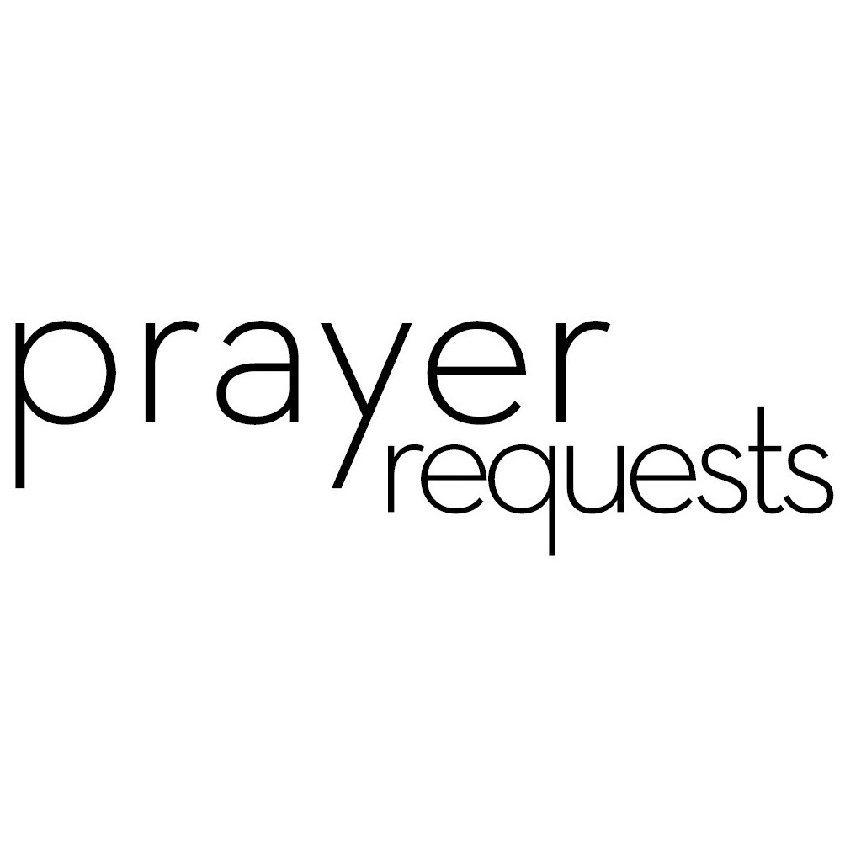Please remember our sisters and brothers in your prayers as they face difficult times. If you would like to add someone or take yourself off this list, please call the church office at 947-2924.

Bette Allen Jim Lucas Kay Patterson
Jean Bennett – Quail Haven Joan MacLean Jim Phillips – St. Joseph’s
Linda Busch Nancy McKenzie Scott Rives
John Currie – Tara Plantation Pat Nugent Bonnie Scott
Betty Elliot Garin Parker Philip Warmbrod
Sheree Kelly Dennis Parks
Margaret Leonard Ina Sue Parks



Linda Ammons – Jim Phillip’s sister Tony Bibey – Jimmy’s son
Alice Byrd – Bonnie Scott’s daughter Dean Cameron
Libby Craven Robert Davis Christopher Freeman – Maria Bigger’s Grandson Jimmie Garner – Joan Power’s Father
Diamond Garnett – Youth at John Hall Church Aaron Ladmin
Vince Mann – Friend of the Leonard’s David Moore – Geraldine’s son
Ann Parker – Barbara Danley’s cousin Kim and Anthony Sanders– Friends of Ashley Bibey Hunter Smith William Stutts – Bonnie Scott’s Brother-in-Law Skip Vann – Jim Phillip’s brother Linda Ray Winslow – Friend of Pat Jackson

All of our military men and women especially the following: Jonathan Baker,
Chris Mohan, Patrick Mohan, Gregory Riyevski, Will Strickland, and Quinn Wicker

JULY CALENDAR

1 9:00 Adult Sunday School Class (library)
10:00 Worship/Congregational Meeting
11:00 Lemonade on the Lawn
2 8:45 Christian Yoga
10:15 Christian Chair Yoga
4 Independence Day (church office closed)
8:45 Christian Yoga
10:15 Christian Chair Yoga
6:00 Choir Practice
8 9:00 Adult Sunday School Class (library)
10:00 Worship
11 6:00 Choir Practice
12 10:00 PW Bible Study (Aroma Café)
13 7:00 Movie Night, “Hidden Figures”
15 9:00 Adult Sunday School Class (library)
10:00 Worship/Communion
16 8:45 Christian Yoga
10:15 Christian Chair Yoga
17 6:30 RACM Board Meeting (Robbins)
18 8:45 Christian Yoga
10:15 Christian Chair Yoga
6:00 Choir Practice
19 10:00 PW Bible Study (Aroma Café)
22 9:00 Adult Sunday School Class
10:00 Worship
23 8:45 Christian Yoga
10:15 Christian Chair Yoga
6:00 PW Salad Supper
24 Mouse Deadline
25 8:45 Christian Yoga
10:15 Christian Chair Yoga
6:00 Choir Practice
26 10:00 PW Bible Study (Aroma Café)
29 9:00 Sunday School Class
10:00 Worship

FINANCIAL REPORT
MONTH: MAY YEAR: 2018
CHURCH ATTENDANCE: 1st Sun 63; 2nd Sun 75; 3rd Sun 71; 4th Sun 82; 5th Sun = Average 73
SUN SCH ATTENDANCE: 1st Sun 46; 2nd Sun 40; 3rd Sun 39; 4th Sun 39; 5th Sun = Average 41
OPERATING FUNDS:
Balance in checking account as of May 1, 2018 | 22,981.97
Tithes and Offerings Received | +15,016.36
Sub-Total | 37,998.33
Expenditures | -12,378.60
Balance in checking account as of May 31, 2018 | 25,619.73
RESTRICTED FUNDS: (Funds designated for specific projects, etc.)

Restricted Funds held in checking account as of May 1, 2018  Employee FICA & w/holding taxes for May '18  Donations/offerings received (2 Cents a Meal $146.84; Due Pres. Women $90;  Frozen Meal Ministry $250) | 27,013.93  +548.56  +486.84
Sub-Total | 28,049.33
Expenditures: (Senior Scholarship $300; Due Presbyterian Women $190;  May 2 Cents a Meal $146.84; One Great Hour of Sharing $10.00) | -646.84
Balance in Restricted Funds as of May 31, 2018 | 27,402.49
RECAP:
Operating Funds Balance | 25,619.73
Building Fund: Equipment etc 93.54 + Other 9,566.44 = | +9,659.98
Restricted Funds Balance | +17,742.51
 | 53,022.22
Apr-May '18 Payroll Taxes on hand (FICA 839.31; FW/H 163.90; SW/H 84.00) | -1,087.21
5/31/18 Checkbook Balance | 51,935.01
OTHER REVENUES ON HAND:
Scholarship C/D with BB&T  BB&T Investments Brokerage Acc. #JAL-059738, Estimated value (4 shares) | 23,346.86  +217.68
Total Other Revenues on hand | 23,564.54


Vacation Bible School will be held on Friday, August 3rd -5th. Bring your children ages 2 years old through rising 6th graders and join the fun and celebration of God! Registration is available online at www.fpccarthage.com.

Congregational Meeting
FPC will hold a congregational meeting to elect the nominating committee on July 1st immediately following the 10:00 a.m. worship service.

Church Shirts Available
Orders for First Presbyterian collared shirts should be turned in to Doris Russell by Sunday, July 8th. The shirts are lime green and bear a logo with the words “First Presbyterian Carthage, NC.” Forms are available at all the church entrances and the church office.


The movie, ‘Hidden Figures’ will be shown on our large screen in the Family Life Center on Friday, July 13th from 7:00 - 9:00 p.m. Set in the 1960’s U.S.A., ‘Hidden Figures’ is a biographical drama about three brilliant African-American mathematicians –– Katherine Johnson, Dorothy Vaughn and Mary Jackson –– and their contributions to space explorations carried out by the National Aeronautics and Space Administration (NASA). Please come enjoy the free movie, popcorn, and beverages.


Mark your calendars!!!!
We are changing things up this year. Our Salad supper will be Monday, July 23 at 6:00 p.m. in the Family Life Center. Our guest speaker will be Joan Edson, Facilitator for Spiritual Nurture for Coastal Carolina Presbyterian Women (CCPW). Our CCPW Moderator, Jeanne Anderson is planning to join us. We have invited John Hall and others to join us and are looking forward to an evening of good food and fellowship.

Circle will on meet again on Thursday, September 6th at 11:00 a.m. in the conference room. We will begin a new study, God’s Promise; I am With You. See Marie Monroe if you would like a study book.

Ladies Lunch will meet Thursday, August 16th at 12:00 p.m. at the Dewberry Deli in Cameron. We will meet at Mrs. Lacy’s in September.

We have replaced all of the tablecloths as well as purchased plastic protectors. Thanks to all who contributed. A special thanks to Marie Monroe for locating and purchasing these for us.

The FPC Presbyterian Women’s Bible Study continues in July using the, “Jesus Calling” Bible Study Series; Experiencing God’s Presence, by Sarah Young. The Bible Study meets on Thursdays at 10:00 a.m. at Aroma Café and Bakery.

June 12— Session 4—God’s Presence Brings You Peace

June 19— Session 5—God’s Presence Awes You

June 26— Session 6—God’s Presence Saves You

A special thank you to all who supported Presbyterian Women this year. Without your help we would not be able to the many things we do!!!


First Presbyterian Church, Carthage is seeking a part time Nursery Attendant. The position will begin in August. CPR certification and prior experience working with young children are preferred. The position requires approximately 2 hours each Sunday. Competitive salary. Mail resume to Administrative Committee, PO Box 397, Carthage, NC 28387 or email resume to infofpc397@gmail.com.

