Non-Profit
Organization
U.S. Postage
PAID
CARTHAGE, NC
28327
Permit No. 35

FIRST PRESBYTERIAN CHURCH
POST OFFICE BOX 397
CARTHAGE, NORTH CAROLINA 28327
(910) 947-2924
fpccarthage.com (web site)
infofpc397@gmail.com (e-mail)

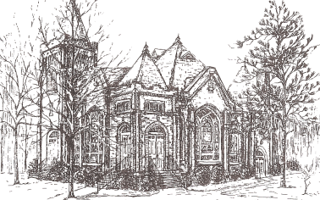THE CHURCH MOUSE

The Reverend Rick Martindale Pastor
Ali Wadsworth Choir Director
Elizabeth Williams Organist
Rhonda Smith Administrative Assistant
Andie Hyman Nursery Attendant
Ann Key Sexton
Marie Monroe Treasurer
Ruth Craig Interim Pianist

Ruth Craig Interim Pianist
Class of 2018
Angie Medlin
J.D. Monroe
Susan Phillips
Marlene Riyevski

Class of 2019
Lucinda Casey
Cristy Dean
Scott Phillips
Paul White

Class of 2020
Doris Russell
Chad Thomason
Michelle Tortora
JoAnn Wahala

FIRST PRESBYTERIAN CHURCH
November 2018

November Is Upon Us!

Wasn’t it just the other day that we were complaining about it being too hot or all excited about that summer vacation? 2018 is quickly coming to a close. We are now in the month of cooler days, election day, our first contemporary service, Thanksgiving, and Stewardship/Commitment Sunday. Did you like how I inserted that last one?

Yes, Commitment Sunday, or as some of us remember it, Stewardship Sunday is approaching. On November 18th we will present before God our commitments for 2019. It is the opportunity for us to commit the entirety of our being, including what we hold dear, to God. We are striving to reach the goal of tithing ten percent to the church. It is a large number for many of us but not in comparison to all God has given to us.

As disciples of Jesus Christ, we know that God has given us so much…our families, friends, gifts and talents, passions, joys, First Presbyterian, fellow disciples, homes, professions, and God’s creation to name a few. We have been given so much.

God ask for 10 percent of our wealth each year to remind us of one very important rule in our lives…God is the center of our lives…not ourselves, not our wealth, and not anything else we hold dear. Jesus knew that money and our possessions would distract us from Who is truly important.

Our giving promotes a right relationship with God. Our giving opens the door for us to be a part of countless opportunities to assist others and be a beacon of light. This might come through programs offered to teach our children and one another. It might come in helping someone who is in desperate need for heat, food, or gas to get to work. It might be seen as a church that helps at the Robbins Food Bank, offers yoga, Grief Share, and countless other opportunities.

Our giving could be used for many other “things” but God ask us to place God first. Doing so helps to keep us in a proper relationship with God and opens the way for our giving to assist others to know our Lord and Savior.

As you prepare for all that November brings please start preparing yourself and your family for Commitment Sunday.

Grace and Peace,

Rick
November Calendar Page
USHERS
*Marlene Riyevski
Lucinda Casey
JoAnn Wahala
Chad Thomason

*Lead Usher

Birthdays

1 Cody Adelmann
4 Anne Lucas
5 Scott Phillips
8 Jeff Medlin
8 Helen Mohan
9 Bill Russell
10 Steve Ingold
10 Harriet Marsh
12 Emily Tortora
15 Megan Phillips
20 Doreen Little
21 Jane Ritter
24 Hallie Patterson
27 Cathy Campbell
29 Chad Thomason
30 Nancy McKenzie

FLOWERS

4 Tina Stromko and Ali Wadsworth
11 Harvest Table, Helen McDonald and JoAnn Wahala

18 Gail and Keith Hardin
25 Kay Grimm
If you would like to place flowers in the sanctuary, please contact Susan Cole (947-5764).

GREETERS

4 Michelle and Scott Tortora

11 Jeannie and Max Muse

18 Gail and Keith Hardin

25 Jennifer and Chad Thomason

In Our Prayers . . .

Bette Allen Jean Bennett – Quail Haven Linda Busch
John Currie – Tara Plantation Betty Elliott Sheree Kelly
Carol Lucas Jim Lucas Joan MacLean
Nancy McKenzie Pat Nugent Garin Parker
Dennis Parks Ina Sue Parks Kay Patterson
Jim Phillips – St. Joseph’s Scott Rives Bonnie Scott
Phillip Warmbrod



Linda Ammons – Jim Phillip’s Sister Becky Bailey
Tony Bibey – Jimmy’s Son Dean Cameron
James Cox – Friend of Kelly Martindale Robert Davis
Samantha Davis’ Family Christopher Freeman – Maria Bigger’s Grandson Jimmie Garner – Joan Power’s father
Jimmie Garner – Joan Power’s Father June Greeson – Susan Cole’s Mother
Aaron Ladmin Neville Little – Peter Little’s Brother
Vince Mann – Friend of the Leonard’s David Martindale – Rick’s Brother
Ann Parker – Barbara Danley’s Cousin Serge Riyevski’s Daughter
Kimberly Sanders and Family Hunter Smith
William Stutts – Bonnie Scott’s Brother-in-Law Skip Vann – Jim Phillip’s brother

All of our military men and women especially the following:
Jonathan Baker, Chris Mohan, Patrick Mohan, Gregory Riyevski, Tim Shiflet,
Will Strickland, and Quinn Wicker

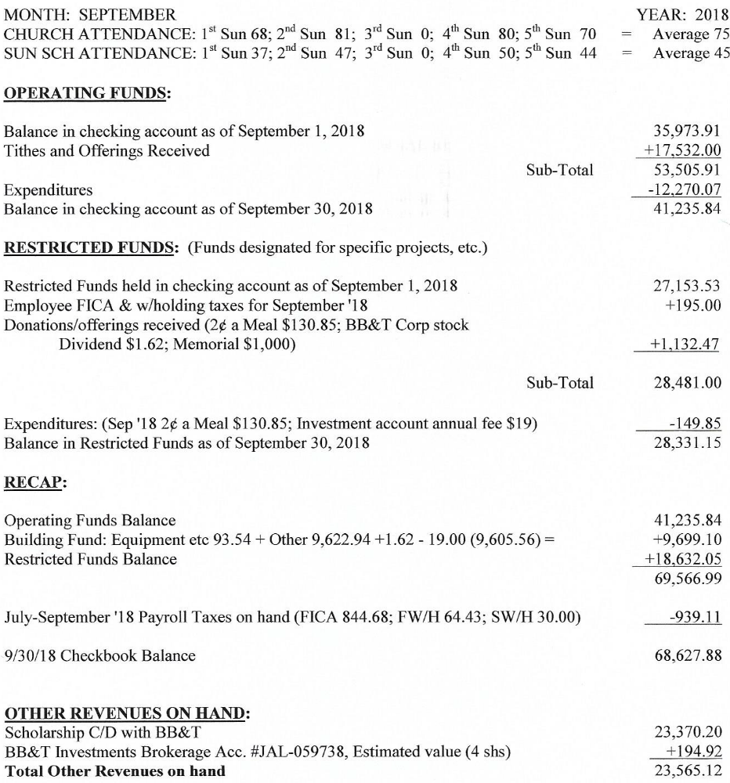

NOVEMBER CALENDAR

1 11:00 PW Circle (conference room)
4 9:45 Sunday School
11:00 Contemporary Worship Service (Family Life Center)
4:00 Confirmation Class (conference room – note change of room)
5:00 Youth Group
5 8:45 Christian Yoga
10:15 Christian Chair Yoga
6 7:00 Bible Study
7 8:45 Christian Yoga
10:15 Christian Chair Yoga
5:30 What’s Up Wednesday
7:00 Choir
11 9:00 Worship Committee (conference room)
9:45 Sunday School
11:00 Worship
2:00 Session (conference room)
4:00 Confirmation Class (conference room)
5:00 Youth Group
12 8:45 Christian Yoga
10:15 Christian Chair Yoga
13 7:00 Bible Study
14 8:45 Christian Yoga
10:15 Christian Chair Yoga
5:30 What’s Up Wednesdays (fellowship hall)
7:00 Choir Practice
15 11:30 Ladies Lunch leaving from church parking lot
17 2:00 Grief Share Surviving Holidays
18 9:45 Sunday School
11:00 Worship/Communion/Commitment Sunday
4:00 Confirmation Class (Back to youth room)
5:00 Youth Group
7:00 Community Thanksgiving Service (First Baptist Church)
19 8:45 Christian Yoga
10:15 Christian Chair Yoga
21 7:00 Choir Practice

(The rest of November is on the opposite page)

All articles/information for the Mouse and the weekly bulletins should be emailed
to the church’s email address: infofpc397@gmail.com

November Month (Continued)

27 1:00 Fold the Mouse (conference room)
28 Deadline for Mouse Articles
8:45 Christian Yoga
10:15 Christian Chair Yoga
7:00 Choir Practice

With the Women
Circle will on meet on Thursday, November 1st at 11:00 am in the conference room.Monroe if you would like a study book. Books are $11.00.

November Calendar Continued

22 Happy Thanksgiving – Church Office Closed
23 Church Office Closed
25 9:45 Sunday School
11:00 Worship
26 8:45 Christian Yoga
10:15 Christian Chair Yoga
28 8:45 Christian Yoga
10:15 Christian Chair Yoga
5:30 What’s Up Wednesday
7:00 Choir

With the Women
Ladies Lunch will meet Thursday, November 15th at 12:00 p.m. at Scott’s Table, 311 SE Broad Street in Southern Pines. Plan to meet at church at 11:30 a.m. if you would like to carpool. We need to give them a head count by Tuesday, November 13th. Please let me know by Tuesday at noon if you plan to go (947-2946, 690-2463 or hmcd2946@gmail.com).

Presbyterian Women will host a Christmas lunch for the congregation after worship on Sunday, December 9th. We are asking for a donation for lunch and all monies collected will go to the Carthage Food Pantry. If you would like to donate an item for our raffle please leave it on the stage in the multipurpose room by December 7th. More details to come.

New Staff Members
We are delighted to welcome two new staff members to our First Presbyterian Church Family. Andie Hyman is our new nursery attendant, she comes to us with years of experience, and is doing a great job.

The new Administrative Assistant is Rhonda Smith. She and her husband Zane moved to Moore County this summer to be closer to family.

Stop by and meet both of these ladies when you have a chance!

Grief Share
“Surviving the Holidays” will be held Saturday, November 17th from 2:00-4:00 p.m. in the Family Life Center of FPC. This is a partnership with Community Presbyterian Church. We encourage people who have lost a loved one, as well as, previous Grief Share participants to attend.

Response to Hurricane Florence
Let us continue to pray for our brothers and sisters in North and South Carolina. Many have lost numerous possessions and entire homes. Others have lost much more than mere possessions.

Let us give to such worthy organizations like the Presbyterian Disaster Assistance (PDA) and Red Cross. PDA is still working with people who lost everything from Hurricane Matthew. They have been in our state for two years and will be here for at least another two years. You can go to their web-site, www.pda.pcusa.org to give.

The Session has approved a gift of $1,000 to PDA to help those affected by the hurricane. We are reaching out to our sister churches and once a plan of action is formulated, we will be asked to help. Let us be prepared to help when the time comes.

Robbins Food Bank (RACM)
How will you make this Advent and Christmas season special? Let’s help those in need. After a long break we will again be helping at the Robbins Food Bank on the first Saturday of December (the 1st). We will leave the church parking lot at 7:30 a.m. and be done by 11:30 a.m. Please place this event on your calendar!

Wine and Design Evening

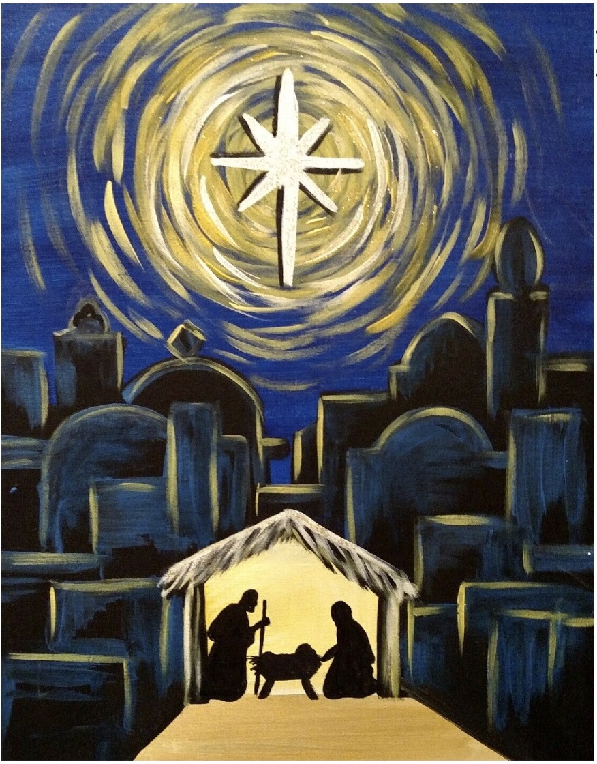 Come enjoy an afternoon of painting and fellowship while painting a beautiful manger scene perfect for the Christmas season. This will be a private painting event held at Wine and Design in Southern Pines on Sunday, Dec 2nd at 3:00 p.m. The cost is $35 per person. You can register using the following link: https://www.wineanddesign.com/calendars/event.php?id=134282 and password: WD42. Or feel free to pay Michelle Tortora via cash or check and she will get you registered.

