

(910) 947-2924
infofpc397@gmail.com
www.FpcCarthage.com


Fpc Carthage FpcBeTheLight

#fpcbethelight
First Presbyterian Church

Located in the heart of Carthage, NC
near the Post Office at 110 South Ray Street,
First Presbyterian welcomes you!

The Reverend Rick Martindale Pastor
Ali Wadsworth Choir Director
Elizabeth Williams Organist
Shelley Hammond Administrative Assistant
Andie Hyman Nursery Attendant
Ann Key Sexton
Marie Monroe Treasurer



The Reverend Rick Martindale, Pastor
Ali Wadsworth, Choir Director
Shelley Hammond, Administrative Assistant
Andie Hyman, Nursery Attendant
Ann Key, Sexton
Marie Monroe, Treasurer

FPC Session
Session Class of 2021 Denise Edmonds, Robert Gordon, Lee McCaskill, Geraldine Moore
Session Class of 2022 Keith Hardin, Elizabeth Martindale, Helen McDonald, Marie Monroe
Session Class of 2023 Lucinda Casey, Tom Leonard, Scott Phillips, Jennifer Thomason

Non-Profit
Organization
U.S. Postage
PAID
CARTHAGE, NC
28327
Permit No. 35
First Presbyterian Church
PO Box 397
Carthage, NC 28327




First Presbyterian Church
A Cornerstone for Christ since 1850.

April 2021 Church News

God Stays

I love March Madness because any basketball team no matter how great or unlikely can win. It doesn’t matter if you are from a powerhouse conference like the ACC or a smaller one like the Missouri Valley Conference. This year is no exception in the men’s tournament. Two one-seeds and two-seeds have fallen! Four double-digit seeds have advanced, including a 15- seed to the Sweet Sixteen. It’s madness! It’s March Madness. It reminds us that no one, not even the experts who study college basketball for a living, knows what’s going to happen.

We celebrate that this year’s tournaments are even taking place. Over the last year, life has been challenging and difficult. None of us foresaw what was going to happen. “Normal” looks very different than what it once did. Yet, despite all the challenges we have faced… God has been with us. God has helped us encounter each day.

Through the evil and maddening events of the last week and year, God remains constant. God’s love nurtures us. When everything seems so wrong, when all hope seems lost… God is with us. God reminds us that all things are possible through God.

The small school with a decent coach and not a single player who will ever become a professional in basketball, can go out and outplay a team with a coach that gets paid 10 times as much, more staff, and with two or three players that will make it to the NBA. Some might call that madness, but I call that beautiful and full of grace. In spiritual circles we call such “life events” blessings from God. God proclaims that all things are possible for those who believe.

I’m reminded of a song by Matthew West, “The God Who Stays.” No matter what happens in our lives, God remains. If family or friends reject us, God won’t. If our life turns upside down, God is still beside us. If we mess up, God still loves us.

We celebrate the joy of Easter because God’s love is amazing and forever. May Easter touch our lives and enable us to live with a new joy. God’s love is realized in the life, death, and resurrection of God’s Son. God makes the impossible, possible. God shares a hope that is eternal! God proclaims God’s dedication and love for us, always!

Grace and Peace, Rick
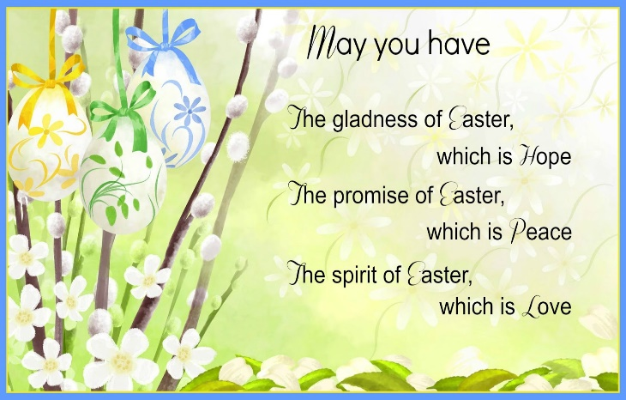
First Pres
prays for you.

Remember our brothers and sisters
in Christ through prayer and petition as they face difficult times.
Debbie Albright Jean Bennett, Quail Haven
Jimmy Bibey Anna Belle Campbell
Benny Cole John Currie, Tara Plantation
Justin & Sarah Edmonds Keith Hardin Margaret Leonard Carol Lucas
Linda McCaskill Gail Meeks
Ina Sue Parks Kay Patterson Otis Patterson Bonnie Scott Phillip Warmbrod

Bo, friend of Geraldine Moore
Karen Bryant, friend of JoAnn Wahala
Brian Casey, Lucinda and David Casey’s son
Judy Claterbos, Mary Thomas’ sister
Jack Denniston, Lucinda and David’s daughter-in-law’s father
Carl Greeson, Susan Cole’s brother
June Greeson, Susan Cole’s mother
Ann Herndon, Kay Patterson’s sister
Sean Kennally, Angie Provost’s son-in-law
Barbara May, friend of Debbie Gordon
Jane Medlin, Carol Lucas’ daughter
Lisa Muller, Cousin of Ina Sue Parks
Tommy Walton, Diane Pangborn’s brother

All of our military men and women and their families, especially the following:
Michael Abercrombie, Jonathan Baker, Kyle Bryant, Chris Mohan,
Patrick Mohan, Michael Schwartz, Will Strickland, and Quinn Wicker.

FPC Stewardship & Finance
February 2021
OPERATING FUNDS:
Balance in checking account as of February 1, 2021 | 93,354.86
Tithes and Offerings Received | +11,888.00
Sub-Total | 105,242.86
Expenditures | -12,955.57
Balance in checking account as of February 28, 2021 | 92,287.29
RESTRICTED FUNDS: (Funds designated for specific projects, etc.)
Restricted Funds held in checking account as of February 1, 2021  Employee FICA & w/holding taxes for February 2021  Donations/offerings received (2ȼ a Meal $25; Bldg Fd $400; Memorials $100;  Cemetery Fund $150; Presbyterian Women $50; Souper Bowl $200) | 136,617.89  +204.03  +925.00
Sub-Total | 137,746.92
Expenditures: Scott Rives, balance of Love Offering $901; Justin and  Sarah Edmonds, Love Offering $3,295 | -4,196.00
Balance in Restricted Funds as of February 28, 2021 | 133,550.92
RECAP:
Operating Funds Balance | 92,287.29
Building Fund: Equip etc 93.54 + Other 102,380.42 + 400.00 + Transfer of 2019  Fall Festival Funds $4,557.95 + Grant 500.00= | +107,931.91
Restricted Funds Balance | +25,619.01
 | 225,838.21
Jan -Feb'21 Payroll Taxes on hand (FICA 402.84; FW/H 0.00; SW/H 0.00) | -402.84
2/28/2021 Checkbook Balance | 225,435.37
OTHER REVENUES ON HAND:
Scholarship C/D with BB&T  BB&T Investments Brokerage Acc. #JAL-059738, Estimated value (4 shs) | 23,639.20  +235.24
Total Other Revenues on hand | 23,874.44
FPC Calendar April 2021
Family Life Center (FLC) Conference Room (CR) Outdoor Worship held at 40 degrees+

Thursday, April 1st 11:00 a.m. Ladies Bible Study (FLC/outside weather-permitting)
Need a study book? Call Helen at (910) 690-2463.
6:00 p.m. Maundy Thursday Tenebrae Service (FLC)
Friday, April 2nd Good Friday
Saturday, April 3rd 7:30 a.m. Robbins’ Food Bank, meet 7 a.m. at FPC to carpool
Sunday, April 4th Resurrection of the Lord / Easter Sunday
7:00 a.m. Sunrise Service
10:00 a.m. Communion Service (FLC)
11:00 a.m. Outdoor Communion Service, weather-permitting
Tuesday, April 6th Last day to pick up Commemorative Easter Lilies
6:30 p.m. Fellowship & Mission (FLC)
Sunday, April 11th 10:00 a.m. Children’s Sunday School, classes for ages 3-12th grade 10:00 a.m. Indoor/Virtual Worship (FLC)
11:00 a.m. Outdoor Worship, weather-permitting
Monday, April 12th Deadline for May Church Mouse Newsletter
2:00 p.m. YogaFaith floor class (FLC)
3:15 p.m. YogaFaith chair class (FLC)
5:30 p.m. RACM Board Meeting (Robbins)
​Sunday, April 18th Communion Sunday
PW Birthday Offering envelopes available in lobby
10:00 a.m. Children’s Sunday School, classes for ages 3-12th grade 10:00 a.m. Indoor/Virtual Worship (FLC)
11:00 a.m. Outdoor Worship, weather-permitting
2:00 p.m. Session Meeting
5:00 p.m. Youth Group
Monday, April 19th 2:00 p.m. YogaFaith floor class (FLC)
3:15 p.m. YogaFaith chair class (FLC)
Sunday, April 25th Annual PW Birthday Offering
10:00 a.m. Children’s Sunday School, ages 3-12th grade
10:00 a.m. Indoor/Virtual Worship (FLC)
11:00 a.m. Outdoor Worship, weather-permitting
5:00 p.m. Youth Group
Monday, April 26th 2:00 p.m. YogaFaith floor class (FLC)
3:15 p.m. YogaFaith chair class (FLC)

FIRST PRESBYTERIAN.
A cornerstone for Christ in the Carthage community since 1850.

Led by God and sustained by the Holy Spirit, FPC supports God’s children as they grow
in their faith, strengthen their relationship with Jesus Christ,
and are challenged to be God’s servants and disciples.

10 a.m. Children’s & Youth 10 a.m. Worship 11 a.m. Worship
Sunday School Indoor Outdoor
2/7 11 24 --
2/14 11 14 --
2/21 10 16 --
2/28 0 38 --
Average 11 23

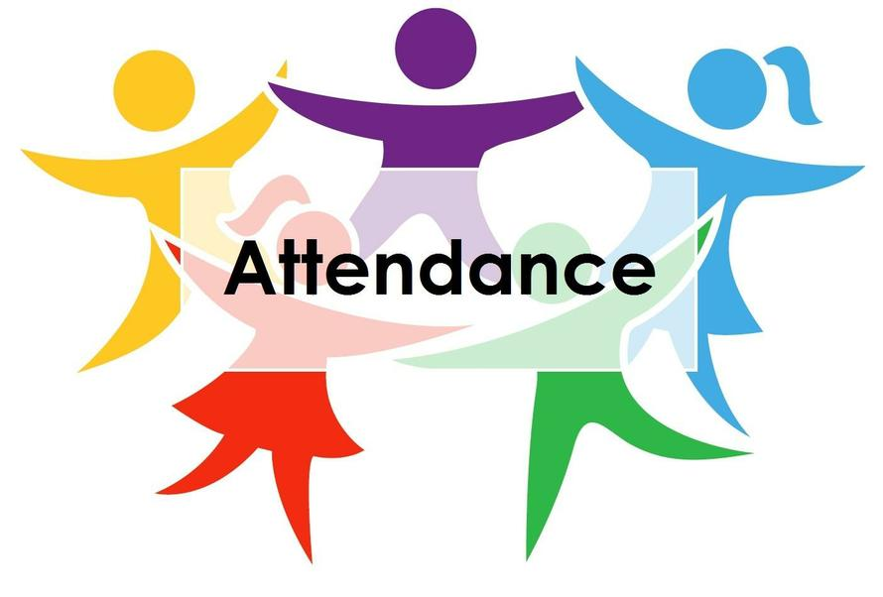



4 David Casey 14 Michelle Tortora
5 Cindy Monroe 16 Regena Nugent
6 Katie Campbell Lucas 18 Kelly Gordon
7 Shane Medlin 19 Ann Key
9 Judi Kelly 21 Lee McCaskill
10 Reid Marshburn 26 Denise Bennett
11 Kayden Dean 26 Shirley Moore
11 Katie Kelly Crenshaw 30 Coy Oakley
11 Sharon McDonald 30 Tina Stromko

Keep us updated! To add or correct a birthday,
contact FPC @ (910) 947-2924 or infofpc397@gmail.com.

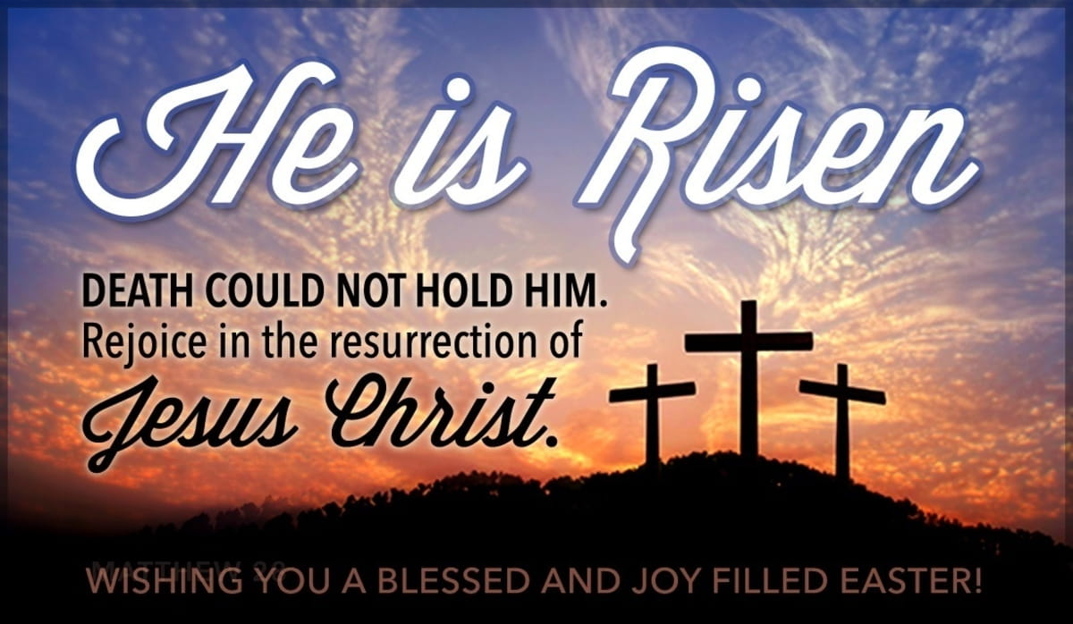
Holy Week

April 1st Maundy Thursday 6 p.m. Tenebrae Service
of light and darkness

April 2nd Good Friday

April 4th Easter Sunday Resurrection of the Lord
7 a.m. Sunrise Service
10 & 11 a.m. Communion Service


Commemorative Easter Lilies

On Easter Sunday,
white lilies are placed in worship to commemorate the promise of new life through the resurrection of Jesus Christ.

From Gail and Keith Hardin
"In Memory of Our Family Members Who Left Us in 2020"
Hardin Crouch (Father)
Juanita Crouch (Mother)
JoAnne Thompson (Mother)
Troy Caulder (Brother)
Ernest Crouch (Uncle)
Danny Lewis (Brother)

Homebound FPC Church Friends & Family in the area will receive the Love of Christ from you when a beautifully made Easter Basket arrives on their doorstep. Thank you FPC for being the hands and feet of Christ this Easter season!


To show our appreciation of Elizabeth Williams’ 20 years of dedicated service
as our church organist,
a love offering is being collected through April 18th
and will be presented to Elizabeth during a May worship service.

Give your “two-cents” on the first Sunday of each month with FPC’s 2 Cents a Meal Offering.
Put your “two-cents” in your regular offering envelope and write the amount in the special offering location. Or, give your offering in a separate envelope with
“two-cents a meal” written on the outside.



The Family Life Center lobby serves as a donation collection site for
FPC “Basket” ministries and missions.
April and May’s focus is our local Nursing Home Outreach ministry for Pinelake and First Health Hospice and Palliative Care. Please donate simple items to show God’s love including: puzzles, word searches, crosswords, adult coloring books, pens, colored pencils, crayons and snacks (Little Debbie Cakes, Lance crackers, etc.). Baskets for Back Pack Pals (crackers and raisins), Sandhills/Moore Coalition (instant potatoes), and Robbins Food Pantry (food and plastic bags) are also located in the FLC lobby. Please hold your books for the Carthage Food Pantry at his time.



