The Reverend Rick Martindale Pastor
Ali Wadsworth Choir Director
Elizabeth Williams Organist
Shelley Hammond Administrative Assistant
Andie Hyman Nursery Attendant
Ann Key Sexton
Marie Monroe Treasurer

Class of 2019
Lucinda Casey
Cristy Dean
Scott Phillips
Paul White

Class of 2020
Doris Russell
Chad Thomason
Michelle Tortora
JoAnn Wahala

Class of 2021
Denise Edmonds
Robert Gordon
Lee McCaskill
Geraldine Moore
Non-Profit
Organization
U.S. Postage
PAID
CARTHAGE, NC
28327
Permit No. 35

FIRST PRESBYTERIAN CHURCH
POST OFFICE BOX 397
CARTHAGE, NORTH CAROLINA 28327
(910) 947-2924
fpccarthage.com (website)
infofpc397@gmail.com (email)

 December 2019 First Presbyterian Church News

Waiting

I was reading this meditation from Barbara Ferguson the other night and wanted to share it with you as we begin this Advent season. It is worth embracing as we walk and run through Advent.

“It was Christmas Eve. The church was filled with expectant worshippers, but just below my balcony seat stood two special couples singing side by side – and waiting. Bill and Esther were waiting for death to claim Bill’s terminally ill mother. Craig and Lynn were waiting for the birth of their first child.

How many others here are waiting for death or for life? I wondered. How many are watching for the coming of God into joyful and tangled or pain-filled existence?

Perhaps we are all waiting, I thought. We are all in this church waiting and hoping for something.

That is what Advent is all about, isn’t it? Advent recalls Israel’s centuries of waiting for the Messiah. The scripture reminds us that we, too, are waiting for God to move in our lives and in our world. Then Advent quietly insists that there is something worth waiting for. It tells us that our hope is not hollow, that as surely as God came to those people in the stable in Bethlehem, so God will come to us. With this assurance we can wait together, trusting and hoping in God.”

 In a world where discovering answers, shopping, ordering tickets, buying groceries, or countless other activities are only a few key strokes away, we are reminded during this season to embrace the tiring but fulfilling practice of waiting. Waiting to discover some new found joy. Waiting to learn some difficult news. But ultimately waiting to discover God’s presence is with us. Please take time each day, if possible, to wait and simply be with God. God’s love is present and fulfilling if we will stop and recognize Immanuel – which means “God is with us.”

Grace and Peace,

Rick
Jean Bennett – Quail Haven
Jimmy Bibey
Anna Belle Campbell
Benny Cole
John Currie – Tara Plantation
Betty Elliott
Keith Hardin
Sheree Kelly
Margaret Leonard
Carol Lucas
Jim Lucas
Nancy McKenzie
Marie Monroe
Pat Nugent
Regena Nugent
Dennis Parks
Ina Sue Parks
Kay Patterson
Nicole and Jordan Phillips
Scott Rives
Bonnie Scott
Phillip Warmbrod

In Our Prayers Remembering our sisters and brothers as they face difficult times.

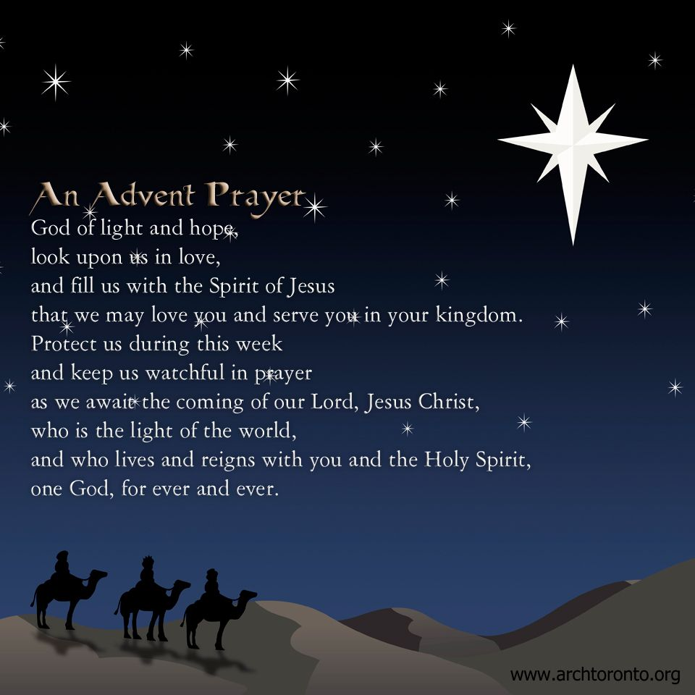

Tony Bibey, Jimmy Bibey’s son
Anna Bristow, Debbie Albright’s sister
Olivia Bryant, Karen Bryant’s granddaughter
Wife of Larry Cockman, friend of Benny Cole
Robert Davis
Jon Foster and Family, friend of Elizabeth Martindale
Carl Greeson, Susan Cole’s brother
Ann Herndon, Kay Patterson’s sister
Zack Isom, Diane Pangborn’s son
Maxine Lawson, Elizabeth William’s sister
Vince Mann, friend of the Leonards
Garin Parker, Barbara Danley’s nephew
Hunter Smith
JoAnne Thompson, Keith Hardin’s mother
Tommy Walton, Diane Pangborn’s brother

Donnie Albright
Mary Brewer
Karen Bryant, friend of JoAnn Wahala
Dean Cameron
James Cox, friend of Kelly Martindale
Caleb Evans, friend of Elizabeth Martindale
Christopher Freeman, Maria Bigger’s grandson
June Greeson, Susan Cole’s mother
Mary Hussey
Aaron Ladmin
Rexine Lloyd, Kelly Martindale’s mother
Jane Medlin, Carol Lucas’ daughter
Kimberly Sanders and Family
William Stutts, Bonnie Scott’s brother-in-law
Skip Vann, Judy Phillip’s brother-in-law

Our military men and women and their families including:
Michael Abercrombie Jonathan Baker Kyle Bryant Chris Mohan
Patrick Mohan Gregory Riyevski Will Strickland Quinn Wicker
To add someone or to remove your name, please call the church office at 947-2924.

Attendance Sunday School Worship
October 6th 36 78
October 13th 39 69
October 20th 38 69
October 27th 37 70
Average 38 72

OCTOBER FINANCIAL REPORT
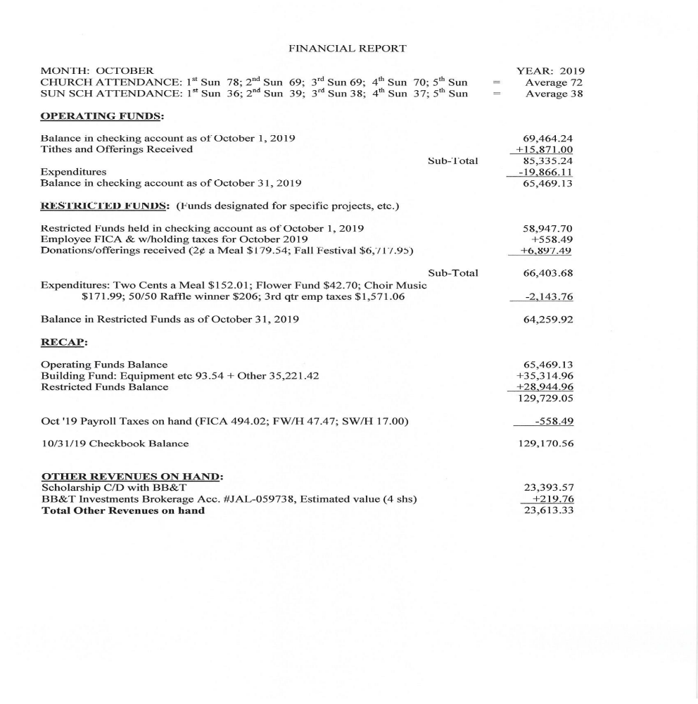


First Sunday in Advent December 1st 11 a.m. Contemporary Worship, FPC Family Life Center
Celebrating God's promise of Hope in our Messiah, Jesus Christ.

Second Sunday in Advent December 8th ​​ 11 a.m. Worship Noon Luncheon Afternoon Carols
Celebrating God's promise of the Peace that only our savior, Jesus Christ, can provide in our lives.

Third Sunday in Advent December 15th ​11 a.m. Christmas Cantata
​Celebrating joy in the upcoming savior’s arrival, both on Christmas day and in the future.

Fourth Sunday in Advent December 22nd ​ 11 a.m. Worship 5 p.m. Christmas in the Barn
Celebrating God's Agape love for mankind - the highest form of love - through his gift to us,
the savior of the world
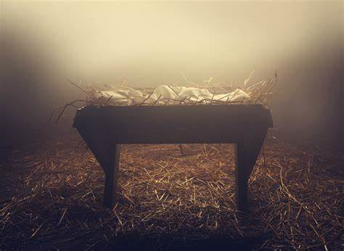
​ Join us for this evening community event at the Moore County Fairgrounds, Carthage.

CHRISTMAS EVE CANDLELIGHT SERVICE
Tuesday, December 24th
9 p.m.
Celebrating Christ's birth – the light of the world – with the lighting of the Christ candle.

www.FPCcarthage.com/advent

​​



Final day to turn in gifts.





PW CHRISTMAS LUNCH
Enjoy good food and fellowship as the Presbyterian Women host their Annual Christmas Luncheon on Sunday, December 8th
after worship. The meal is free to all, and there will be a holiday raffle and donation basket for the Carthage Food Pantry.
(Make donation checks payable to Presbyterian Women.) Raffle prizes are needed, and may be placed on the stage in our Family Life Center. If you would like to help with the meal,
please contact Helen McDonald, 690-2463.

Our Day Circle will not meet this month.

The Night Circle will meet on Thursday, December 12 at 6:30 pm in the conference room. If you are interested please contact Tina Stromko.
Ladies Lunch will meet on Thursday, December 19 at 12:00 at The Soup Co. in Carthage. If you need a ride please contact Helen at 910-690-2463.



Women’s Circle

Thursday, December 12th
6:30 p.m. @ FPC
Our Day Circle will not meet this month.

Ladies Lunch

Thursday, December 19th
Noon @ The Soup Company
If you need a ride, please call Helen. 690-2463.

Saturday, January 18th “When Only Faith Remains”
women of faith gathering with local author, Amy O’Reilly.
10 a.m. – noon at Community Presbyterian Church, Pinehurst.
Pre-register at moorewomenmorefaith@gmail.com


Session Notes:

The session approved the Budget for 2020 in November. It will be shared with the congregation at our congregational meeting this month.

Last month we gave $400. to Family Promise, $600. to Camp Monroe, and $750. to the Sandhills Coalition. These are just three organizations we have supported this year financially.

Officer training was held on November 16th as our elder-elects prepare to serve FPC and God.

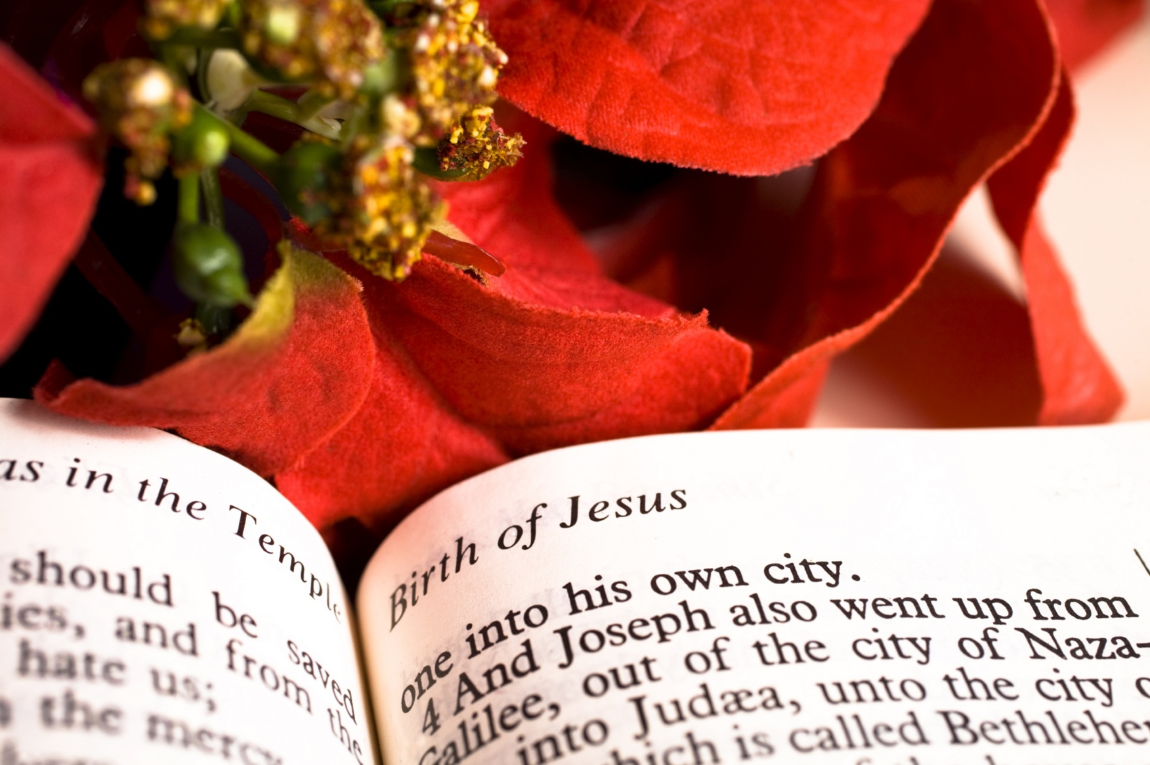

Sanctuary Poinsettias this Advent Season are given

in Honor of
Addison, Hartley and Carter, by Nancy Carter

in Memory of
Mary Pangborn, by Tom and Diane Pangborn
Danny Isom, by Tom and Diane Pangborn
Linda McCrimmon Busch, by Dell & JoAnn Wahala
Joan Morrison MacLean, by Dell & JoAnn Wahala
Our Parents, by Dell & JoAnn Wahala
Mr. And Mrs. Lassie L. Scott, by Ann Lynch
Cleet and Margaret Cleetwood, by David & Lucinda Casey
Joseph and Miriam Casey, by David & Lucinda Casey
Leona Patterson, by Otis Patterson and children
Linda Busch, by the Martindale Family
Joan MacLean, by the Martindale Family
Bette Allen, by the Martindale Family
Jim Phillips, by the Martindale Family
Presley Mae Phillips by the Martindale Family

December… Celebrating Jesus, the light of the world.
Sunday December 1st 9:00 a.m. Fellowship and Mission Committee (conference room)
9:45 a.m. Sunday School
11:00 a.m. Contemporary Worship Service, Pennies for Hunger (FLC)
Tuesday December 3rd 2:00 p.m. CHS High School Reunion Committee (conference room)
6:00 p.m. Men’s Group (conference room)
Wednesday December 4th Christian Faith Yoga – 8:45 a.m. Floor, 10:15 a.m. Chair 5:30 p.m. What’s Up Wednesday (ages 4-6th grade)
7:00 p.m. Choir practice
Saturday December 7th 7:30 a.m. Robbins’ Food Bank (meet at FPC to carpool)
Sunday December 8th Angel Tree gifts due
9:45 a.m. Sunday School
11:00 a.m. Worship
12:00 p.m. Congregational Meeting
12:15 p.m. Presbyterian Women’s Christmas Luncheon
2:00 p.m. Caroling
Monday December 9th Christian Faith Yoga – 8:45 a.m. Floor, 10:15 a.m. Chair
7:00 p.m. Session Meeting
Wednesday December 11th Christian Faith Yoga – 8:45 a.m. Floor, 10:15 a.m. Chair 5:30 p.m. What’s Up Wednesday (ages 4-6th grade)
7:00 p.m. Choir practice
Thursday December 12th 6:00 p.m. Praise Team practice
6:30 p.m. Evening Women’s Bible Study & Fellowship Circle
Saturday December 14th Family Life Center reserved – AKA Retirement Luncheon
Sunday December 15th 9:45 a.m. Sunday School
11:00 a.m. Christmas Cantata Worship Service

Thank you VERY much for the food and plastic bag donations made for the Robbins Food Pantry throughout 2019! Great job! It’s so wonderful to have these much-needed items for December’s Food Bank 1st Saturday on 12/7. To help guide your selections while cleaning out your pantry and grocery shopping, check out the “Shelf Life of Food Bank Products” info on the FLC donation tote. Many foods are edible and can be donated after expiration dates. We continue to appreciate your generosity as we head into 2020!

Stop by the angel tree in the upper narthex to choose an angel
(or two). There are many gift choices still available. Be sure to wrap your gifts, attach the angel to the OUTSIDE of each package, and place gifts under the tree by Sunday, December 8th.

5:00 p.m. Youth Group (grades 7-12)
Monday December 16th Christian Faith Yoga – 8:45 a.m. Floor, 10:15 a.m. Chair
Tuesday December 17th Deadline for January 2020 Mouse church newsletter
6:00 p.m. Men’s Group (conference room)
Wednesday December 18th Christian Faith Yoga – 8:45 a.m. Floor, 10:15 a.m. Chair 5:30 p.m. What’s Up Wednesday (ages 4-6th grade)
7:00 p.m. Choir practice
Thursday December 19th 12:00 p.m. Ladies Lunch, The Soup Company
1:00 p.m. Fold Church Mouse Newsletter (conference room)
6:00 p.m. Praise Team practice
Sunday December 22nd 9:45 a.m. Sunday School
11:00 a.m. Worship Service with Communion
5:00 p.m. Christmas in the Barn, Moore County Fairgrounds
Tuesday December 24th 9:00 p.m. Candlelight Christmas Eve Service
Wednesday December 25th Christmas Day – Church Office closed
Thursday December 26th Church Office closed
Sunday December 29th 9:45 a.m. Sunday School
11:00 a.m. Worship




Happy Birthday!

5 Kelly Martindale
7 Nicolas Carter
12 Herman Seawell, Sr.
14 Abby Phillips
16 Linda Myrick
19 Tanya Adelman
19 Jackson Smith
22 Brandon Kelly
24 Pat Burt
24 Tom Pangborn
31 John McCaskill

Greeters
1st Geraldine Moore
8th Ann Key
15th Dale & Kathryn Buie and Family
22nd Dennis Parks
29th Denise & Justin Edmonds

Ushers
Cristy Dean (lead)
Paul White
Denise Edmonds
Lee McCaskill

