Non-Profit
Organization
U.S. Postage
PAID
CARTHAGE, NC
28327
Permit No. 35

FIRST PRESBYTERIAN CHURCH
POST OFFICE BOX 397
CARTHAGE, NORTH CAROLINA 28327
(910) 947-2924
fpccarthage.com (web site)
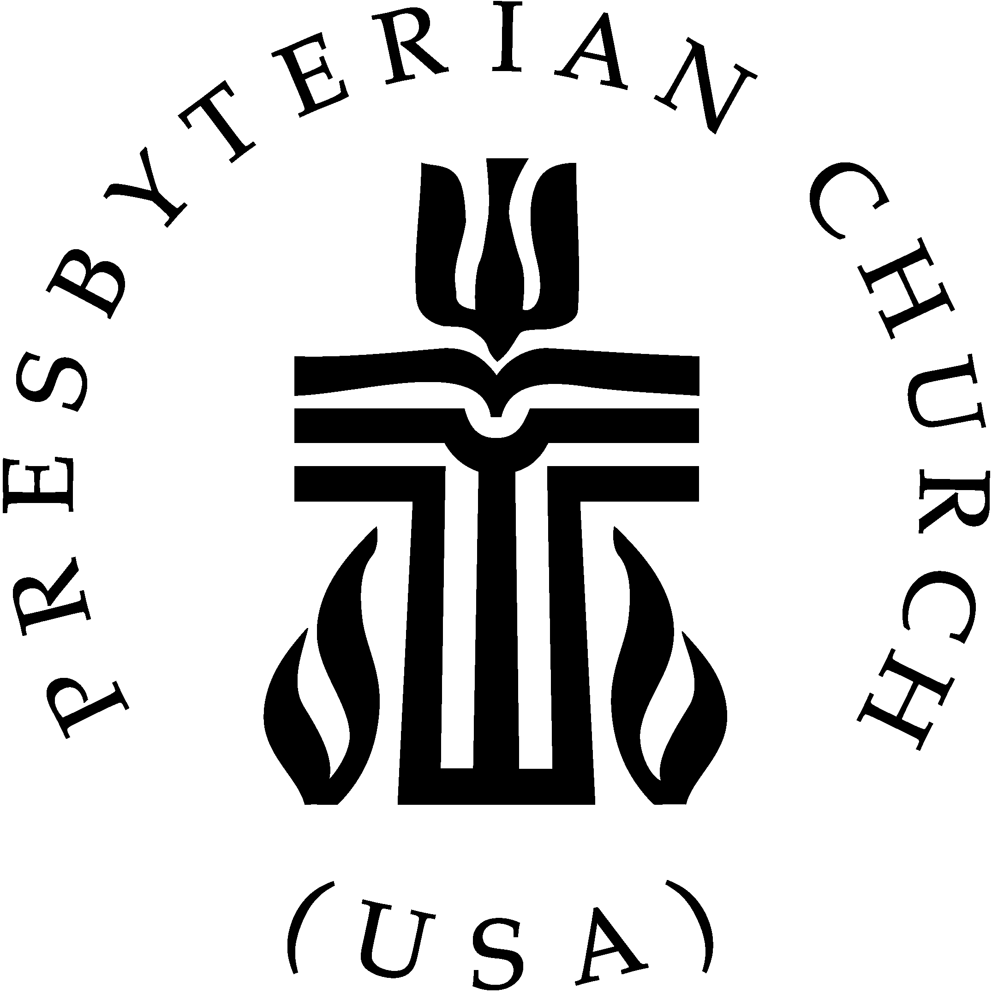infofpc@yahoo.com (e-mail)

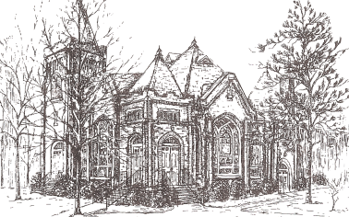THE CHURCH MOUSE
The Reverend Rick Martindale Pastor
Elizabeth Williams Organist & Choir Director
Ann Key Sexton
Marie Monroe Treasurer
Shanon Venable Administrative Assistant
Sarah Frick Nursery Attendant
Class of 2017
John Baker
Robert Gordon
Margaret Leonard
Bill Russell

Class of 2018
Angie Medlin
J.D. Monroe
Susan Phillips
Marlene Riyevski

Class of 2019
Lucinda Casey
Cristy Dean
Scott Phillips
Paul White

FIRST PRESBYTERIAN CHURCH
OCTOBER 2017

Mayberry Is Coming to Carthage

We are going to try a Bible study which is quite different than any other done
at FPC! It will make you laugh. You will reminisce. You will not have to do any
preparation in the days leading up to it…no homework (well maybe just a little).
Yet, my hope is that this Bible study will inspire you! It will direct your actions in
the days and weeks after. Ultimately that is what I always long for Bible studies to
do…change our lives.

This is a short 4 week Bible study which makes it easier for our very busy
people to participate as well as those sitting on their couches eating bonbons! We
will also be done before Thanksgiving week!

Each week we will touch upon one area of our Christian faith. If you miss a
week you will not be “behind.” But it’s only 4 weeks so why miss? Over the four
weeks we will be discussing service to God, God’s peace, mercy, and commitment
to Jesus. You might find yourself turning back to the scripture passages
(workbook) to find strength and hope well after the study is over.

Sign-up today for the Mayberry Bible Study in the narthex or office. I hope
this will be something different, reshaping our lives to better serve our Lord and
Savior.

The Mayberry Bible Study will begin on Tuesday, October 17th at 7 p.m. It
will run about an hour. We will not meet the night of Halloween. Deadline for
signing up will be Tuesday, October 10th. Please sign-up as soon possible so
everyone has a workbook the first night. If you have any questions please don’t
hesitate to contact me (947-2924 or revmartindale@hotmail.com).

Grace and Peace,

Rick
October Calendar Page
USHERS

Youth
*JD Monroe
Scott Phillips
Margaret Leonard

*Lead Usher

GREETERS

- Tom Stewart

8 Scott and Megan Phillips

15 Geraldine Moore

22 David and Lucinda Casey

29 Tom and Diane Pangborn

Birthdays
2 Robert Pearson
2 Angie Prevost
4 Laura Gordon
6 Catherine Martindale
6 Elizabeth Martindale
9 Ben White
15 Jacob Adelmann
15 Helen McDonald
15 Leon Monroe
15 Matthew Monroe
16 Jennifer Prevost Kennally
17 Jeannie Muse
18 Anna Belle Campbell
21 Caroline Carter Reynolds
21 Caroline Lucas
21 Mack McDonald
22 Max Muse
24 Kim Smith
27 Elizabeth Barringer
27 Gabe Phillips
31 Hammond Bennett

FLOWERS

- Linda & Lee McCaskill

8 Cristy & Damon Dean family

15 Angie & Jeff Medlin family

22 Sarah Seawell

29 Marlene & Serge Riyevski

If you would like to place flowers in the sanctuary, please contact Susan Cole (947-5764).

In Our Prayers . . .

Bette Allen Family of Heather Kelly
Jean Bennett – Quail Haven Linda Busch
Susan Cole John Currie – Tara Plantation
Sheree Kelly Jennifer Prevost Kennally
Margaret Leonard Jim Lucas
Joan MacLean Nancy McKenzie
Garin Parker Dennis Parks
Ina Sue Parks Kay Patterson
Jim Phillips – St. Joseph’s Scott Rives
Bonnie Scott Will Thomason Phillip Warmbrod



Linda Ammons – Jim Phillips’ sister Tony Bibey – Jimmy’s son
Cheryl Bowman Karen Bryant – Friend of JoAnn Wahala
Dean Cameron Terrie Campbell – Friend of Maria Bigger
Libby Craven Lee Cunningham – Marlene Riyevski’s Uncle
Robert Davis Christopher Freeman – Maria Bigger’s Grandson Jimmie Garner – Joan Power’s Father
Diamond Garnett – Youth at John Hall Church Christina Harris – Niece of The Russell’s
Wendy Horne – Linda Myrick’s Niece Bo Houff – Elizabeth Barringer’s Son-in-Law
Aaron Ladmin Vince Mann – Friend of the Leonards
David Moore – Geraldine’s son Ann Parker – Barbara Danley’s cousin Patrick Pusser – Friend of Maria Bigger
Hunter Smith William Stutts – Bonnie Scott’s Brother-in-Law
Skip Vann – Jim Phillips’ brother Linda Ray Winslow – Friend of Pat Jackson

All of our military men and women especially the following: Jonathan Baker,
Chris Mohan, Patrick Mohan, Gregory Riyevski, Will Strickland, and Quinn Wicker.

OCTOBER CALENDAR

1 9:45 Sunday School
11:00 Worship
2:30 Grief Share: Surviving the Holidays
5:00 Youth Group
2 8:45 Christian Yoga
6:30 Grief Share
7:15 Nominating Committee (fellowship hall)
4 5:30 What’s Up Wednesday
7:00 Choir
5 11:00 PW Circle (conference room)
7 7:30 Food Bank (meet at FPC)
8 9:45 Sunday School
11:00 Worship
2:00 Session Meeting (conference room)
5:00 Youth Group
9 8:45 Christian Yoga
6:30 Grief Share
11 5:30 What’s Up Wednesday
7:00 Choir
14 Presbytery Meeting (Fayetteville)
15 9:45 Sunday School
11:00 Worship/Communion
5:00 Youth Group
16 8:45 Christian Yoga
6:30 Grief Share
17 7:00 Bible Study
18 5:30 What’s Up Wednesday
7:00 Choir
19 11:45 Ladies Lunch (Pik N Pig)
22 9:45 Sunday School
11:00 Worship
3:00 John Hall Presbyterian Church Benefit Concert
5:00 Youth Group
23 6:30 Grief Share
24 Mouse Articles Due
7:00 Bible Study
25 5:30 What’s Up Wednesday
7:00 Choir
28 9:00 Fall Festival
29 9:45 Sunday School
11:00 Worship
5:00 Youth Group
31 1:00 Fold Mouse

FINANCIAL REPORT

MONTH: AUGUST (Summer Schedule ends 8/20/17) YEAR: 2017
CHURCH ATTENDANCE: 1st Sun 74; 2nd Sun 55; 3rd Sun 60; 4th Sun 77; 5th Sun = Average 67
SUN SCH ATTENDANCE: 1st Sun 14; 2nd Sun 11; 3rd Sun 37; 4th Sun 00; 5th Sun = Average 21
OPERATING FUNDS:
Balance in checking account as of Aug 1, 2017 | 26,643.90
Tithes and Offerings Received | +11,790.05
Sub-Total | 38,433.95
Expenditures | -14,531.53
Balance in checking account as of Aug 31, 2017 | 23,902.42
RESTRICTED FUNDS: (Funds designated for specific projects, etc.)
Restricted Funds held in checking account as of Aug 1, 2017  Employee FICA & w/holding taxes for Aug '17 (less adj to correct error $5.22)  Donations/offerings received (Bldg Fund $4,000; 2 Cents a Meal $144.60;  Fall Festival: Doll House ticket sales $225 & 50/50 Raffle ticket sales $20 | 44,887.42  553.33  +4,389.60
Sub-Total | 49,830.35
Expenditures: (BB&T mortgage pmt $2,812.47 [prin] + $183.55 [int]=$2,996.02;  July 2 Cents a Meal $144.60) | -3,140.62
Balance in Restricted Funds as of Aug 31, 2017 | 46,689.73
RECAP:
Operating Funds Balance | 23,902.42
Building Fund Balance: $30,051.79 + 4,000.00 = $34,051.79 - 2,996.02= | +31,055.77
Restricted Funds Balance | +15,633.96
 | 70,592.15
July-Aug Payroll Taxes on hand (FICA 812.12; FW/H 196.78; SW/H 80.00) | -1,088.90
8/31/17 Checkbook Balance | 69,503.25
BUILDING FUND REVENUES ON HAND:
Building Fund funds held in BB&T Church checking account  BB&T Investments Brokerage Acc. #JAL-059738, Estimated value | 31,055.77  +6,176.06
Total Building Funds on hand | 37,231.83
BUSINESS LOAN (for construction):  Principal balance as of 7/31/17  8/31/27 principal payment  Principal balance as of 8/31/17 | 48,714.69  -2,812.47  45,902.22
Fall Festival

The Fall Festival will be held Saturday, October 28th and we hope to see you there! If you are interested in donating items or buying raffle tickets, here is what you need to know:
The Boutique is accepting your donations of jewelry, scarves, belts, pocketbooks, Christmas items, etc. The items should be in good condition and remember, NO CLOTHES. Please get items to Lucinda Casey or Nancy Carter as soon as you can so they can make plans to display the items.
It’s time to get all those items you would like to donate for the Fall Festival White
Elephant/Yard Sale! You can deliver small items to the church and store them on the stage area of the old Fellowship Hall. We will also be picking up items Oct.17th- 27th. Please call Tom Pangborn (910-280-9686) or Steve Ingold (910-986-4426) to schedule a pickup of any large items. Please, NO CLOTHING, books, cassette tapes, or videos.

The Bakery Booth is a yummy location to visit! For those of you (women and men) who plan to bake cakes, pies, cupcakes, candies, cookies, breads, etc. and jams/jellies, please contact Susan Cole ASAP at 947-5764.

The silent auction typically makes the most money during our Fall Festival, but in order for it to be a success, we need the congregation’s help. If every family could give something (new) of value to the silent auction it would be greatly appreciated. Think of something you would like to bid on yourself, i.e., holiday items, theme gift baskets, electronics, gift certificates, household décor, etc. Thank you in advance for your donation!

Volunteers who are willing to sit and manage the Arts and Crafts table on the day of the festival should contact Joan MacLean or Doris Russell to schedule a time slot. You do not have to be there the entire time. Joan is making a schedule to ensure the table is covered from 9:00 a.m. until 3:00 p.m. the day of the festival.

Doll House Raffle tickets will be on sale October 15th at 10:35 a.m. and immediately after church. The tickets are also available during normal church business hours as well as from Kay Grimm.

All articles/information for the Mouse should be emailed to Shanon at the church’s email address: infofpc@yahoo.com
With the Women

Circle will meet on Thursday, October 5th at 11:00 a.m. in the conference room. You can get a study book from Marie Monroe. Books are $11 this year. Presbyterian Women will meet on Sunday, October 8th at 7:00 p.m. in the fellowship hall. All interested women are invited to join us as we plan our year. We will meet for lunch on Thursday, October 19th at Pik n Pig at 11:45 a.m. We hope you can come. Also, let Helen (690-2463 or hmcd2946@gmail) know if you need a ride.

Grief Share

Grief Share continues to meet through December 4th on Monday nights from 6:30 p.m. – 8:30 p.m. Feel free to bring your dinner to eat during the sessions if you wish. At each meeting, participants learn about grief-related issues.
While it’s ideal for group members to attend all 13 sessions, each weekly session is designed to be “open,” meaning a person can begin attending at any time. Members will find comfort, answers, and hope in every session!

“Surviving the Holidays” is a one-time, two-hour program on Sunday, October 1st from 2:30-4:30 p.m. in the conference room. Like Grief Share, it includes a student guide, DVD of 40 minutes, and a discussion after the video. For questions or to preregister, please call Bill and Doris at 949-6549 or call the church office.

FPC
Phillip Warmbrod would love to hear from his FPC family. Feel free to use the church’s return address in your correspondence. Letters should be addressed to the following:

Phillip Warmbrod 0762662
Tabor City Correctional Institution
4600 Swamp Fox Hwy. West
Tabor City, NC 28463

Let us continue to keep Linda Busch in our prayers. Please take the time to send a note or card!
Linda Busch
Wangensbach
Alte Landstr. 136
8700 Kuesnacht, Switzerland
Upcoming Events

Sunday, November 19th – Community Thanksgiving Service at UMC
Saturday, November 25th – Youth traveling to Operation Christmas Child processing center

