First Presbyterian Church
110 S. Ray Street
Post Office Box 397
Carthage, North Carolina 28327
(910) 947-2924
www.fpccarthage.com
infofpc397@gmail.com

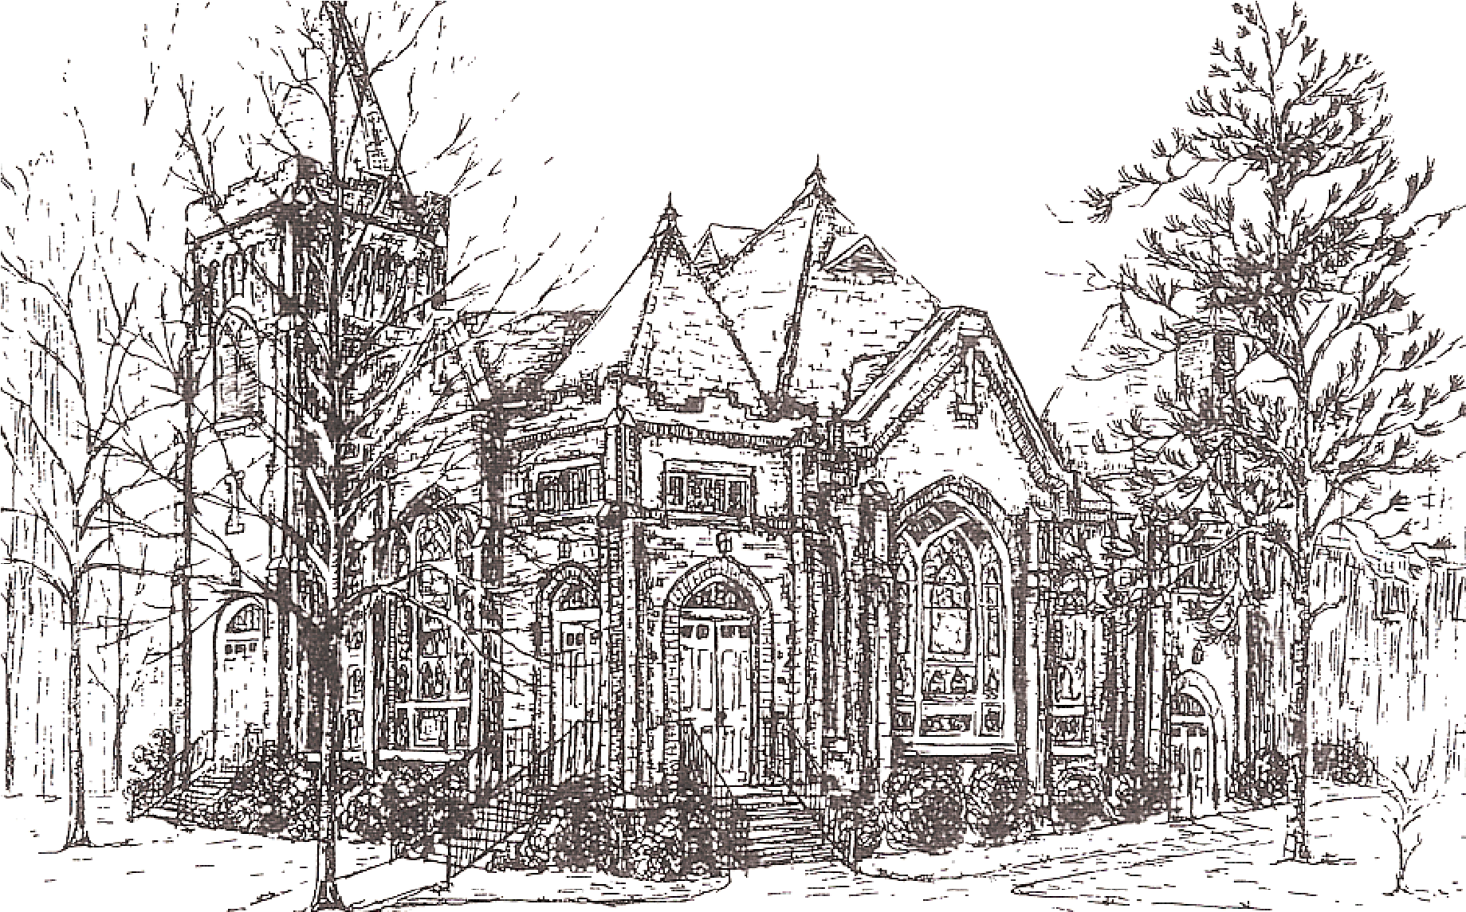

June 7th, 2026

We welcome you not as strangers but as a part of God’s family! We are a community of faith that gathers to praise our Lord and Savior, serve others, search for answers, and enjoy the fellowship of one another. We hope today you will be challenged and discover encouragement. The peace of Christ be with you!

SERVICE FOR THE LORD’S DAY

2nd Sunday after Pentecost June 7th, 2026

GATHERING AROUND GOD’S WORD
Worship begins with the Prelude. Please use this time for silent preparation.

PRELUDE

GREETING AND ANNOUNCEMENTS
Leader: The Lord be with you.
People: And also with you.

CHORAL INTROIT “How Lovely is Your Dwelling Place” Liam Lawton
(Congregation – Please join on the second time)
How lovely is your dwelling place, O Lord, my God!
How lovely is your dwelling place, is your dwelling place, O God!

CALL TO WORSHIP (Responsive) (based on Psalm 33:1.12)
Leader: Rejoice in the Lord! Praise the Lord with instruments and shouts of joy!
People: God loves justice and righteousness. The earth is full of God’s love.
Leader: Let all creation revel in awe of God, our Creator.
People: God’s love endures forever.
Leader: Amen! Let us worship together.

PRAYER OF PRAISE

*HYMN OF ADORATION # 305
“Come Sing, O Church, in Joy!”

*PRAYER OF CONFESSION (Unison)
Holy God, we confess, a bit pridefully, that we appreciate decency and order, forgetting that we seek the order that is of our own making. We confess that clear rules and social norms give us comfort, forgetting how many of your beloved children are hurt and excluded by them. We confess that we place our trust in ability, strength, and the works we produce, forgetting our total reliance on your grace. Forgive us, God, and free us to live in courageous faith, that we may abide in your righteousness. Amen.

*DECLARATION OF PARDON

*GLORIA PATRI
Glory be to the Father, and to the Son, and to the Holy Ghost;
as it was in the beginning, is now and ever shall be,
world without end. Amen, amen.

A MOMENT WITH OUR CHILDREN

*HYMN OF PREPARATION # 450
“Be Thou My Vision”

PRAYERS OF THE PEOPLE AND THE LORD’S PRAYER
…Our Father who art in heaven, hallowed be thy name. Thy kingdom come,
thy will be done, on earth as it is in heaven. Give us this day our daily bread;
and forgive us our debts, as we forgive our debtors; and lead us not
into temptation, but deliver us from evil. For thine is the kingdom and
the power and the glory, forever. Amen.

PROCLAIMING GOD’S WORD

OLD TESTAMENT LESSON Genesis 12:1-9, Page 10

ANTHEM A. H. Brown
“Just As I Am”

NEW TESTAMENT LESSON Matthew 9:9-13, 18-26, page 9
Leader: The Word of the Lord.
People: Thanks be to God.

SERMON The Rev. Karen Allen
“Faith and Mercy Out-of-Bounds”

RESPONDING TO GOD’S WORD

AFFIRMATION OF FAITH Page 35
“Apostles’ Creed”

OFFERING AND OFFERTORY George C. Stebbins “Take Time to be Holy”

*DOXOLOGY Hymn # 606

*PRAYER OF DEDICATION

ORDINATION/INSTALLATION OF OFFICERS
Leader: We are given countless gifts, but it is the same Spirit who gives them.
People: There are different ways of serving God, but it is the same Lord who is
served.
Leader: God works through each of us in unique ways, but it is God’s purpose
that is accomplished.
People: To each of us is given a gift of the Spirit to be used for the common
good.
Leader: Together we are the body of Christ, and individually members of it.

Angie Medlin

Constitutional Questions
Questions to the Congregation
1. Do we, the members of the church accept Angie as a ruling elder, chosen by God through the voice of this congregation to lead us in the way of Jesus Christ? (We do).
2. Do we agree to pray for them, to encourage them, to respect their decisions, and to follow as they guide us, serving Jesus Christ who alone is Head of the Church? (We do).

Prayer of Ordination/Installation
Declaration of Ordination/Installation
Welcome

SENDING GOD’S WORD INTO THE WORLD

*HYMN OF COMMITMENT # 838
“Standing on the Promises”

*CHARGE AND BLESSING

CONGREGATIONAL MEETING

*Please stand if able.

Opportunities for the Week of June 7th – June 14th

Sunday: 8:45 a.m. Sunday School
9:30 a.m. Session Meeting
10:00 a.m. Worship / 2 Cents a Meal / Rev. Karen Allen
11:05 a.m. Congregational Meeting
11:10 a.m. Lemonade on the Lawn
11:15 a.m. Session Meeting

Wednesday: 5:45 p.m. Choir Practice

Sunday: 8:45 a.m. Sunday School
10:00 a.m. Worship Service /Rev. Elizabeth Pope

Announcements

Please take a moment and welcome back Rev. Karen Allen as she brings forth our message.
There was a brief Session meeting today at 9:30 a.m. to examine Angie Medlin who was elected to fill the vacancy on Session in the class of 2027.

The Session called a congregational meeting that will be held today following the worship service for the purpose of hearing a report from the Nominating Committee.

There is also a regularly scheduled Session meeting at 11:15 a.m. today.

We have numerous "basket ministry" bins in the Family Life Center. Please continue to donate items to any of the ministries each month.

The new address for Phillip Warmbrod: Phillip Warmbrod #0762662, Greene Correctional Institution, P.O. Box 247, Phoenix, MC 21131. Please feel free to send a card to Phillip, his scheduled release date is around the end of July.

The flowers in the church are given in the Glory of God by Ann & Joe Lynch.

