First Presbyterian Church

Located in the heart of Carthage, NC
near the Post Office at 110 South Ray Street,
First Presbyterian welcomes you!
(910) 947-2924
infofpc397@gmail.com

www.FpcCarthage.com


Fpc Carthage


#fpcbethelight

The Reverend Rick Martindale Pastor
Ali Wadsworth Choir Director
Elizabeth Williams Organist
Shelley Hammond Administrative Assistant
Andie Hyman Nursery Attendant
Ann Key Sexton
Marie Monroe Treasurer



The Reverend Rick Martindale, Pastor
Shelley Hammond, Administrative Assistant
Ann Key, Sexton
Marie Monroe, Treasurer
Ali Wadsworth, Choir Director
Robert Wilson, Organist

FPC Session
Session Class of 2021 Denise Edmonds, Robert Gordon, Lee McCaskill, Geraldine Moore
Session Class of 2022 Keith Hardin, Elizabeth Martindale, Helen McDonald, Marie Monroe
Session Class of 2023 Lucinda Casey, Tom Leonard, Scott Phillips, Jennifer Thomason

Non-Profit
Organization
U.S. Postage
PAID
CARTHAGE, NC
28327
Permit No. 35
First Presbyterian Church
PO Box 397
Carthage, NC 28327





First Presbyterian Church
A Cornerstone for Christ since 1850.
October 2021News

Make the Most of Your Life

One day in July, a farmer sat in front of his home smoking his corncob pipe. Along came a stranger who asked, “How’s your cotton coming?”
“Ain’t got none,” was the answer. “Didn’t plant none. Afraid of the boll weevil.”
“Well, how’s your corn?” “Didn’t plant none. Afraid of a drought.”
“How about your potatoes?” “Ain’t got none. Scared of tater bugs.”
The stranger finally asked, “Well what did you plant?”
“Nothin’,” answered the farmer. “I just played it safe.”

This reminds me of the Luke parable of the slaves that were each given money while their master was away (Luke 19:11-27). The first slave took a pound and made ten more pounds. The second slave took his pound and made five more pounds. The third slave wrapped up his money and kept it hidden until the master returned.

Playing it safe or doing nothing at all are not good options for us as Christians. Each farmer takes a chance when they plant their crop. Many bad things could happen, but the goal is a healthy, full crop. Not planting is simply wasting the opportunity.

The parable of the ten pounds conveys the story when two take what they are freely given and do amazing things, increasing what they had many times over. They did not allow fear to grip their decision making. It’s safe to say, they didn’t ignore fear but tried their best to make wise decisions – and succeeded!

The third person believes his master is a harsh man and was afraid to even try to create more. He didn’t even invest his money in something very secure like in a bank to gain interest. Fear clouded his judgement.

We are not called to play it safe or live in fear. We are called to trust our Master who walks with us and guides us. We are to love those that others won’t love. We are to offer compassion to those who aren’t afforded compassion. We are to embody a way of life that we would like to have if we were on the receiving end. Playing it safe or living in fear only thwarts the opportunities God has given each of us to positively impact the lives of others.

Grace and Peace,
Rick

First Pres prays for you.
Remember our brothers and sisters in Christ through prayer as they face difficult times.

Debbie Albright Family of Jean Bennett
Anna Belle Campbell Kayla Carter and family
Benny Cole Susan Cole and family
John Currie, Tara Plantation Margaret Leonard
Carol Lucas Linda McCaskill
Nancy McKenzie Gail Meeks
Max Muse, Pinelake Linda Myrick and family
Ina Sue Parks Kay Patterson
Judy Phillips, Accordius, Aberdeen Herman Seawell
Tom Stewart Phillip Warmbrod

Artie Barber, friend of the Monroes
Terry Barber, friend of the Monroes
Bo, friend of Geraldine Moore
Karen Bryant, friend of JoAnn Wahala
Ken Cameron, friend of the Martindales
Judy Claterbos, Mary Thomas’ sister
Jack Denniston, Lucinda and David’s daughter-in-law’s father
June Greeson, Susan Cole’s mother
Ann Herndon, Kay Patterson’s sister
Johnathon Johnson, Geraldine Moore’s grandson-in-law
Sean Kennally, Angie Provost’s son-in-law
Molly Lowry, wife of Jerrod Lowry
Barbara May, friend of Debbie Gordon
Jane Medlin, Carol Lucas’ daughter
Lisa Muller, Cousin of Ina Sue Parks

All of our military men and women and their families, especially the following:
Michael Abercrombie, Jonathan Baker, Kyle Bryant, Jack Mason, Chris Mohan,
Patrick Mohan, Greg Riyevski, Michael Schwartz, and Quinn Wicker.

To add someone or take yourself off this list, please call the church office at 947-2924.
FPC Stewardship & Finance
August 2021
OPERATING FUNDS:
Balance in checking account as of Aug 1, 2021 | 85,195.66
Tithes and Offerings Received | +15,004.00
Sub-Total | 100,199.66
Expenditures | -10,333.45
Balance in checking account as of Aug 31, 2021 | 89,866.21
RESTRICTED FUNDS: (Funds designated for specific projects, etc.)
Restricted Funds held in checking account as of Aug 1, 2021  Employee FICA & w/holding taxes for Aug 2021  Donations/offerings received (2ȼ a Meal $248.86; Bldg Fd $100; Playground $50; Presbyterian Women $340; Memorials $350) | 104,662.19  +329.62  +1,088.86
Sub-Total | 106,080.67
Expenditures: Military Support Mission/Student-2-Student at UP | -273.82
Balance in Restricted Funds as of Aug 31, 2021 | 105,806.85
RECAP:
Operating Funds Balance | 89,866.21
Building Fund: Equip 93.54 + Grant 500.00 + Other 76,997.97 + 100.00= | +77,691.51
Restricted Funds Balance | +28,115.34
 | 195,673.06
July-Aug '21 Payroll Taxes on hand (FICA 535.86; FW/H 52.00 + .04 excess) | -587.90
8/31/2021 Checkbook Balance | 195,085.16
OTHER REVENUES ON HAND:
Scholarship C/D with BB&T  Truist Financial Corp, Estimated value (4 shs) | 23,040.37  +221.32
Total Other Revenues on hand | 23,261.69

FPC Calendar October 2021 Family Life Center (FLC) Conference Room (CR)

Saturday, October 2nd 7:30 a.m. Robbins’ Food Bank, meet 7 a.m. at FPC to carpool

Sunday, October 3rd 10:00 a.m. Sunday School
11:00 a.m. Multiple Indoor Worship Experiences / Virtual /
World Communion Sunday / 2 Cents a Meal
Offering
4:00 p.m. Sunday Funday!, ages 4 through 6th grade
5:00 p.m. Youth Group, grades 7-12

Thursday, October 7th 11:00 a.m. Women’s Day Circle & Bible Study (FLC)

Saturday, October 9th 9:30 a.m. Presbytery Meeting

Sunday, October 10th 10:00 a.m. Sunday School
11:00 a.m. Multiple Indoor Worship Experiences / Virtual
2:00 p.m. Session Meeting
5:00 p.m. Youth Group, grades 7-12
6:45 p.m. Nominating Committee

Monday, October 11th 5:30 p.m. RACM Board Meeting (Robbins)

Saturday, October 16th Wedding

Sunday, October 17th 10:00 a.m. Sunday School
11:00 a.m. Multiple Indoor Worship Experiences / Virtual
5:00 p.m. Youth Group, grades 7-12

Monday, October 18th Deadline for November Church Mouse Newsletter

Sunday, October 24th 10:00 a.m. Sunday School
11:00 a.m. Multiple Indoor Worship Experiences / Virtual
5:00 p.m. Annual Church Picnic (outdoors)

Sunday, October 31st 10:00 a.m. Sunday School
11:00 a.m. Multiple Indoor Worship Experiences / Virtual
Halloween

_____________ FPC Connect News & Announcements___________

Thank you
The Greeson Family extends their thanks for the kind thoughts, prayers, phone calls and cards. My brother, Carl, passed away on August 9, 2021 after two years of declining health.
A graveside service to celebrate his life will be held on Friday, October 8th, at Springwood Presbyterian Church Cemetery, Whitsett, NC.
May God's love bring our family strength and peace.
Susan G Cole

Children ages 4 through 6th grade, join us on the first Sunday of every month
from 4-5 p.m. for our new “Sunday Funday” – beginning October 3rd with a pumpkin painting party! Be sure to invite a friend!

Join us for food, fun and fellowship
at our annual Church Picnic,
5 p.m., October 24th.
Come enjoy the fresh, fall air together!

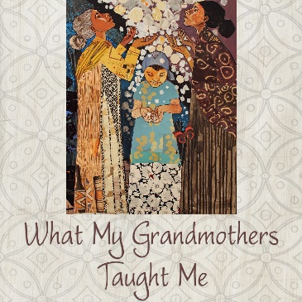
It’s not too late to join us for our new Bible study,
“What My Grandmothers Taught Me,”
on the first Thursday of the month at 11 a.m. in the
multipurpose room of FPC’s Family Life Center.
For a study book, please contact
Helen McDonald at hmcd2946@gmail.com or 690-2463.
See you October 7th!

The session did need not meet last month because of Rick being diagnosed with COVID. We will meet next week.

We’re in need of a Nursery Attendant to provide nurturing child care on Sundays from 10:30 a.m. to 12:15 p.m. If you love creating a happy, safe environment for our children, while sharing the love of Jesus, please see Lucinda Casey or Lee McCaskill. Salary is $40 each Sunday and CPR Certification and complete COVID-19 Vaccination is required.


FPC Basket Ministries & Mission
OCTOBER & NOVEMBER FOCUS
_____________________________________________________________________________

FPC’s Family Life Center Donation Station
serves as a year-round collection site
for local missions and ministries.
Please consider donating any of the following items:

raisins, crackers, double-bagged plastic grocery bags, puzzles, word searches, adult coloring books, pens,
colored pencils, crayons, calendars, Little Debbie Cakes, healthy snacks, Biotin products, prayer shawls, toiletries, small radios, bird feeders, games, pajamas, sweats, socks,
hair accessories, blankets, chapstick, back scratchers,
non-perishable foods, instant mashed potatoes, etc.

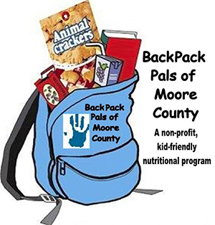

FPC Youth will begin packing OCC shoeboxes soon!
Please donate items for girls and boys ages 2-14 including: socks, underwear, shirts, washcloths, soap, crayons, coloring books, small toys, and small musical instruments, as well as
plastic shoe box size containers.

National Collection Week – November 15-22.

Youth will volunteer at an OCC Processing Center in Boone or Charlotte in November or December!


Sanctuary Flowers
Given to the Glory of God!
October 3rd Helen and CJ McDonald
October 10th Ina Sue and Denise Parks
October 17th Given in honor of Anna Belle’s 99th birthday
October 24th Jeannie and Max Muse
October 31st Megan and Scott Phillips

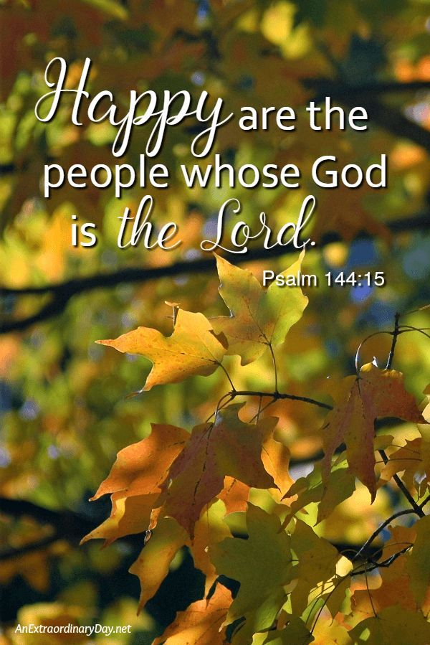
Happy Birthday!
2 Angie Prevost
4 Laura Gordon Faircloth
6 Catherine Martindale
6 Elizabeth Martindale
9 Ben White
13 Bill Thomas
15 Jacob Adelmann
15 Helen McDonald
15 Leon Monroe
15 Matthew Monroe
16 Jennifer Prevost Kennally
17 Jeannie Muse
18 Anna Belle Campbell
21 Caroline Carter Reynolds
21 Mack McDonald
22 Max Muse
24 Kim Kelly
27 Elizabeth Barringer
27 Gabe Phillips
31 Hammond Bennett


Advent Poinsettias
Poinsettias in honor or in memory of a loved one may be placed in the Sanctuary during the season of Advent Sunday, November 28th, through Sunday, January 2nd.
If you would like to place a poinsettia, please contact the church office with your loved one’s name by November 15th at 947-2924, or infofpc397@gmail.com.



Mark your calendars!

We’re kicking off our new
2021-2022
Ladies Bible Study
“What My Grandmothers Taught Me”
… with a guest speaker!

Monday, August 2nd
6:30 p.m.

Look for more details later this month!

For a study book please
call or email Helen McDonald at
690-2463 or hmcd2946@gmail.com.



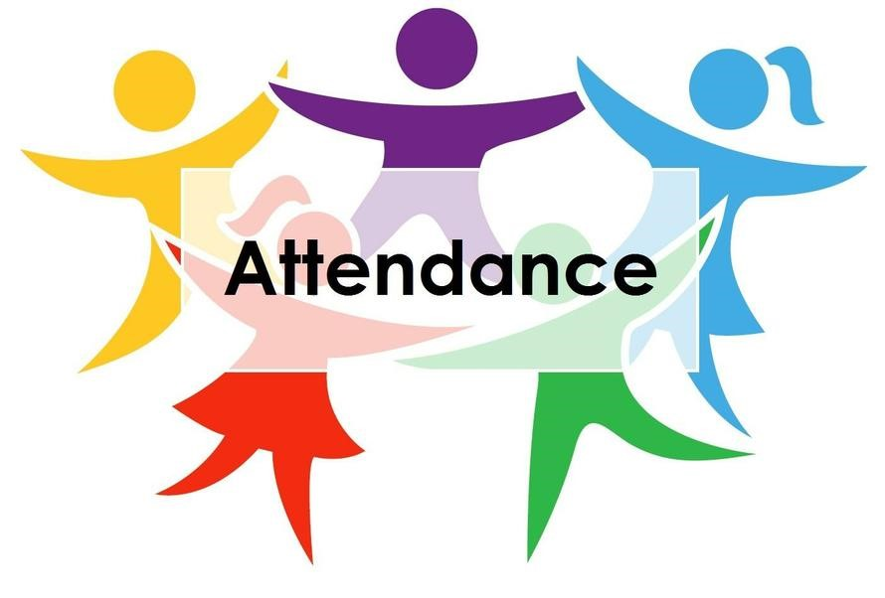
First Presbyterian
A cornerstone for Christ since 1850.

11 a.m. Service began 8/22.
Sunday School on 8/29 had an attendance of 14.

8/1 49
8/8 31
8/15 33
8/22 44
8/29 52
Average 42

