Class of 2019
Lucinda Casey
Cristy Dean
Scott Phillips
Paul White

Class of 2020
Doris Russell
Chad Thomason
Michelle Tortora
JoAnn Wahala

Class of 2021
Denise Edmonds
Robert Gordon
Lee McCaskill
Geraldine Moore

The Reverend Rick Martindale Pastor
Ali Wadsworth Choir Director
Elizabeth Williams Organist
Shelley Hammond Administrative Assistant
Andie Hyman Nursery Attendant
Ann Key Sexton
Marie Monroe Treasurer

Ruth Craig Interim Pianist
Non-Profit
Organization
U.S. Postage
PAID
CARTHAGE, NC
28327
Permit No. 35

FIRST PRESBYTERIAN CHURCH
POST OFFICE BOX 397
CARTHAGE, NORTH CAROLINA 28327
(910) 947-2924
fpccarthage.com (website)
infofpc397@gmail.com (email)

Octoberinto faith
First Presbyterian Church News

What’s Happening?
Good communication is vital in any healthy relationship. It doesn’t matter if you are siblings, friends, co-workers, belong to the same club, married, etc. Without effective communication your relationship with another is going to struggle and ultimately falter.

In the life of FPC, good or effective communication is vital. Years ago, the session decided to spend approximately $500/annually to use One Call Now, the automated message program we use to receive updates on what is happening in the life of the church.

We also use our website and Facebook page to share information with a much larger audience. These are great tools to help communicate what is taking place at FPC. Another tool that we use is our church newsletter, lovingly known as the Church Mouse. Shelley, our Administrative Assistant, has done a great job in updating not only the Church Mouse but also our electronic means of communication.

We are always trying, as a church staff, to do a better job of keeping you aware of what is taking place in the church. I’ve been wondering since the beginning of the year about adding a new column in the Church Mouse concerning the actions of the session. It was confirmed recently that it is time to make this a reality.

Beginning next month start looking for bullet points or a list of actions decided upon by the session. As most of us know, it is the session that decides what takes place at FPC. What will FPC be doing in the fall, winter, spring, or summer? What changes are going to be implemented? What ministries and opportunities are we going to be involved in as a church? I will probably try to add a question or statement to help you better understand the scope or what the session does for God’s church at 110 South Ray Street. For example, how often does the session meet? Stay tuned for the answer, it might surprise some of you. 😊

If you think of new and better ways for us to communicate, please share them. May God bless each of you this month as we work to do a better job of communicating with one another…and with our Lord and Savior.

 Grace and Peace,

Rick

In Our Prayers
Please remember our sisters and brothers in your prayers as they face difficult times.

Jean Bennett – Quail Haven Jimmy Bibey Anna Belle Campbell
John Currie – Tara Plantation Betty Elliott Sheree Kelly Margaret Leonard Carol Lucas Jim Lucas
Nancy McKenzie Pat Nugent Regena Nugent Dennis Parks Ina Sue Parks Kay Patterson
Otis Patterson Scott Rives Bonnie Scott Phillip Warmbrod

Linda Ammons, Jim Phillip’s sister
Tony Bibey, Jimmy Bibey’s son
Karen Bryant, friend of JoAnn Wahala
Dean Cameron
Wife of Larry Cockman, friend of Benny Cole
James Cox, friend of Kelly Martindale
Robert Davis
Jimmie Garner, Joan Power’s father
Carl Greeson, Susan Cole’s brother
June Greeson, Susan Cole’s mother
Ann Herndon, Kay Patterson’s sister
Nikki Hollandsworth, Michelle Lester’s cousin
Zack Isom, Diane Pangborn’s son
Aaron Ladmin
Maxine Lawson, Elizabeth William’s sister
Rexine Lloyd, Kelly Martindale’s mother
Vince Mann, friend of the Leonards
Garin Parker, Barbara Danley’s nephew
Kimberly Sanders and Family
Hunter Smith
William Stutts, Bonnie Scott’s brother-in-law
Skip Vann, Jim Phillip’s brother

All of our military men and women and their families, especially the following:
Jonathan Baker, Kyle Bryant, Chris Mohan, Patrick Mohan, Gregory Riyevski,
Will Strickland, and Quinn Wicker.

To add someone or take yourself off this list, please call the church office at 947-2924.


Attendance Sunday School Worship

August 4th 32 84
August 11th 39 69
August 18th 40 70
August 25th 40 90
Average 38 78

to First Presbyterian

AUGUST FINANCIAL REPORT

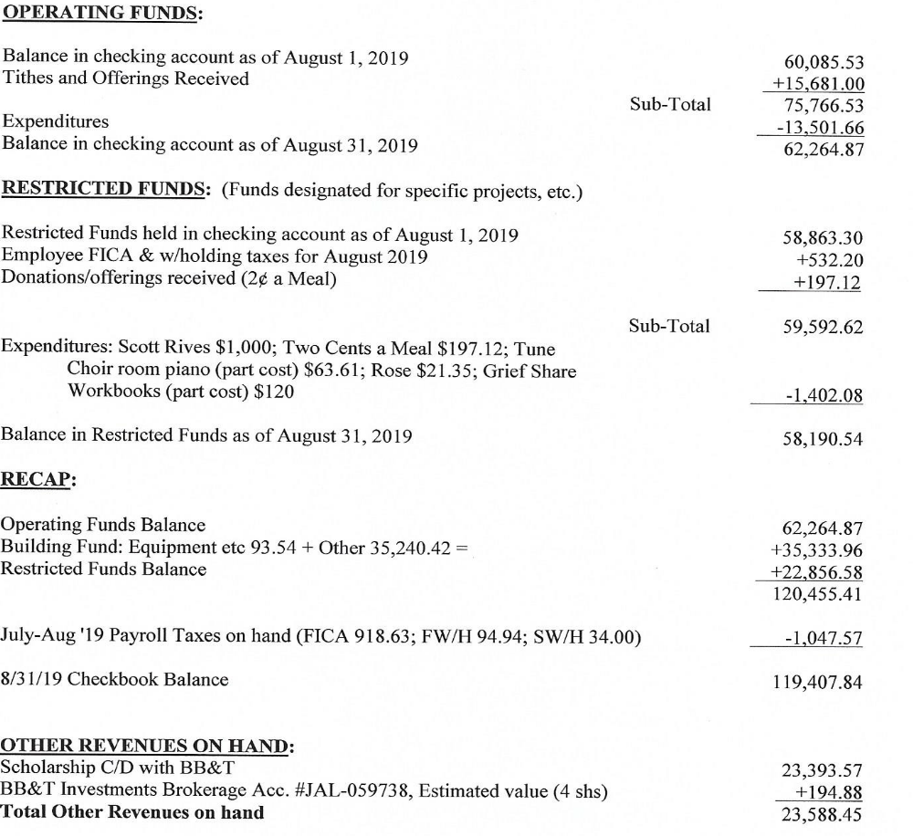

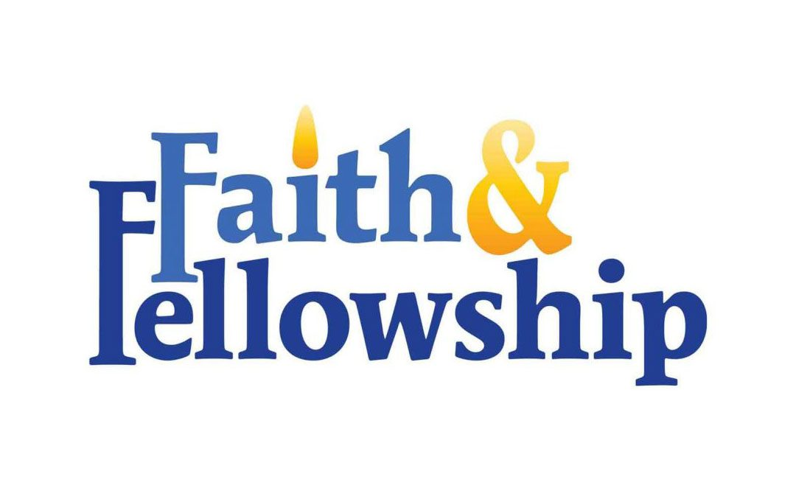
Presbyterian Women

We are excited!!!!!!

Our new evening Circle will meet on Thursday, October 10th at 6:30 p.m. in the conference room. Let Tina Stromko know if you are interested.

The Day Circle will meet on Thursday, October 3rd at 11:00 am in the conference room.

Our Bible study this year is Love Carved in Stone: A Fresh Look at the Ten Commandments by Eugenia Gamble. Please join us.


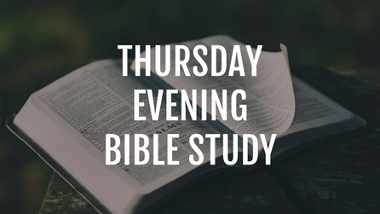

October 17th 11:30 a.m.
Mrs. Lacy’s Magnolia House
405 Carthage St., Sanford
Meet at FPC at 11 a.m.
to carpool. If you need a
ride, please call Helen at
690-2463.

Receive PW news.
Help in times of need.
Discover fellowship with purpose.
Text/call (910) 690-2463, or email hmcd2946@gmail.com.



5:00 p.m. Wednesdays


5:30 p.m. Sundays
7th-12th grades meet Sunday evenings at 5:30 p.m. in the FPC Family Life Center to have fun, be challenged, plan local mission projects, and explore what it means to be a Christian.



October 22nd 6 p.m.
When you are grieving a loved one's death, the holiday season can be especially painful. GriefShare's Surviving the Holidays seminar helps participants discover how to deal with emotions; what to do about traditions; helpful tips for surviving social events;
and how to find hope for the future.

During the school year, our children meet on Wednesday nights for a meal, a fun time learning about the Bible, crafts, music, and games for ages 4-6th grade!

11 a.m.
1st Thursdays
10/3, 11/7, 12/5

​Morning Bible Study Circle Dates:

11 a.m.
10/3, 11/7, 12/5
Morning Circle 1st Thursdays

6:30 p.m.
2nd Thursdays
10/10, 11/14, 12/12



Fall Festival
Saturday October 12th 9am-3pm

8-noon






11am-3pm


11am-1pm
Live Music &



$5 activity wristbands



spot
Updates from our Fall Fest Organizers
Come participate in the fun, and tell your friends and family about this special FUN-raiser! 70% will help with needed church repairs - 30% will go to Carthage & Robbins Food Banks. See Doris for 8.5x11 posters and 4x6 cards to help spread the word, or stop by the church office.

Start setting up and decorating in the FLC beginning the morning of Oct. 7th!

From The Bakery Team: Cakes, pies, cookies, candies, sausage balls, breads, jams and jellies, pickles and other canned goods are needed. Contact Susan Cole, Bakery Chair at 947-5764 or sgcole@embarqmail.com to signup your delicious goodies right away. Thanks for your contributions!

Silent Auction Items needed. FPC families, please donate at least one Silent Auction item. Be sure to email 502mcduffy@gmail.com, or call Susan Phillips at 947-2637 with the donor’s name and value of your item.

Enter our first annual Chili Cook-Off. Each ticket sold at our Fall Festival will include chili samples and a bowl of their favorite recipe. The team with the most fan-favorite tickets wins bragging rights and a trophy. Contestants are encouraged, not required, to name their chili and decorate their table for the “best booth theme and decorations” prize! Contact mrs.jenniferthomason@gmail.com.

-Now selling! Fall Fest Amish Quilt raffle tickets for $5, and 50/50 raffle tickets for $1.

-Donate your Holiday Spot, Plant Sale, and Yard Sale items. We can help pick up larger items for you closer to October 12th due to church storage space.

Volunteers are still needed the day of the festival to help with morning set up, working at festival booths, relieving workers to enjoy festival activities, and with cleanup.

Octoberinto faith
*The FPC Family Life Center will be reserved Monday, October 7th – Monday, October 14th for the Fall Festival.

Wednesday, October 2nd Christian Faith Yoga – 8:45 a.m. Floor, 10:15 a.m. Chair 5:30 p.m. What’s Up Wednesday (ages 4-6th grade)
Thursday, October 3rd 11:00 a.m. PW Circle & “Loved Carved in Stone” Bible study
7:00 p.m. Praise Team practice
Saturday, October 5th 7:30 a.m. Robbins’ Food Bank (meet at FPC to carpool)
Please donate your plastic grocery bags in the FLC.
Sunday, October 6th 9:00 a.m. Fellowship and Mission Committee (conference room)
9:45 a.m. Sunday School
11:00 a.m. Contemporary Worship Service (Family Life Center)
5:00 p.m. Youth Group (grades 7-12)
Wednesday, October 9th 5:30 p.m. What’s Up Wednesday (ages 4-6th grade)
7:00 p.m. Choir practice
Thursday, October 10th 6:30 p.m. Evening Women’s Circle Bible Study (conference room)
Saturday, Oct. 12th 9 a.m. – 3 p.m. FPC Fall Festival
Sunday, October 13th 9:00 a.m. Worship Committee (conference room)
9:45 a.m. Sunday School
11:00 a.m. Worship
2:00 p.m. Session meeting
5:00 p.m. Youth Group (grades 7-12)
Monday, October 14th 6:30 p.m. RACM Board Meeting
Wednesday, October 16th Christian Faith Yoga – 8:45 a.m. Floor, 10:15 a.m. Chair
5:30 p.m. What’s Up Wednesday (ages 4-6th grade)
7:00 p.m. Choir practice
Thursday, October 17th 11:30 a.m. Ladies’ Lunch, Mrs. Lacy’s Magnolia House, Sanford
7:00 p.m. Praise Team practice
Sunday, October 20th 9:45 a.m. Sunday School
11:00 a.m. Communion Worship Service
5:00 p.m. Youth Group (grades 7-12)
Monday, October 21st Christian Faith Yoga – 8:45 a.m. Floor, 10:15 a.m. Chair
Tuesday, October 22nd Deadline for November Mouse church newsletter
6:00 p.m. GriefShare “Surviving the Holidays” event (Family Life Center)
Wednesday, October 23rd Christian Faith Yoga – 8:45 a.m. Floor, 10:15 a.m. Chair
5:30 p.m. What’s Up Wednesday (ages 4-6th grade)
7:00 p.m. Choir practice
Thursday, October 24th 7:00 p.m. Praise Team practice
Sunday, October 27th 9:45 a.m. Sunday School
11:00 a.m. Worship
5:00 p.m. Youth Group (grades 7-12)
Monday, October 28th Christian Faith Yoga – 8:45 a.m. Floor, 10:15 a.m. Chair
Tuesday, October 29th 1:00 p.m. Fold Mouse Newsletter (conference room)
Wednesday, October 30th Christian Faith Yoga – 8:45 a.m. Floor, 10:15 a.m. Chair
5:30 p.m. What’s Up Wednesday (ages 4-6th grade)

October
Happy Birthday!

2 Angie Prevost
4 Laura Gordon Faircloth
6 Catherine Martindale
6 Elizabeth Martindale
9 Ben White
15 Jacob Adelmann
15 Helen McDonald
15 Leon Monroe
15 Matthew Monroe
16 Jennifer Prevost Kennally
17 Jeannie Muse
18 Anna Belle Campbell
21 Caroline Carter Reynolds
21 Caroline Lucas
21 Mack McDonald
22 Max Muse
24 Kim Smith
27 Elizabeth Barringer
27 Gabe Phillips
31 Hammond Bennett




Greeters
6 Pat Nugent
13 Angie and Jeff Medlin Family
20 Carol and Paul White
27 Ashley Bibey and Michael Bullins

Ushers
Michelle Tortora, lead usher
Robert Gordon
Scott Phillips
Doris Russell

Flowers
6 Jennifer & Chad Thomason Family
13 Ann Lynch
20 Sarah Seawell
27 Tracy & Bill Thomas

To place flowers – a beautiful example of God’s creation – in Sunday worship, call Susan Cole. 947-5764.

