Class of 2019
Lucinda Casey
Cristy Dean
Scott Phillips
Paul White

Class of 2020
Doris Russell
Chad Thomason
Michelle Tortora
JoAnn Wahala

Class of 2021
Denise Edmonds
Robert Gordon
Lee McCaskill
Geraldine Moore

The Reverend Rick Martindale Pastor
Ali Wadsworth Choir Director
Elizabeth Williams Organist
Shelley Hammond Administrative Assistant
Andie Hyman Nursery Attendant
Ann Key Sexton
Marie Monroe Treasurer

Ruth Craig Interim Pianist
Non-Profit
Organization
U.S. Postage
PAID
CARTHAGE, NC
28327
Permit No. 35

FIRST PRESBYTERIAN CHURCH
POST OFFICE BOX 397
CARTHAGE, NORTH CAROLINA 28327
(910) 947-2924
fpccarthage.com (website)
infofpc397@gmail.com (email)

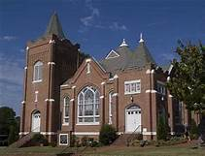FIRST PRESBYTERIAN CHURCH



AUGUST 2019

Things Are Starting to Gear Back Up
The summer months are quickly coming to an end. School will officially start on Monday, August 26th. Yay!! Between now and then many of our young families might find themselves away before school draws us back together. That’s nothing new.

We have, however, been worshipping at 10 a.m. for the last many weeks, and this coming Sunday we will move back to our normal 11 a.m. worship hour. Our Children’s Church, during worship, will also be coming to an end. This was something new. If you liked it, please share it with our Christian Education Committee.

Sunday School is back in session for all ages starting this month. We will gather at 9:45 a.m. with singing, prayer concerns, birthdays, and announcements led by J.D. Monroe. Sunday School classes begin at 10 a.m. All the children and youth classes meet on the top floor of the education building. There are two adult classes that meet as well. One meets in the library, while the other meets downstairs in the fellowship hall. Come join us.

Speaking of other news, know that our new pictorial directory is out! If you had your picture taken or a picture submitted, please stop by the church to pick up your directory. You can pick it up Sunday before or after worship as well. Bill Russell and his committee did a great job!

We have set August 25th as our next congregational meeting after worship to hear from the Nominating Committee. During that meeting we will elect two people to serve on the 2022 Cemetery Committee, as well as four people to serve as elders for the class of 2022.

May you find great joy this month as traditions come and go, and new activities stop and begin. We are God’s church, which is constantly moving and doing something new!

Grace and Peace,

Rick
In Our Prayers . . .
Please remember our sisters and brothers in your prayers as they face difficult times.

If you would like to add someone or take yourself off this list, please call the church office at 947-2924.

Jean Bennett – Quail Haven Jimmy Bibey Anna Belle Campbell
John Currie – Tara Plantation Betty Elliott Judi Kelly
Sheree Kelly Margaret Leonard Carol Lucas
Jim Lucas Nancy McKenzie Pat Nugent
Regena Nugent Dennis Parks Ina Sue Parks
Kay Patterson Scott Rives Serge Riyevski
Bonnie Scott Phillip Warmbrod

Linda Ammons, Jim Phillip’s sister
Dean Cameron
James Cox, friend of Kelly Martindale
Robert Davis
Christopher Freeman, Maria Bigger’s grandson
Jimmie Garner, Joan Power’s father
Carl Greeson, Susan Cole’s brother
June Greeson, Susan Cole’s mother
Ann Herndon, Kay Patterson’s sister
Zack Isom, Diane Pangborn’s son
Aaron Ladmin
Maxine Lawson, Elizabeth William’s sister
Rexine Lloyd, Kelly Martindale’s mother
Vince Mann, friend of the Leonards
Garin Parker, Barbara Danley’s nephew
Kimberly Sanders and Family
Hunter Smith
William Stutts, Bonnie Scott’s brother-in-law
JoAnne Thompson, Keith Hardin’s mother
Skip Vann, Jim Phillip’s brother

All of our military men and women and their families, especially the following:
Jonathan Baker, Chris Mohan, Patrick Mohan, Gregory Riyevski,
Will Strickland, and Quinn Wicker.


After he had washed their feet, had put on his robe, and had returned to the table, he said to them, “Do you know what I have done to you? You call me Teacher and Lord – and you are right, for that is what I am. So if I, your Lord and Teacher, have washed your feet, you also ought to wash one another’s feet. For I have set an example,
that you should do as I have done to you.”
John 13: 14-15

JUNE FINANCE REPORT
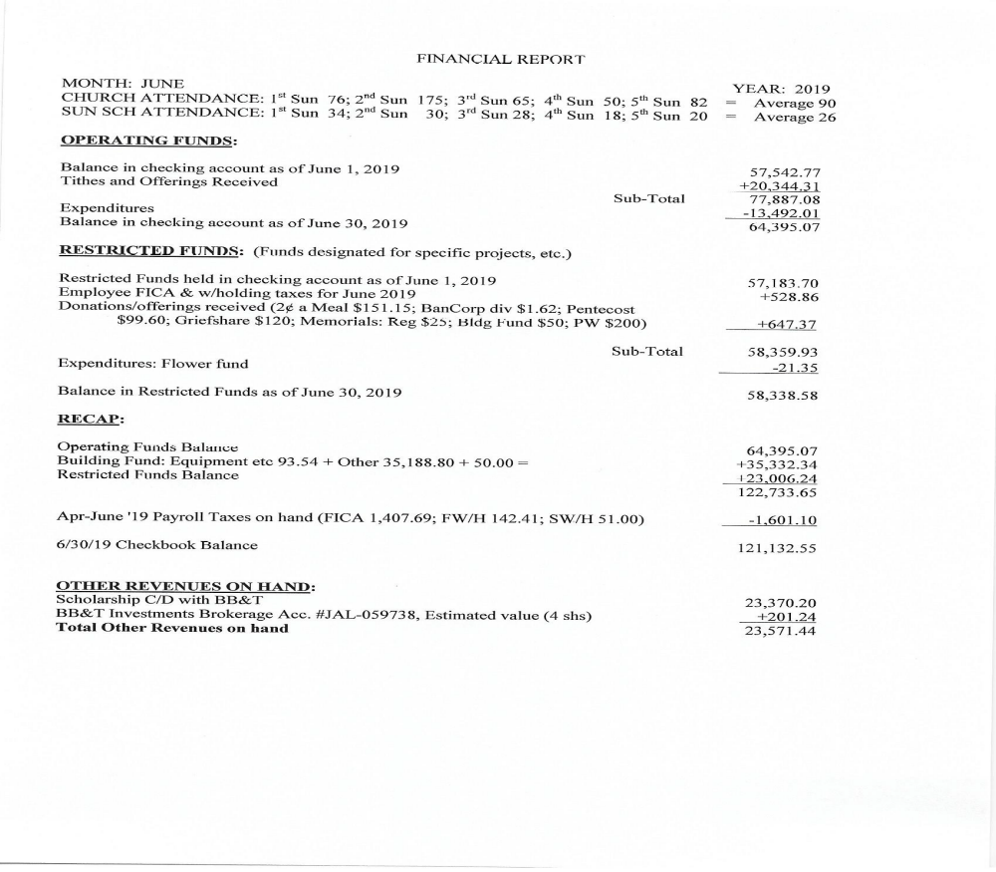
ATTENDANCE CHURCH SUNDAY SCHOOL
 1st Sunday 6/2 76 34
2nd Sunday 6/9 175 30
3rd Sunday 6/16 65 28
4th Sunday 6/23 50 18
5th Sunday 6/30 82 20
Average 90 26

Choir and Praise Team
Practices are
on Wednesdays through September 4th.
6:00 p.m. Choir
7:00 p.m. Praise



Carthage Elementary


Through mid-August in our Family Life Center

October 12th 9 a.m. – 3 p.m.

Kids Zone Chili Cook Off Lunch
Bake Sale The Holiday Spot
Yard Sale Plant Sale
Kona Ice Buggy Town Coffee
Music Silent Auction

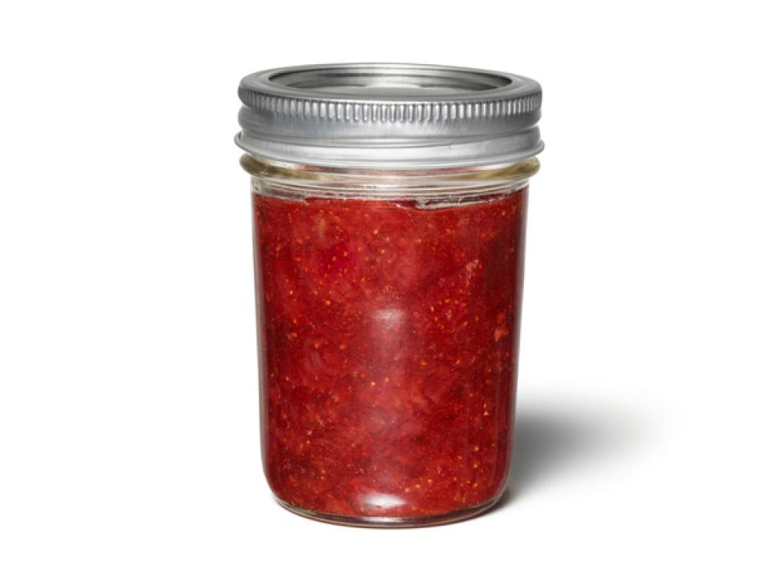

Plan to join us for the festival by helping and participating!
Volunteers are needed to post flyers in places you frequent, and to help with setup, tear down, decorating, and station rotations.


Lemonade on the lawn

August 11th After church


Team-winning recipes needed!
Form a team
Name your chili
Make a large batch
Theme-decorate your booth
Give out samples
Collect the most fan-favorite tickets and…
Win bragging rights and a trophy! Interested? Contact Paul White, Scott Phillips or Jennifer Thomason mrs.jenniferthomason@gmail.com.


Tickets only $1!
Help raise funds for church repairs and local food banks. See Denise Edmonds or Gail and Keith Hardin for tickets.

September 29th

Volunteers needed!
Sign-up in the lower narthex
to setup grill, cleanup, in the kitchen, or to provide baked beans, cookies, brownies or homemade ice cream.

POPULAR SALE ITEMS canned and baked goods
Remember to make extra!

 Receive PW news.
Help in times of need.
Discover fellowship with purpose.
Call (910) 690-2463, or email hmcd2946@gmail.com.
*******************************************************************************

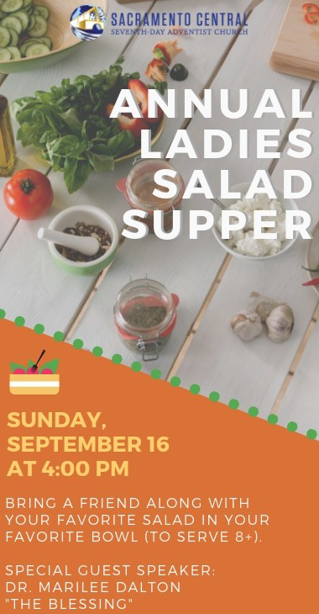
Invite your friends and family to our annual PW Salad Supper!
Monday, August 5th, at 6:00 p.m. in our Family Life Center
Bring your favorite salad to share and after a wonderful meal learn from our guest speaker about one of the fastest growing crimes in Moore County –
human trafficking. Designed for adults and those who are in middle school
or above, you’ll be informed of what to watch for and how we can protect
all children, including our own. Childcare is available for younger children.
Contact Helen McDonald by August 4th to reserve your childcare spot.


Food Fellowship Fun
August 15th
Aroma Café
Noon

Presbytery of Coastal Carolina Presbyterian Women
Annual Fall Gathering
Saturday, August 17th
at Laurinburg Presbyterian Church
St. Andrews Professor Dr. Tanner Capps, who will also do a workshop during our upcoming Bible Study, is the event’s guest speaker.
Registration is from 8:30 – 9:15 a.m. 600 West Church St., Laurinburg



11:00 a.m. 1st Thursdays of the month, beginning September 5th
This fall take a fresh look at the Ten Commandments with Eugenia Gamble’s “Love Carved in Stone.”
To order your copy, email Marie at mmonroe@pinehurst.net.

We’d love to start an evening Circle.
Would you?
See Helen McDonald if interested!

 school supply drive * raffle fundraiser * Salad Supper * & so much more!

Thursday, August 1st 10:00 a.m. Community Bible Study (Aroma Café)
Sunday, August 4th 9:00 a.m. Fellowship and Mission Committee (conference room)
9:45 a.m. Sunday School
11:00 a.m. Contemporary Worship Service (Family Life Center)
Monday, August 5th Christian Faith Yoga – 8:45 a.m. Floor, 10:15 a.m. Chair
6:00 p.m. Presbyterian Women’s Annual Salad Supper (FLC)
Tuesday, August 6th 6:00 p.m. GriefShare, “Stuck” (FLC)
Wednesday, August 7th Christian Faith Yoga – 8:45 a.m. Floor, 10:15 a.m. Chair 6:00 p.m. Choir practice
Thursday, August 8th 10:00 a.m. Community Bible Study (Aroma Café)
Saturday, August 10th 7:30 a.m. Robbins’ Food Bank
Sunday, August 11th 9:00 a.m. Worship Committee (conference room)
9:45 a.m. Sunday School
11:00 a.m. Worship
12:00 p.m. Lemonade on the Lawn
2:00 p.m. Session meeting
Monday, August 12th Christian Faith Yoga – 8:45 a.m. Floor, 10:15 a.m.
Tuesday, August 13th 6:00 p.m. GriefShare, “Lessons of Grief” (FLC)
Wednesday, August 14th Christian Faith Yoga – 8:45 a.m. Floor, 10:15 a.m. Chair
6:00 p.m. Choir practice
7:00 p.m. Praise Team practice
Thursday, August 15th 10:00 a.m. Community Bible Study (Aroma Café)
12:00 p.m. Ladies Lunch at Aroma Café
Saturday, August 17th 8:30 a.m. Presbytery Women’s Fall Gathering, Laurinburg
Sunday, August 18th Last day of School Supply Drive for Carthage Elementary
9:45 a.m. Sunday School
11:00 a.m. Communion Worship Service
Monday, August 19th Christian Faith Yoga – 8:45 a.m. Floor, 10:15 a.m. Chair
Tuesday, August 20th Deadline for September Mouse church newsletter
6:00 p.m. GriefShare, “Lessons of Grief” cont. (FLC)
Wednesday, August 21st Christian Faith Yoga – 8:45 a.m. Floor, 10:15 a.m. Chair
6:00 p.m. Choir practice
7:00 p.m. Praise Team practice
Sunday, August 25th 10:00 a.m. Fall Sunday School Kickoff covered-dish breakfast (FLC)
11:00 a.m. Worship Service
Monday, August 26th Christian Faith Yoga – 8:45 a.m. Floor, 10:15 a.m. Chair
Tuesday, August 27th Fold Mouse Newsletter (conference room)
6:00 p.m. GriefShare, “Heaven” (FLC)
Wednesday, August 28th Christian Faith Yoga – 8:45 a.m. Floor, 10:15 a.m. Chair
7:00 p.m. Praise Team practice

Happy Birthday!
1 Ashton Monroe
3 Ruth Tyson
5 Aubrey Tortora
6 John McDonald
6 Tom Stewart
7 Marie Monroe
9 Ruby Ingold
9 Ashley Bibey
11 Sheree Kelly
11 Gail Meeks
15 Carl Nunnery
16 Jeff Key
17 Will Thomason
21 Ty White
22 Meredith Marshburn
22 Linda McCaskill
24 Megan Baker
25 Denise Edmonds
27 Rick Martindale
29 Alex Thomason

Update us with church-family
birthdays anytime.
(910) 947-2924 infofpc397@gmail.com.

USHERS
Chad Thomason*
Geraldine Moore
Lucinda Casey
JoAnn Wahala
*Lead Usher

GREETERS
4 Denise Edmonds
11 Dennis Parks
18 Debbie and Robert Gordon
25 Ruby Ingold

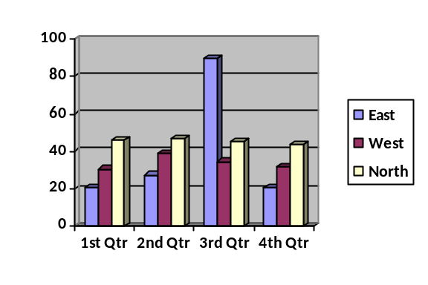

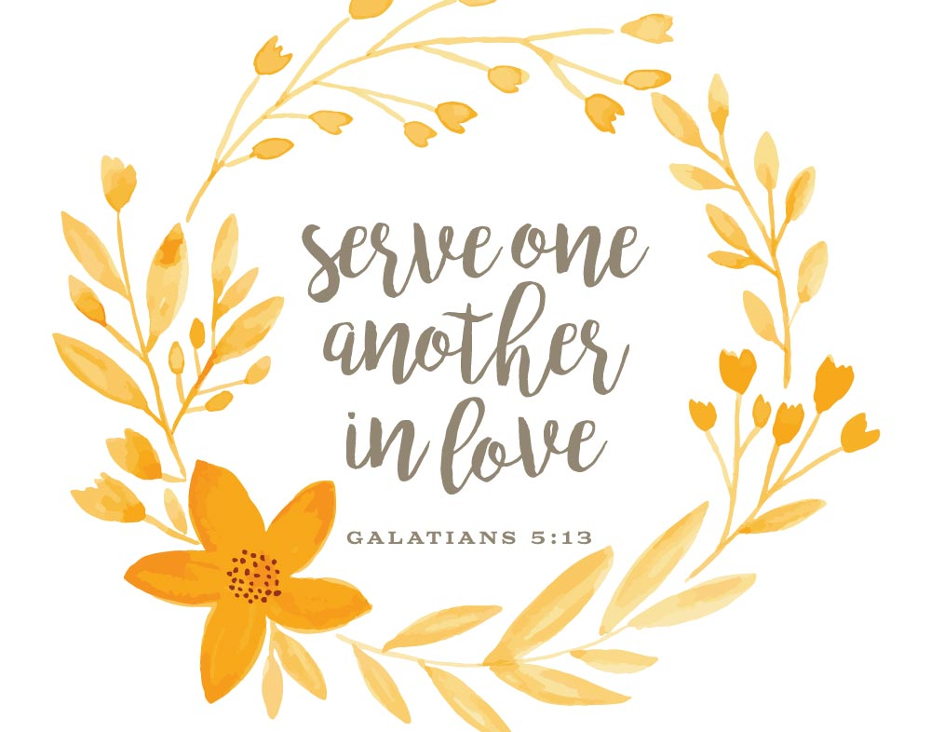
*****************************
Dear Church Family,

Since my arrival six years ago, you have come to be family to me, as you were for my mother. You have always been supportive and continue to be since my mother’s passing. I’ve been experiencing surprising situations since her death, which I was not prepared to handle. God bless all of you for your love and kindness from my family and me. I’ve never had such a warm and loving experience like this. I did make one smart decision when I came here… I joined a real family. Thank you so much for your kindness.

Scott Rives

Flowers
4 Elizabeth Williams
11 Sheree & Mike Kelly
18 Otis Patterson
25 Megan & Scott Phillips Family

A beautiful example of God’s creation,
flowers, can be provided for worship service by calling Susan Cole at 947-5764.

