Class of 2020
Doris Russell
Chad Thomason
Michelle Tortora
JoAnn Wahala

Class of 2021
Denise Edmonds
Robert Gordon
Lee McCaskill
Geraldine Moore

Class of 2022
Keith Hardin
Elizabeth Martindale
Helen McDonald
Marie Monroe

The Reverend Rick Martindale Pastor
Ali Wadsworth Choir Director
Elizabeth Williams Organist
Shelley Hammond Administrative Assistant
Andie Hyman Nursery Attendant
Ann Key Sexton
Marie Monroe Treasurer



Non-Profit
Organization
U.S. Postage
PAID
CARTHAGE, NC
28327
Permit No. 35

FIRST PRESBYTERIAN CHURCH
POST OFFICE BOX 397
CARTHAGE, NORTH CAROLINA 28327
(910) 947-2924
fpccarthage.com (website)
infofpc397@gmail.com (email)



First Presbyterian Church News January 2020

West Community Gathering Is Coming to FPC

Did you know that the Presbytery of Coastal Carolina is made up of approximately 180 churches? We have one of the largest presbyteries in the entire nation. Because of our large size we are split into communities to help us stay more connected with one another. Twice a year the churches in the West Community meet to do the business of the presbytery, worship, have a time of continuing education, and fellowship together.

The West Community will be meeting on Thursday, January 23rd from 8:30 a.m. – 1 p.m... at our church! We have potentially elders from 65 churches that will be at FPC! The session is preparing for the meeting. The luncheon will be catered.

We need volunteers to help make this event a success. Mark your calendars if you can help on this day. The following are going to lead this event: Helen McDonald, Doris Russell, JoAnn Wahala, Geraldine Moore, and Michelle Tortora. Volunteers will be needed to direct people on where to park, greet people as they enter the building, help with preparing a light breakfast, and other odd jobs.

A big part of preparing for this meeting will be cleaning and tidying up our facilities before everyone arrives. We want our guests to feel at home and help them to see the great joy we take in calling FPC our church home. Don’t be surprised if we have a “clean-up day” or “cleanup evening” before the big event. Stay tuned for ways that you can help.

The theme for the West Community Gathering will be “Thawing out the Frozen.” Typically, anyone can attend as a guest. Consider joining us to see how this smaller version of a presbytery meeting operates, while embracing a great worship service, and discovering how the frozen chosen can “thaw.” I will keep you up-to-date on information as we approach the January 23rd meeting.

May 2020 be a year filled with great joy, and may we each grow in our relationship with Jesus Christ, our Lord and Savior. Opportunities are present, and God is calling us to grab hold!
www.FPCcarthage.com
 Grace and Peace,

Rick

News & Events tab
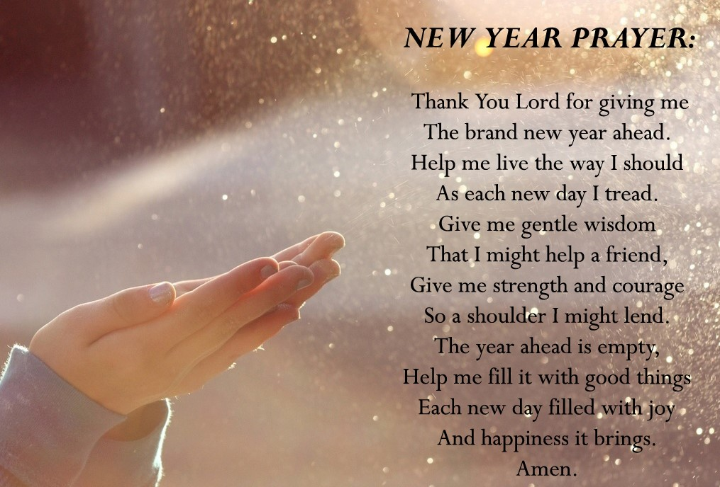
Donnie Albright
Tony Bibey, Jimmy Bibey’s son
Mary Brewer
Anna Bristow, Debbie Albright’s sister
Karen Bryant, friend of JoAnn Wahala
Olivia Bryant, Karen Bryant’s granddaughter
Dean Cameron
Wife of Larry Cockman, friend of Benny Cole
James Cox, friend of Kelly Martindale
Robert Davis
Caleb Evans, friend of Elizabeth Martindale
Christopher Freeman, Maria Bigger’s grandson
Jon Foster and Family, friend of Elizabeth Martindale
Carl Greeson, Susan Cole’s brother
June Greeson, Susan Cole’s mother
Ann Herndon, Kay Patterson’s sister
Mary Hussey
Zack Isom, Diane Pangborn’s son
Aaron Ladmin
Maxine Lawson, Elizabeth William’s sister
Rexine Lloyd, Kelly Martindale’s mother
Vince Mann, friend of the Leonards
Jane Medlin, Carol Lucas’ daughter
Garin Parker, Barbara Danley’s nephew
Kimberly Sanders and Family
Hunter Smith
William Stutts, Bonnie Scott’s brother-in-law
JoAnne Thompson, Keith Hardin’s mother
Skip Vann, Judy Phillip’s brother-in-law
Tommy Walton, Diane Pangborn’s brother

Jean Bennett – Quail Haven
Jimmy Bibey
Anna Belle Campbell
Benny Cole
John Currie – Tara Plantation
Betty Elliott
Keith Hardin
Sheree Kelly
Margaret Leonard
Carol Lucas
Jim Lucas
Nancy McKenzie
Marie Monroe
Pat Nugent
Regena Nugent
Dennis Parks
Ina Sue Parks
Kay Patterson
Nicole and Jordan Phillips
Scott Rives
Bonnie Scott
Phillip Warmbrod

Our military men and women
and their families including:

Michael Abercrombie
Jonathan Baker
Kyle Bryant
Chris Mohan
Patrick Mohan
Gregory Riyevski
Michael Schwartz
Will Strickland
Quinn Wicker

To add someone or to remove your name, please call the
church office at 947-2924.

In Our Prayers
Remembering our sisters and brothers
as they face difficult times.



NOVEMBER FINANCIAL REPORT

OPERATING FUNDS:
Balance in checking account as of November 1, 2019 | 65,469.13
Tithes and Offerings Received | +16,925.00
Sub-Total | 82,394.13
Expenditures | -18,045.03
Balance in checking account as of November 30, 2019 | 64,349.10
RESTRICTED FUNDS: (Funds designated for specific projects, etc.)
Restricted Funds held in checking account as of November 1, 2019  Employee FICA & w/holding taxes for November 2019  Donations/offerings received (2ȼ a Meal $130.10; Fall Festival $46; GriefShare $100; Playground Equip $50; Shoebox Ministry $100; Joint Thanksgiving offering for Carthage Food Pantry $312) | 64,259.92  +519.77  +738.10
Sub-Total | 65,517.79
Expenditures: Two Cents a Meal $309.64; Frozen Meal Ministry $12.24 | -321.88
Balance in Restricted Funds as of November 30, 2019 | 65,195.91
RECAP:
Operating Funds Balance | 64,349.10
Building Fund: Equipment etc. 93.54 + Other 35,221.42 | +35,314.96
Restricted Funds Balance | +29,880.95
 | 129,545.01
Oct-Nov '19 Payroll Taxes on hand (FICA 949.32; FW/H 94.94; SW/H 34.00) | -1,078.26
11/30/19 Checkbook Balance | 128,466.75
OTHER REVENUES ON HAND:
Scholarship C/D with BB&T  BB&T Investments Brokerage Acc. #JAL-059738, Estimated value (4 shs) | 23,393.57  +213.96
Total Other Revenues on hand | 23,607.53

Attendance Sunday School Worship
November 3rd 27 70
November 10th 44 61
November 17th 46 68
November 24th 25 52
Average 36 63

Children & Youth

“One of the greatest values of the church
is providing a community for you and your kids.
A place where they can feel safe,
have meaningful discussion with a caring adult,
and to ask the tough questions.
We all need this type of community."
-Parenting Beyond Your Capacity


5:30 p.m. Wednesdays 5:00 p.m. Sundays
ages 4 – 6th grade 7th – 12th grade
Children meet during the Have fun,
school year for a fun time be challenged
learning about the Bible and explore
with crafts, music, games what it means
and dinner. to be a Christian.

www.FPCcarthage.com
Family Life & Youth tab

Women of Faith



1st Thursdays, 11 a.m. 2nd Thursdays, 6:30 p.m.


3rd Thursdays

www.FPCcarthage.com
Women of Faith tab

Men of Faith

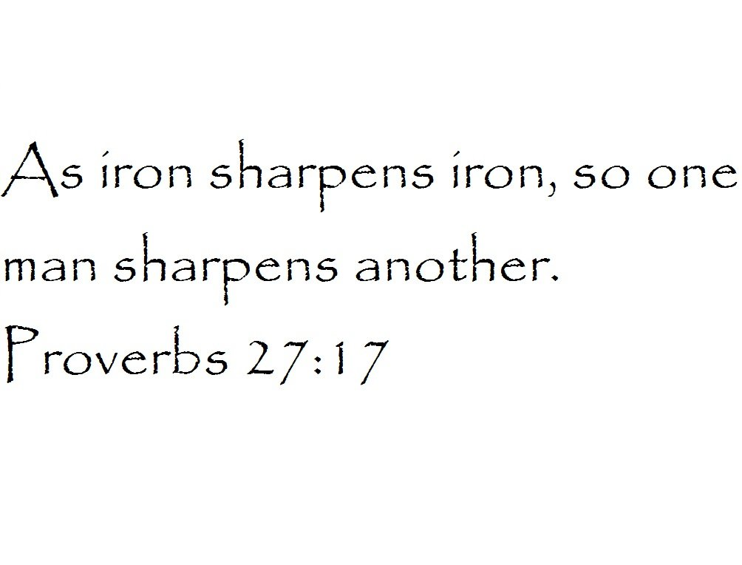

Men’s Group
1st & 3rd Tuesdays, 6 p.m.
Meeting twice monthly to fit your schedule.

www.FPCcarthage.com
Men of Faith tab

Community



8 - 11:15 a.m.
FIRST SATURDAYS
Monthly the Robbins' Food Bank
of Robbins Area Christian Ministries.

Serve as many Food Bank First Saturdays as
you'd like - to fit your schedule!

To carpool, meet at FPC at 7:30 a.m.

www.FPCcarthage.com
More… tab
“Ways to Serve”


Monday & Wednesday mornings
Floor Class, 8:45 a.m. Chair Class, 10:15 a.m.
$5 per class. Beginners welcome!
No registration required.

www.FPCcarthage.com
News & Events tab
“Yoga Faith”
“Ways to Serve”

@ FPC

Stay up-to-date this year with our website www.FPCcarthage.com.
Featuring Google Calendar, our News & Events spot, and faith interest tabs.

Worship
A meaningful time for our faith to gather as family in Christ,
and to praise and worship Jesus, our Lord and Savior.

Check out our website’s Worship tab! www.FPCcarthage.com/worship


9:45 a.m. 11 a.m.
10 a.m. Summer Service
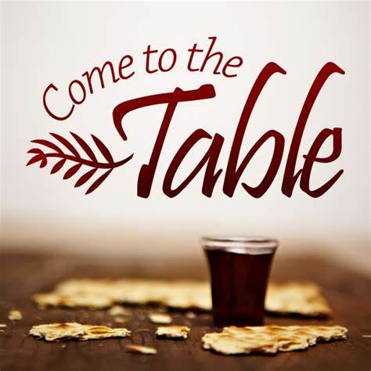
Communion
3rd Sundays


1st Sundays Family Service
Pennies for Hunger Children’s Offering

Music Ministry

Wednesdays 7 p.m. Thursdays 6 p.m.
practice for practice for
traditional Sunday Worship. Contemporary Worship .

January Flowers
5th Poinsettias
12th Geraldine Moore
19th Ann & Tom Currie
26th Debbie & Robert Gordon
Greeters
5th Keith Hardin
12th Diane & Tom Pangborn
19th Pat Nugent
26th Dennis Parks
Ushers
Robert Gordon
Helen McDonald
Marie Monroe
Doris Russell

www.FPCcarthage.com
News & Events tab – “Calendar”

HAPPY BIRTHDAY!
9 John Baker III
10 Alma Baker
12 Paul White
13 Hal Meeks
14 Duncan Kelly
14 Keith Hardin
16 Tom Leonard
24 Riley Medlin
25 Carson Kelly
26 Ali Smith
29 Pat Nugent

www.FPCcarthage.com
News & Events tab,
Church Mouse login



Please donate these needed items throughout the year:
Debbie Cakes, Healthy Snacks, Crackers, Hard Candies
Biotene Products, Non-alcohol mouthwashes, Lip Balm
Toothette Oral Care Swabs, Sensitive Toothpastes
Baby Wipes, Mild Soaps and Body Washes
Travel-Size Products
www.FPCcarthage.com More… tab – “Ways to Serve”



“I would like to express my appreciation and humbly thank everyone for their thoughts, prayers, cards, calls, and inquiries about my recent surgery and recovery. What a surprise to go in for a laparoscopic gallbladder procedure and wake up in a hospital room with a 5” incision. It has definitely been an experience, but God has been with me all the way. I am improving each day but still have some more healing to do. Thank you again and continued prayers are requested.”
-Marie Monroe

SESSION NOTES
-The Session approved repairing part of the roof in the Family Life
Center above the men’s bathroom. Work was completed earlier
this month. Work to the walls will be done later.
- The Session approved giving $400. to the New Century Middle
School’s Food Locker.
-FPC will be hosting the West Community of our presbytery at our
January Gathering on the 23rd. About 65 churches will be at this
event.
-We give thanks for Lucinda Casey, Cristy Dean, Scott Phillips, and
Paul White for their faithful service over the last three years on
the Session.

JANUARY @ FPC
First Presbyterian's Family Life Center serves as a collection site for ministries and missions. This year, FPC welcomes a new local ministry – HOSPICE CARE BAGS for patients and their families.

Wednesday, 1st New Year’s Day – Church Office closed
Thursday, 2nd 11:00 a.m. Morning Women’s Fellowship & Bible Study, conference room
5:30 p.m. Praise Team practice
Saturday, 4th 7:30 a.m. Robbins’ Food Bank, meet at FPC to carpool
Sunday, 5th 9:00 a.m. Fellowship and Mission Committee, conference room
9:45 a.m. Sunday School
11:00 a.m. Contemporary Family Worship, Family Life Center
Monday, 6th Epiphany
YogaFaith Classes – 8:45 a.m. floor / 10:15 a.m. chair
Tuesday, 7th 2:00 p.m. CHS High School Reunion Committee, conference room
6:00 p.m. Men’s Group, conference room
Wednesday, 8th YogaFaith Classes – 8:45 a.m. floor / 10:15 a.m. chair
5:30 p.m. What’s Up Wednesday, ages 4-6th grade
Presbyterian Women would like to thank everyone who helped and supported
our annual Christmas Lunch
on Sunday, December 8th.
All donations went to the Carthage Food Pantry.

7:00 p.m. Choir practice
Thursday, 9th 6:00 p.m. Praise Team practice
6:30 p.m. Evening Women’s Fellowship & Bible Study, conference room
Sunday, 12th 9:00 a.m. Worship Committee, conference room
9:45 a.m. Sunday School, all ages
11:00 a.m. Worship/ Installation of New Elders
2:00 p.m. Session meeting, conference room
5:00 p.m. Youth Group, 7th-12th grades
Monday, 13th YogaFaith Classes – 8:45 a.m. floor / 10:15 a.m. chair
Wednesday, 15th YogaFaith Classes – 8:45 a.m. floor / 10:15 a.m. chair
5:30 p.m. What’s Up Wednesday, ages 4-6th grade
7:00 p.m. Choir practice
Thursday, 16th 12:00 p.m. Ladies Lunch, Aroma Café & Bakery
6:00 p.m. Praise Team practice
Saturday, 18th 10:00 a.m. “When Only Faith Remains” women’s gathering, Community Pres.
Sunday, 19th 9:45 a.m. Sunday School, all ages
11:00 a.m. Worship Service with Communion
Monday, 20th YogaFaith Classes – 8:45 a.m. floor / 10:15 a.m. chair
Tuesday, 21st 6:00 p.m. Men’s Group, conference room
Wednesday, 22nd YogaFaith Classes – 8:45 a.m. floor / 10:15 a.m. chair
5:30 p.m. What’s Up Wednesday, ages 4-6th grade
7:00 p.m. Choir practice
Thursday, 23rd 8:30 a.m. West Community Presbytery Meeting, FPC
6:00 p.m. Praise Team practice
Sunday, 26th 9:45 a.m. Sunday School, all ages
11:00 a.m. Worship/Baptism
5:00 p.m. Youth Group, 7th-12th grades
Monday, 27th YogaFaith Classes – 8:45 a.m. floor / 10:15 a.m. chair
Wednesday, 29th YogaFaith Classes – 8:45 a.m. floor / 10:15 a.m. chair
5:30 p.m. What’s Up Wednesday, ages 4-6th grade
7:00 p.m. Choir practice
Thursday, 29th 6:00 p.m. Praise Team practice

