Non-Profit
Organization
U.S. Postage
PAID
CARTHAGE, NC
28327
Permit No. 35

FIRST PRESBYTERIAN CHURCH
POST OFFICE BOX 397
CARTHAGE, NORTH CAROLINA 28327
(910) 947-2924
fpccarthage.com (web site)
infofpc397@gmail.com (e-mail)

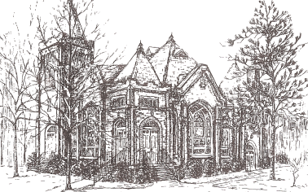THE CHURCH MOUSE

The Reverend Rick Martindale Pastor
Ali Wadsworth Choir Director
Elizabeth Williams Organist
Shelley Hammond Administrative Assistant
Andie Hyman Nursery Attendant
Ann Key Sexton
Marie Monroe Treasurer

Ruth Craig Interim Pianist
Class of 2019
Lucinda Casey
Cristy Dean
Scott Phillips
Paul White

Class of 2020
Doris Russell
Chad Thomason
Michelle Tortora
JoAnn Wahala

Class of 2021
Denise Edmonds
Robert Gordon
Lee McCaskill
Geraldine Moore
FIRST PRESBYTERIAN CHURCH
March 2019

Lent Is Here!

Lent is a time of reflection. It is a time for us to examine our lives, our motivations, our inner thoughts, and our desire to walk with Jesus Christ. Are you ready to walk with Jesus during His final days on earth? The Lenten season is a wonderful time to make a “sacrifice” of giving up something you love. I typically find myself giving up a food item (giving up ice-cream was a particularly challenging time!) but it can be anything. It’s also a perfect time to begin a new practice like praying or reading scripture in the morning or evening. The great thing about developing a new spiritual habit during Lent is that it might carry over for the rest of your life! That’s a win-win!

The season of Lent begins with Ash Wednesday on March 6th. The Community Lenten Series will begin that day at Carthage United Methodist Church at noon, followed by lunch. Look later in the newsletter for a complete list of churches and dates for this Lenten season.

At 5:30 p.m. everyone is invited to a pancake, sausage, and bacon supper put on by the leaders of What’s Up Wednesdays. We have done this meal for several years and it is a wonderful meal. At 6:30 p.m. everyone is invited to the sanctuary for our Ash Wednesday service.

If you haven’t taken advantage of this wonderful time of the church year please do so. We have the opportunity to become closer to God in a very real and lasting way.

Confirmands Join the Church!

I want to share the good news if you weren’t in church on February 24th. Nine of our young people joined FPC. Those who joined are:
Murphy Buie Matthew Leonard Catherine Martindale
Elizabeth Martindale Riley Medlin Abby Phillips
Gabe Phillips Emily Tortora Joey Tortora.

They are a great group of kids who shared some very powerful statements of faith with the session. They answered the appropriate questions during worship and were joyfully welcomed into our church family. Please congratulate them for all their hard work during confirmation. I expect great things from this group.

Grace and Peace,

Rick

March Calendar Page
Birthdays

3 Jimmy Bibey
3 Ken Fara
5 Emily Muse
6 Otis Patterson
8 Joey Tortora
10 Bonnie Scott
12 Johnny Scott
13 Angie Medlin
14 Jordan Smith
15 Peter Little
17 Mike Kelly
19 Tom Currie
21 Margaret Leonard
23 Maria Bigger
26 Susan Cole
27 Barbara Kelly
28 Lucinda Casey
29 Connor Lucas
31 Dennis Parks
31 Christopher Phillips
If someone’s birthday is
missing or incorrect please let the
church office know.

USHERS

Paul White*
Denise Edmonds
Lee McCaskill
Cristy Dean

*Lead Usher

FLOWERS

3 Doreen and Peter Little
10 Bonnie Scott
17 Doris and Bill Russell
24 Barbara Danley
31 Michelle and Scott Tortora
If you would like to place flowers in the sanctuary, please contact Susan Cole (947-5764).

GREETERS
3 Geraldine Moore

10 Doreen and Peter Little

17 Tom Stewart

24 Barbara Danley

31 JoAnn Wahala

In Our Prayers . . .

Jean Bennett – Quail Haven Jimmy Bibey John Currie – Tara Plantation
Betty Elliott Sheree Kelly Carol Lucas
Jim Lucas Joan MacLean – First Health Nancy McKenzie Pat Nugent
Pat Nugent Dennis Parks Ina Sue Parks
Kay Patterson Jim Phillips – St. Joseph’s Scott Rives
Bonnie Scott Phillip Warmbrod



Linda Ammons – Jim Phillip’s Sister Dean Cameron
James Cox – Friend of Kelly Martindale Robert Davis
Christopher Freeman – Maria Bigger’s Grandson Jimmie Garner – Joan Power’s Father
Carl Greeson – Susan Cole’s Brother June Greeson – Susan Cole’s Mother
Aaron Ladmin Vince Mann – Friend of the Leonards
Garin Parker – Barbara Danley’s Nephew Kimberly Sanders and Family
Hunter Smith William Stutts – Bonnie Scott’s Brother-in-Law
Skip Vann – Jim Phillip’s brother

All of our military men and women especially the following:
Jonathan Baker, Chris Mohan, Patrick Mohan, Gregory Riyevski, Tim Shiflet,
Will Strickland, and Quinn Wicker

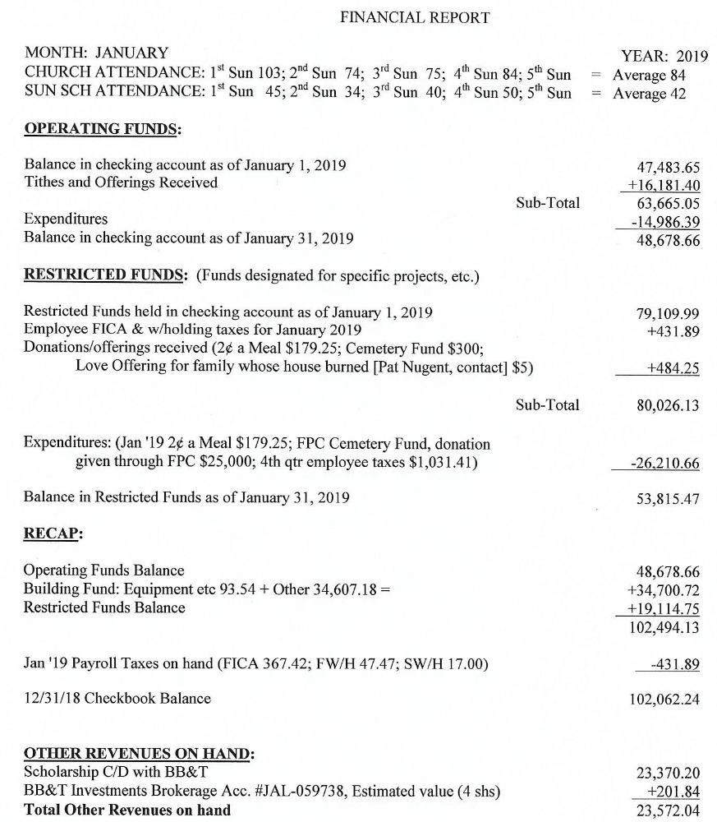

MARCH CALENDAR

2 7:30 Robbins’ Food Bank
9:30 Presbytery Meeting at Laurinburg Presbyterian Church
4:00 Funeral Service for Linda Busch
3 9:00 Fellowship and Mission Committee (conference room)
9:45 Sunday School
11:00 Contemporary Worship Service (Family Life Center)
12:00 Empty Bowls (Country Club of Whispering Pines)
5:00 Youth Group
4 8:45 Christian Yoga
10:15 Christian Chair Yoga
6 8:45 Christian Yoga
10:15 Christian Chair Yoga
12:00 Community Lenten Series (Methodist Church)
5:30 Pancake Supper w/What’s Up Wednesday
6:30 Ash Wednesday Service
7:00 Choir
7 11:00 Presbyterian Women’s Circle (conference room)
10 9:00 Worship Committee (conference room)
9:45 Sunday School
11:00 Worship
2:00 Session Meeting (conference room)
5:00 Youth Group
13 8:45 Christian Yoga
10:15 Christian Chair Yoga
12:00 Lenten Series (First Baptist Church)
5:30 What’s Up Wednesdays (fellowship hall)
7:00 Choir Practice
14 7:00 Praise Team
16 7:30 Robbins’ Food Bank
17 9:45 Sunday School
11:00 Worship
5:00 Youth Group
18 8:45 Christian Yoga
10:15 Christian Chair Yoga

(The rest of March is on the next page)

All articles/information for the Mouse and the weekly bulletins should be emailed
to the churches email address: infofpc397@gmail.com

March Calendar Continued

20 Deadline for April Mouse
8:45 Christian Yoga
10:15 Christian Chair Yoga
12:00 Community Lenten Series (First Presbyterian Church)
5:30 What’s Up Wednesdays (fellowship hall)
7:00 Choir Practice
21 12:00 Ladies Lunch at Aroma Cafe
7:00 Praise Team
24 9:45 Sunday School
11:00 Worship
5:00 Youth Group
25 8:45 Christian Yoga
9:45 Christian Chair Yoga
26 1:00 Fold Mouse (conference room)
27 8:45 Christian Yoga
9:45 Christian Chair Yoga
12:00 Community Lenten Series (John Hall Church)
5:30 What’s Up Wednesday
7:00 Choir Practice
28 7:00 Praise Team
31 9:45 Sunday School
11:00 Worship
5:00 Youth Group

Fellowship and Mission

1. No yoga on Monday, March 11th.
2. We will meet at 9:00 a.m. Sunday, March 3rd in the conference room.
3. The school supplies collected for Carthage Elementary were delivered. Our generosity was greatly appreciated.
4. Empty bowls, a fundraiser for the Moore Coalition, is Sunday, March 3rd from 12 – 2 p.m. at the Country Club of Whispering Pines.
5. If you would like to join Bill Russell and Ann Currie on the new directory committee contact
Bill (949-6549).
6. If you would like to volunteer to help with the Easter Sunrise breakfast, please contact Geraldine Moore (947-5363).

With the Women

March 3rd is Celebrate the Gifts of Women’s Sunday.

Circle will meet on Thursday, March 7th at 11:00 a.m. in the conference room.

Ladies Lunch will meet on March 21st at 12:00 at the Aroma Café in Carthage.

Thanks to everyone for donating school supplies for needy children at the elementary school.

A special thank you to all who helped with bereavement food or meals. If you would like be added to the email or receive a call to help please let Helen McDonald know at hmcd2946@gmail.com or call/text (910) 690-2463.

Mark your calendar!! PW Annual Spring Gathering will be at College Heights Presbyterian Church in Fayetteville on Saturday, April 6th. Debbie Gordon will be installed to the PW Coastal Carolina Coordinating Team as our Facilitator of Mission/Celebration Giving. Registration is from 8:30 - 9:30 a.m. Plenary begins at 10:00 a.m. Hope you can attend.

Community Lenten Series

Our Community Lenten Series has been taking place for many years. It is a wonderful opportunity to worship, fellowship, and eat with our brothers and sisters in Christ throughout the Carthage area.

At noon each Wednesday during Lent (except during Holy Week) we gather together at a different church here in town. We have a short worship service together. Then that church provides a meal for everyone for a very reasonable price (typically $3.00).

Come and take part in this meaningful Lenten activity each week. The locations for 2019 are:

March 6 Carthage United Methodist Church
March 13 First Baptist Church
March 20 First Presbyterian Church
March 27 John Hall Presbyterian Church – 520 Dowd Street

April 3 Mt. Olive AME Zion Church – 440 Bethlehem Church Road
April 10 First Missionary Baptist Church – 576 Needmore Road

