Class of 2020
Doris Russell
Chad Thomason
Michelle Tortora
JoAnn Wahala

Class of 2021
Denise Edmonds
Robert Gordon
Lee McCaskill
Geraldine Moore

Class of 2022
Keith Hardin
Elizabeth Martindale
Helen McDonald
Marie Monroe

Non-Profit
Organization
U.S. Postage
PAID
CARTHAGE, NC
28327
Permit No. 35
FIRST PRESBYTERIAN CHURCH
POST OFFICE BOX 397
CARTHAGE, NORTH CAROLINA 28327
(910) 947-2924
fpccarthage.com (website)
infofpc397@gmail.com (email)
FpcCarthage (facebook)



The Reverend Rick Martindale Pastor
Ali Wadsworth Choir Director
Elizabeth Williams Organist
Shelley Hammond Administrative Assistant
Andie Hyman Nursery Attendant
Ann Key Sexton
Marie Monroe Treasurer

Ruth Craig Interim Pianist
Octoberinto faith
First Presbyterian Church News

“For where two or three are gathered in my name, I am there among them (Matthew 18:20).”

Jesus reminds us that we are never alone. We are a part of something and Someone much greater than ourselves. God is with us as a community of faith. God is with us as we wrestle with the challenges of life. We have learned how to worship virtually. The days of sending an audio tape to a member have been replaced with live worship (and interacting on Facebook). It’s a vast improvement but it still doesn’t replace being together physically and God knows it.

Worshipping God on Sunday mornings is important for our spiritual growth. It enables us to grow closer to God and know God. Most of us, however, will argue that a huge part of worshipping is the importance of being together. We know how much God loves us but being able to laugh with one another, hug one another, smile, and enjoy the fellowship of one another is important. We know nothing is more important than God, yet the fellowship of Christians is crucial to our walking with God. Jesus knew this and embodied it by how He brought people together.

On March 22nd we started our first virtual service. It helped to fill a void. We wanted to worship “together” even if it was from our own homes. We also wanted to feel as though we were again a community of faith, even if we were still isolated from one another.

On August 22nd, exactly five months later, we began worshipping outside. Why? Because some were getting hungry for something more than simply worshipping virtually. It makes sense. We are social creatures. We want to spend time together even if we can’t hug one another or shake hands.

Last Sunday, September 27th, we had a fall tailgate picnic. Everyone brought their own food and we ate and fellowshipped together. It was awesome! Yes, we even shared some homemade ice-cream! Thanks to the Tortoras, Monroes, Russells, and Geraldine Moore for providing some awesome ice-cream and desserts. Tom Currie provided some very tasty scuppernong grapes.

Do not be surprised if we do this again before it gets too cold. It might be too cold for ice-cream (of course the question is, is it ever too cold for ice-cream? 😊). Yet we could still gather and sit in our lawn chairs, walk around in the parking lot and visit with one another.

Where two or three are gathered together, God is with us. God is with us if we are sitting at home by ourselves right now or if we are searching for peace in a very crazy home. FPC is attempting to work on providing opportunities for those who need to interact, who desire to embrace God’s love by fellowshipping with one another.

Grace and Peace Be with You,
Rick
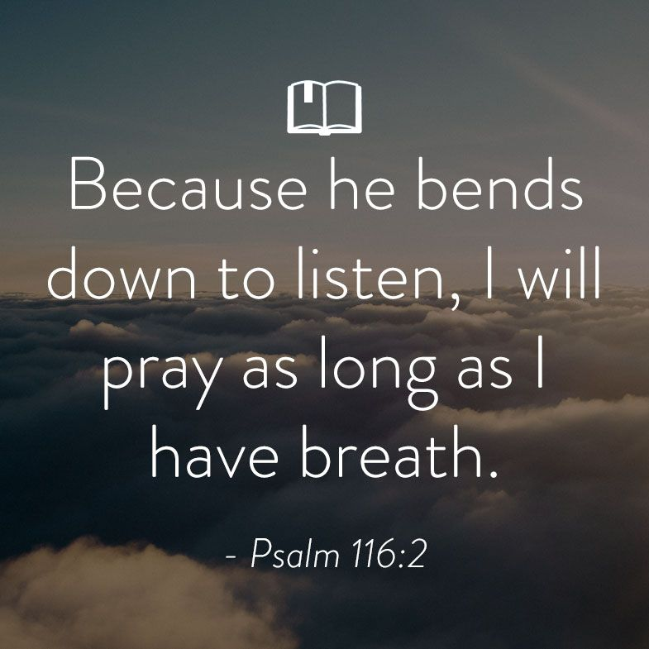
Please remember
our sisters and brothers
in your prayers
as they face
difficult times.

In Our
Prayers…

Debbie Albright Alma Baker Jean Bennett, Quail Haven
Jimmy Bibey Anna Belle Campbell John Currie, Tara Plantation Betty Elliott Gail Hardin Keith Hardin
Sheree Kelly Margaret Leonard Carol Lucas Barbara May Linda McCaskill Nancy McKenzie
Ina Sue Parks Kay Patterson Judy Phillips Bonnie Scott Phillip Warmbrod Elizabeth Williams

Karen Bryant, friend of JoAnn Wahala Carl Greeson, Susan Cole’s brother
June Greeson, Susan Cole’s mother Ann Herndon, Kay Patterson’s sister
Sean Kennally, Angie Provost’s son-in-law Danny Lewis, Gail Hardin’s brother-in-law
Jane Medlin, Carol Lucas’ daughter Parker Megs, Union Pines student Jonah Monk, Sarah and Jonathan Monk’s son Debbie, Marlene Riyevski’s sister
Charles McNeil, Serge Riyevski’s son-in-law Tommy Walton, Diane Pangborn’s brother

All of our military men and women and their families, especially the following:
Michael Abercrombie, Jonathan Baker, Kyle Bryant, Chris Mohan,
Patrick Mohan, Michael Schwartz, Will Strickland, and Quinn Wicker.

If you would like to add someone or take yourself off this list,
please call the church office at 947-2924, or email infoFPC397@gmail.com.


Happy Birthday!

2 Angie Prevost
4 Laura Gordon Faircloth
6 Catherine Martindale
6 Elizabeth Martindale
9 Ben White
13 Bill Thomas
15 Jacob Adelmann
15 Helen McDonald
15 Leon Monroe
15 Matthew Monroe
16 Jennifer Prevost Kennally
17 Jeannie Muse
18 Anna Belle Campbell
21 Caroline Carter Reynolds
21 Caroline Kosbe
21 Mack McDonald
22 Max Muse
24 Kim Kelly
27 Elizabeth Barringer
27 Gabe Phillips
31 Hammond Bennett


OCTOBER

Ushers
Marie Monroe, lead usher
Robert Gordon
Helen McDonald
Doris Russell

Flowers
4 Outside Service
11 Outside Service
18 Denise & Lee Edmonds
25 Nancy Carter

October into faith

Thursday, October 1st 11:00 a.m. PW Circle “Loved Carved in Stone” Bible study
Saturday, October 3rd 7:30 a.m. Robbins’ Food Bank
Please donate double-bagged plastic grocery bags in the FLC.
9:30 a.m. Coastal Carolina Presbytery Meeting (virtual)
Sunday, October 4th 10:00 a.m. Outdoors/Virtual Worship with Communion followed by a
Congregational Meeting to elect our Nominating Comm.
Monday, October 5th Christian Faith Yoga – 2 p.m. Floor, 3:15 p.m. Chair (FLC)
Sunday, October 11th 10:00 a.m. Outdoors/Virtual Worship Service
2:00 p.m. Session meeting
Monday, October 12th Columbus Day
Christian Faith Yoga – 2 p.m. Floor, 3:15 p.m. Chair (FLC)
Thursday, October 15th Last day for Carthage Elementary School Supply Drive
Sunday, October 18th TBA Worship Service/PW Thank Offering
Monday, October 19th Christian Faith Yoga – 2 p.m. Floor, 3:15 p.m. Chair (FLC)
Tuesday, October 20th Deadline for November Mouse church newsletter
6:00 p.m. Men’s Group
Sunday, October 25th TBA Worship Service
Monday, October 26th Christian Faith Yoga – 2 p.m. Floor, 3:15 p.m. Chair (FLC)
6:00 p.m. Worship Committee
Thursday, October 29th 6:00 p.m. Building and Ground Committee
Saturday, October 31st Halloween

Because of COVID-19, programs, events, and even worship is in a stage of constant limbo. Please stay tune to announcements on Sunday mornings and through our One Call Now phone tree as we update and make changes to our calendar.

Programs like Sunday School and youth will hopefully begin soon.

Worship opportunities and times will probably be changing this month. More will become available after the session meets on October 11th.

Thanks for your understanding and patience.

Thank you for your gratitude…
Many meals were delivered to our church friends and family last month! If you would like to help with providing a meal, simply email or call Helen McDonald at hmcd2946@gmail.com or (910) 690-2463.

A huge number of books donated by FPC friends and family were recently delivered to the Carthage Food Pantry by Robert and Debbie Gordon. Gently-used and new books can be dropped off at the Donation Station in the FPC Family Life Center throughout the year for the Pantry, and for the Literacy Council in an event of an overabundance.

Cards from FPC, along with donated prayer blanket shawls, new clothing, calendars, and large print word search books, were recently delivered by Keith and Gail Hardin to the very appreciative First Health Hospice & Palliative Care, Peak Resources Nursing Home, and Tara Plantation organizations.

Upcoming Opportunities
Wednesday & Thursday Study Hall
The Family Life Center will be open during regular church hours Wednesdays and Thursdays
for students in need of internet service and/or a change of study scenery. Students should
sign up in advance by emailing Rick at revmartindale@hotmail.com. A parent of a 6th grader
and under needs to supervise their child. Seventh graders and up may work independently.
Adult volunteers are needed in order for FPC to host student study days. To volunteer, contact
Michelle Tortora at mrstortora@hotmail.com.

Day Circle
Ladies Bible study will meet on the FPC lawn at 11 a.m. on Thursday, October 1st, weather permitting. Bring a chair and join us to discuss Lessons 7 and 8 of our current study.

School Supply Drive
Now through October 15th, the following school supplies can be donated at the Family Life Center Donation Station for Carthage Elementary students in need: glue sticks, crayons, play dough, dry erase markers, erasers, scissors, colored pens, highlighters, gallon Ziploc bags, clear sheet protectors, tissues, card stock, baby wipes, pencils, and construction paper.

Thank Offering
Presbyterian Women will collect their annual Thank Offering during October 18th morning
worship. Grant recipients will be announced in the near future.

September 2020 Financial Report

CHURCH ON THE LAWN DURING THE MONTH OF AUGUST 2020, DUE TO COVID-19 VIRUS

OPERATING FUNDS:
Balance in checking account as of August 1, 2020 | 80,893.06
Tithes and Offerings Received | +22,131.00
Sub-Total | 103,024.06
Expenditures | -14,373.02
Balance in checking account as of August 31, 2020 | 88,651.04
RESTRICTED FUNDS: (Funds designated for specific projects, etc.)
Restricted Funds held in checking account as of August 1, 2020  Employee FICA & w/holding taxes for August 2020  Donations/offerings received (2ȼ a Meal $10.00; Bldg Fd $200; Memorials $150) | 93,266.65  +552.72  +360.00
Sub-Total | 94,179.37
Expenditures: Cemetery Fund donations $300; PW donations $400;  RACM donation & Grant $4,500 | -5,200.00
Balance in Restricted Funds as of August 31, 2020 | 88,979.37
RECAP:
Operating Funds Balance | 88,651.04
Building Fund: Equip etc 93.54 + Other 60,328.62 + $200.00=$60,528.62 = | +60,622.16
Restricted Funds Balance | +28,357.21
 | 177,630.41
July-Aug '20 Payroll Taxes on hand (FICA 979.09; FW/H 106.00; SW/H 30.00 +.02) | -1,115.11
8/31/2020 Checkbook Balance | 173,597.30
OTHER REVENUES ON HAND:
Scholarship C/D with BB&T  BB&T Investments Brokerage Acc. #JAL-059738, Estimated value (4 shs)  Total Other Revenues on hand | 23,635.62  +152.92  23,788.54

Fall Tailgate Picnic Pictures

