Class of 2019
Lucinda Casey
Cristy Dean
Scott Phillips
Paul White

Class of 2020
Doris Russell
Chad Thomason
Michelle Tortora
JoAnn Wahala

Class of 2021
Denise Edmonds
Robert Gordon
Lee McCaskill
Geraldine Moore

The Reverend Rick Martindale Pastor
Ali Wadsworth Choir Director
Elizabeth Williams Organist
Shelley Hammond Administrative Assistant
Andie Hyman Nursery Attendant
Ann Key Sexton
Marie Monroe Treasurer

Ruth Craig Interim Pianist
Non-Profit
Organization
U.S. Postage
PAID
CARTHAGE, NC
28327
Permit No. 35

FIRST PRESBYTERIAN CHURCH
POST OFFICE BOX 397
CARTHAGE, NORTH CAROLINA 28327
(910) 947-2924
fpccarthage.com (website)
infofpc397@gmail.com (email)


First Presbyterian Church News

Big Change Coming to the Cemetery
The Cemetery Committee has been hard at work this year (and 2018) beyond keeping the cemetery looking nice as always. They have been busy finalizing plans, picking out brick, granite, and other material as the church prepares to break ground in the cemetery. If you haven’t heard, we are getting ready to build a columbarium, thanks to generous anonymous donations. Some might be wondering what is a columbarium?

A columbarium is an above ground structure to place the cremated remains of a loved one. Our columbarium will have 144 niches. Each niche can hold up to two urns like a husband and wife, for example. It will be a beautiful addition to our cemetery and provide people with another option when a loved one leaves their earthly body and enters God’s loving embrace.

Work on the columbarium should begin in the next month or so and be completed by early next year. If you have questions, please reach out to anyone on the cemetery committee. Members include Steve Ingold (chair), Benny Cole, Damon Dean, Kelly Martindale, Lee McCaskill, and Geraldine Moore.

The artist rendering below shows what it will look like. We will be adding two parking spots and a walkway to the columbarium.

Grace and Peace,

Rick
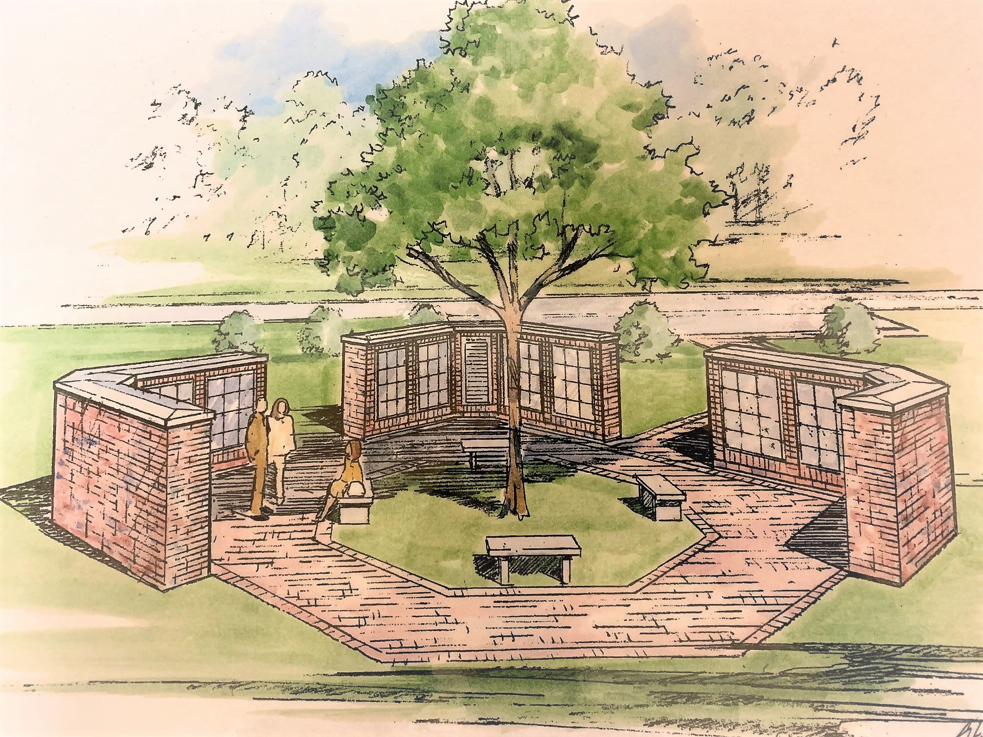
In Our Prayers . . .
Please remember our sisters and brothers in your prayers as they face difficult times.

Jean Bennett – Quail Haven Jimmy Bibey Anna Belle Campbell
John Currie – Tara Plantation Betty Elliott Sheree Kelly Margaret Leonard Carol Lucas Jim Lucas
Nancy McKenzie Pat Nugent Regena Nugent Dennis Parks Ina Sue Parks Kay Patterson Scott Rives Bonnie Scott Phillip Warmbrod

Linda Ammons, Jim Phillip’s sister
Tony Bibey, Jimmy Bibey’s son
Dean Cameron
Wife of Larry Cockman, friend of Benny Cole
James Cox, friend of Kelly Martindale
Robert Davis
Christopher Freeman, Maria Bigger’s grandson
Jimmie Garner, Joan Power’s father
Carl Greeson, Susan Cole’s brother
June Greeson, Susan Cole’s mother
Ann Herndon, Kay Patterson’s sister
Zack Isom, Diane Pangborn’s son
Aaron Ladmin
Maxine Lawson, Elizabeth William’s sister
Rexine Lloyd, Kelly Martindale’s mother
Vince Mann, friend of the Leonards
Garin Parker, Barbara Danley’s nephew
Kimberly Sanders and Family
Hunter Smith
William Stutts, Bonnie Scott’s brother-in-law
JoAnne Thompson, Keith Hardin’s mother
Skip Vann, Jim Phillip’s brother

All of our military men and women and their families, especially the following:
Jonathan Baker, Kyle Bryant, Chris Mohan, Patrick Mohan, Gregory Riyevski,
Will Strickland, and Quinn Wicker.

To add someone or take yourself off this list, please call the church office at 947-2924.


Attendance Sunday School Worship

July 7th 18 69
July 14th 15 69
July 21st 23 86
July 28th 17 53
Average 18 69

to First Presbyterian.

JULY FINANCIAL REPORT

OPERATING FUNDS:
Balance in checking account as of July 1, 2019 | 64,395.07
Tithes and Offerings Received | +12,839.25
Sub-Total | 77,234.32
Expenditures | -17,148.79
Balance in checking account as of July 31, 2019 | 60,085.53
RESTRICTED FUNDS: (Funds designated for specific projects, etc.)
Restricted Funds held in checking account as of July 1, 2019  Employee FICA & w/holding taxes for July 2019  Donations/offerings received (2ȼ a Meal $155.88; Griefshare $30; Love  Offering [Rives] $2,896) | 58,338.58  +515.37  +3,081,88
Sub-Total | 61,935.83
Expenditures: 2nd Qtr employee taxes $1,601.10; Scott Rives $1,000; Two  Cents a Meal (2 mos) $307.03; Mother's Day $15; Pentecost $149.40 | -3,072.53
Balance in Restricted Funds as of July 31, 2019 | 58,863.30
RECAP:
Operating Funds Balance | 60,085.53
Building Fund: Equipment etc 93.54 + Other 35,238.80 + BanCorp div $1.62 = | +35,333.96
Restricted Funds Balance | +23,529.34
 | 118,948.83
July '19 Payroll Taxes on hand (FICA 450.90; FW/H 47.47; SW/H 17.00) | -515.37
7/31/19 Checkbook Balance | 118,433.46
OTHER REVENUES ON HAND:
Scholarship C/D with BB&T  BB&T Investments Brokerage Acc. #JAL-059738, Estimated value (4 shs) | 23,393.57  +191.08
Total Other Revenues on hand | 23,584.65

into faith @fpc

At Robbins Food Bank 9/7 10/5 11/2 8-11 a.m. Carpool from FPC at 7:30 a.m.


GriefShare Celebration Night
“What Do I Live for Now?”
9/3 6 p.m.

Fall Kick-Offs – Youth Group!

 9/8 5:30 p.m.

 9/11 5 p.m.


“Love Carved in Stone”
A Fresh Look at the Ten Commandments
Women’s Circle and Bible Study begins September 5th
Join us at 11 a.m. in FPC conference room.
1st Thursdays


September 29th 5 p.m.
Signup in the lower narthex to help out
with this annual fellowship event!

Presbyterian Women





Receive PW news.
Help in times of need.
Discover fellowship with purpose.
Call (910) 690-2463, or email hmcd2946@gmail.com.

Noon 9/19 at The Market Place
in Pinehurst’s Omlstead Village
Meet at FPC at 11:30 a.m. to carpool. If you need a ride, please call Helen at 690-2463.

We’d love to start an evening Circle.
Would you?
See Helen McDonald if interested!

Thank you FPC friends & family for contributing school supplies for Carthage Elementary!
They were most appreciative.


Fall Festival
Saturday October 12th 9am-3pm



50/50
raffle tickets $1

Amish Quilt
raffle tickets $5


Do you have a WINNING chili recipe for our first annual Chili Cook-Off? Each ticket sold at our Fall Festival will include chili samples and a bowl of their favorite recipe. The team that collects the most fan-favorite tickets wins bragging rights and a trophy. Contestants are encouraged, not required, to name their chili and decorate their table for the “best booth theme and decorations” prize! If you are interested please let Paul White, Scott Phillips or Jennifer Thomason know.
mrs.jenniferthomason@gmail.com
Plan to help and participate by providing…
Spot items.

 Youth volunteers

 cuttings & rootings too!

Books, cookbooks, household items, furniture, needed! Pick up for larger items will be available closer to 10/12.



We are asking each family to donate one (or more) item for the Silent Auction. When you decide what you will donate, email 502mcduffy@gmail.com, or call Susan Phillips at 947-2637. We also want to know the value of your item to get Auction Sheets ready.

Thank you,
Susan Phillips and
Barbara Danley

welcomes your goodies! Cakes, pies, cookies, candies, sausage balls, breads, jams and jellies, pickles and other canned goods. The Bakery items are displayed in an attractive manner for sale on the day of the Fall Festival. Contact Susan Cole, Bakery Chair @ 910-947-5764 or sgcole@embarqmail.com to signup your delicious goodies right away. Thanks for your contributions! The Bakery Team


8-noon 11-3 Live music & Chili Cook-Off Lunch 11-1
into faith… SEPTEMBER
Sunday, September 1st 9:00 a.m. Fellowship and Mission Committee (conference room)
9:45 a.m. Sunday School
11:00 a.m. Contemporary Worship Service (Family Life Center)
Monday, September 2nd Labor Day – Church Office closed and No Yoga classes.
Tuesday, September 3rd 6:00 p.m. GriefShare Celebration “What Do I Live For Now” (FLC)
Wednesday, September 4th Christian Faith Yoga – 8:45 a.m. Floor, 10:15 a.m. Chair 6:00 p.m. Choir practice
Thursday, September 5th 11:00 a.m. PW Circle & “Loved Carved in Stone” Bible study begins
Saturday, September 7th 7:30 a.m. Robbins’ Food Bank (meet at FPC to carpool)
Sunday, September 8th 9:00 a.m. Worship Committee (conference room)
9:45 a.m. Sunday School
11:00 a.m. Worship
2:00 p.m. Session meeting
5:00 p.m. Youth Group Kickoff (grades 7-12), 101 Hardaway Court, W. P.
Monday, September 9th Christian Faith Yoga – 8:45 a.m. Floor, 10:15 a.m. Chair
Tuesday, September 10th 3:30 p.m. ADK Meeting (FLC reserved to 7:30 p.m.)
Wednesday, September 11th Christian Faith Yoga – 8:45 a.m. Floor, 10:15 a.m. Chair
5:30 p.m. What’s Up Wednesday Kickoff (ages 4-6th grade)
7:00 p.m. Choir practice
Thursday, September 12th 7:00 p.m. Praise Team practice
Saturday, September 14th 7:00 a.m. Better Angels event (FLC reserved to 5:00 p.m.)
Sunday, September 15th 9:45 a.m. Sunday School
11:00 a.m. Communion Worship Service
5:00 p.m. Youth Group (grades 7-12)
Monday, September 16th Christian Faith Yoga – 8:45 a.m. Floor, 10:15 a.m. Chair
Tuesday, September 17th Deadline for October Mouse church newsletter
Wednesday, September 18th Christian Faith Yoga – 8:45 a.m. Floor, 10:15 a.m. Chair
5:30 p.m. What’s Up Wednesday (ages 4-6th grade)
7:00 p.m. Choir practice
Thursday, Sept. 19th 12:00 p.m. Ladies’ Lunch, The Market Place in Pinehurst’s Olmstead Village
7:00 p.m. Praise Team practice
Saturday, September 21st 7:30 a.m. AKA Tea event (FLC reserved to 6:30 p.m.)
Sunday, September 22nd 9:45 a.m. Combined Sunday School (Family Life Center)
11:00 a.m. Worship
5:00 p.m. Youth Group (grades 7-12)
Monday, September 23rd Christian Faith Yoga – 8:45 a.m. Floor, 10:15 a.m. Chair
Tuesday, September 24th Fold Mouse Newsletter (conference room)
Wednesday, September 25th Christian Faith Yoga – 8:45 a.m. Floor, 10:15 a.m. Chair
5:30 p.m. What’s Up Wednesday (ages 4-6th grade)
7:00 p.m. Choir practice
Thursday, September 26th 7:00 p.m. Praise Team practice
Sunday, September 29th 9:45 a.m. Sunday School
11:00 a.m. Worship
5:00 p.m. Fall Church Picnic
SEPTEMBER USHERS
Lee McCaskill*
Cristy Dean
Paul White
Denise Edmonds
*Lead Usher

Happy Birthday!


1 John (Buddy) Baker, Jr.
5 Diane Pangborn
9 Jean Bennett
10 Justin Edmonds
13 Ali Wadsworth
15 Nathan Phillips
16 Bobby Wallace
17 Catherine Monroe Collins
17 Judy Phillips
18 Nancy McClendon
21 Tracy Ingold
22 Ian Estep
23 Lisa Baker
27 Carly Monroe
30 Gail Hardin

Update us with church-family
birthdays anytime.
(910) 947-2924 infofpc397@gmail.com.

FLOWERS
1 Angie & Jeff Medlin Family
8 Cristy & Damon Dean Family
15 Gail & Keith Hardin
22 Margaret & Tom Leonard Family
29 Ina Sue & Dennis Parks

Flowers are a beautiful example of God’s creation.
To place flowers in Sunday worship, call Susan Cole at 947-5764.

GREETERS
1 Tom Stewart
8 Geraldine Moore
15 Ann Key
22 Pat Jackson
29 Cristy and Damon Dean Family

