Class of 2019
Lucinda Casey
Cristy Dean
Scott Phillips
Paul White

Class of 2020
Doris Russell
Chad Thomason
Michelle Tortora
JoAnn Wahala

Class of 2021
Denise Edmonds
Robert Gordon
Lee McCaskill
Geraldine Moore

The Reverend Rick Martindale Pastor
Ali Wadsworth Choir Director
Elizabeth Williams Organist
Shelley Hammond Administrative Assistant
Andie Hyman Nursery Attendant
Ann Key Sexton
Marie Monroe Treasurer

Ruth Craig Interim Pianist
Non-Profit
Organization
U.S. Postage
PAID
CARTHAGE, NC
28327
Permit No. 35

FIRST PRESBYTERIAN CHURCH
POST OFFICE BOX 397
CARTHAGE, NORTH CAROLINA 28327
(910) 947-2924
fpccarthage.com (website)
infofpc397@gmail.com (email)

 FIRST PRESBYTERIAN CHURCH July 2019
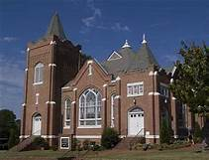

Children’s Church
With the start of the “summer schedule” we initiated a Children’s Church time for our youngest members of the congregation. After A Moment with our Children during worship, those in 5th grade or younger are invited to go up to the top floor of our education building and have a time of singing, prayer, learning a bible story, and participating in a craft. They will have approximately 30 minutes together before worship ends. A special thank you to Michelle Tortora for putting this together and for those leading our children during this time.

Nominating Committee
Jesus established His Church on what some would have considered a weak group of followers. The disciples often failed to understand Jesus and what He asked of them. They struggled to follow Jesus.
But with the coming of the Holy Spirit at Pentecost, this struggling group of disciples became pillars of hope and a firm foundation. They lived with new energy, passion, understanding, and commitment.
Our church family can be a wonderful pillar of Christ’s love, even in our struggles. What helps this congregation is the dedication and love exemplified by each of us toward one other with the help of the Holy Spirit. As the ruling elders, twelve men and women, along with myself as the pastor, we are tasked with leading this wonderful congregation to do – not our will – but God’s. It’s a great struggle, even with the Holy Spirit guiding us.
Please pray for the Nominating Committee that oversees selecting our new class of elders, and two to serve on the cemetery committee. On their own, this group might pick decent people, but not necessarily the people that God desires. Only with God’s help and each of our prayers, can this committee select the ones chosen by God.
Let us continue to pray for Doris Russell, Chair, Geraldine Moore, Vice-Chair, Ann Currie, Jeff Medlin, and Elizabeth Martindale. With God’s help they will open their hearts to embrace God’s will for FPC. Let us also pray for one another as some of us will be asked to embrace the call to serve as an elder or committee member. All things are possible for those who are willing to follow God’s will and not their own.

VBS – Power Up: Raise Your Game
VBS was a great success last month! We had 81 sign-up and participate on either day. We also had a huge turnout of 175 people at our celebration Sunday service.
The children and all our many volunteers had a wonderful experience. Thanks again to Jennifer Thomason and Cristy Dean, along with a crew of nearly 50 people, who made this year’s VBS one of our best! This congregation is blessed by the countless people who helped to allow God’s love and grace shine in our community!
Grace and Peace,

Rick
In Our Prayers . . .

Please remember our sisters and brothers in your prayers as they face difficult times.
If you would like to add someone or take yourself off this list, please call the church office at 947-2924.

Jean Bennett – Quail Haven Jimmy Bibey Anna Belle Campbell
John Currie – Tara Plantation Betty Elliott Judi Kelly
Sheree Kelly Margaret Leonard Carol Lucas
Jim Lucas Nancy McKenzie Pat Nugent
Regena Nugent Dennis Parks Ina Sue Parks
Kay Patterson Scott Rives Serge Riyevski
Bonnie Scott Phillip Warmbrod

Linda Ammons – Jim Phillip’s sister Dean Cameron
James Cox – friend of Kelly Martindale Robert Davis
Christopher Freeman – Maria Bigger’s grandson Jimmie Garner – Joan Power’s father
Carl Greeson – Susan Cole’s brother June Greeson – Susan Cole’s mother Ann Herndon – Kay Patterson’s sister Aaron Ladmin
Maxine Lawson – Elizabeth William’s sister Vince Mann – friend of the Leonards
Garin Parker – Barbara Danley’s nephew Kimberly Sanders and Family
Hunter Smith William Stutts – Bonnie Scott’s brother-in-law
Skip Vann – Jim Phillip’s brother



This 4th of July, as we celebrate our nation’s freedom, please say a special prayer for our military men and women and their families:
Jonathan Baker, Chris Mohan, Patrick Mohan, Gregory Riyevski, Will Strickland, and Quinn Wicker.


Opportunities for Fellowship

Grief Video Seminars Tuesdays through September 3rd 6:00 – 8:00 p.m.
9 a.m.
Adult Sunday School

10 a.m.
Worship with
Children's Church

June 23rd
“My God is So Big” and the
Creation Story
June 30th
“Rise and Shine” on Noah’s Ark
July 7th
Family Contemporary Service
in our Family Life Center
July 14th
“Jesus Loves the Little Children”
July 21st
“Jesus Loves Me”
July 28th
“This Little Light of Mine” Shines in Matthew 5:14-16
Through July
July 2nd Journey of Grief
July 9th Grief and Relationships
July 16th Why?
July 23rd Guilt and Anger
July 30th Complicating Factors
Learn about: eye-opening reasons why the pain of losing a loved one is so overwhelming; overlooked, yet common strongholds that grief has on your mind, body, and spirit; ways to get things done when you have no energy; Join us this week or any week through September 3rd in the FPC Family Life Center for Grief Share video seminars essential to recovery from hurt and grief caused by the loss of a loved one - featuring grief recovery experts and real-life grief recovery experiences.


After church, enjoy cool lemonade
and cool conversation.
July 14th & August 11th


Serve this summer.
Put your hands and feet to work for the Lord, by serving those in need at the Robbins’ Food Bank through the Robbins Area Christian Minsitries.
Carpool from FPC at 7:30 a.m.
FPC Food Bank First Saturdays
July 6th & August 10th
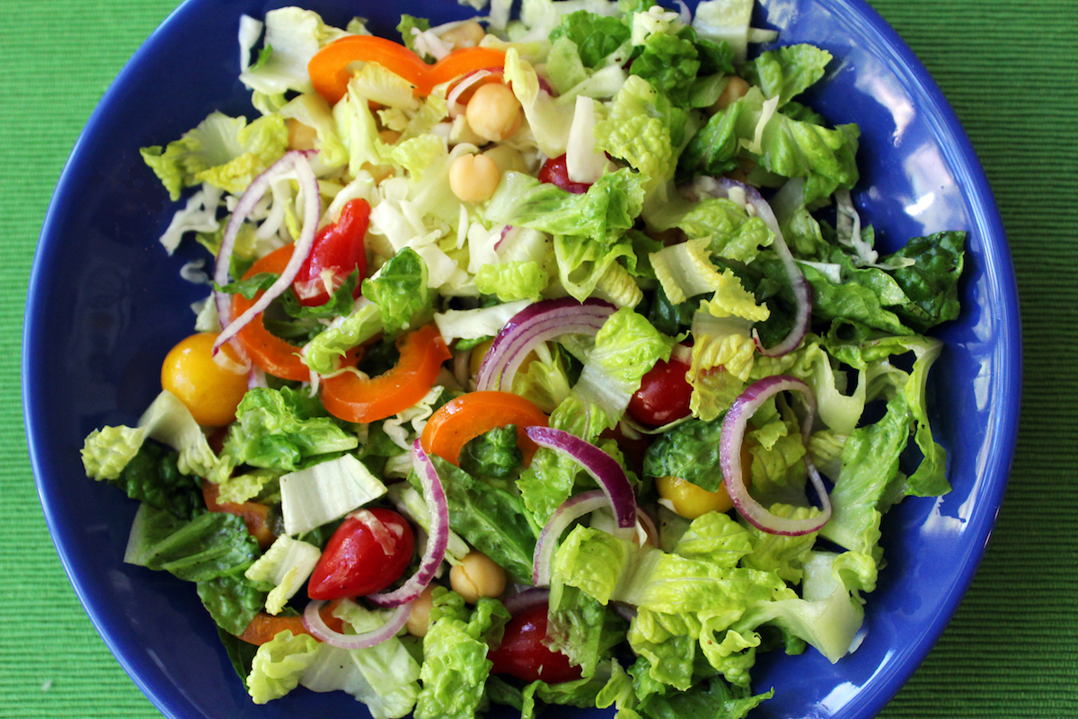Summer Salad Supper August 5th
Don’t miss this wonderful time of fellowship offered by the Presbyterian Women.
6:00 p.m. in the Family Life Center.


1 8:45 Christian Faith Yoga
10:15 Christian Faith Chair Yoga
2 10:00 Community Bible Study at Aroma Café
6:00 Grief Share (conference room)
3 8:45 Christian Faith Yoga
10:15 Christian Faith Chair Yoga
5:00 Nominating Committee (conference room)
7:00 Praise Team practice
4 Fourth of July, Church Office closed
6 7:30 Robbins’ Food Bank
7 9:00 Fellowship and Mission Committee (conference room)
9:00 Adult Sunday School (library)
10:00 Contemporary Worship Service (Family Life Center)
9 6:00 Grief Share (conference room)
10 7:00 Choir practice
11 10:00 Community Bible Study at Aroma Café
14 9:00 Worship Committee (conference room)
9:00 Adult Sunday School (library)
10:00 Worship and Children’s Church
11:00 Lemonade on the Lawn
15 6:00 RACM Board Meeting (Robbins)
16 6:00 Grief Share (conference room)
17 6:00 Choir practice
7:00 Praise Team practice
18 10:00 Community Bible Study at Aroma Café
21 9:00 Adult Sunday School (library)
10:00 Communion Worship Service and Children’s Church
23 Deadline for July Mouse
6:00 Grief Share (conference room)
24 8:45 Christian Faith Yoga
10:15 Christian Faith Chair Yoga
6:00 Choir practice
7:00 Praise Team practice
25 10:00 Community Bible Study at Aroma Café
28 9:00 Adult Sunday School (library)
10:00 Worship and Children’s Church
29 8:45 Christian Faith Yoga
10:15 Christian Faith Chair Yoga
30 1:00 Fold Mouse Newsletter (conference room)
6:00 Grief Share (conference room)
31 8:45 Christian Faith Yoga
10:15 Christian Faith Chair Yoga
6:00 Choir practice
7:00 Praise Team practice
Upcoming Church Mouse Newsletter Deadlines: July 23rd, August 20th, September 17th, October 22nd, November 19th, and December 17th

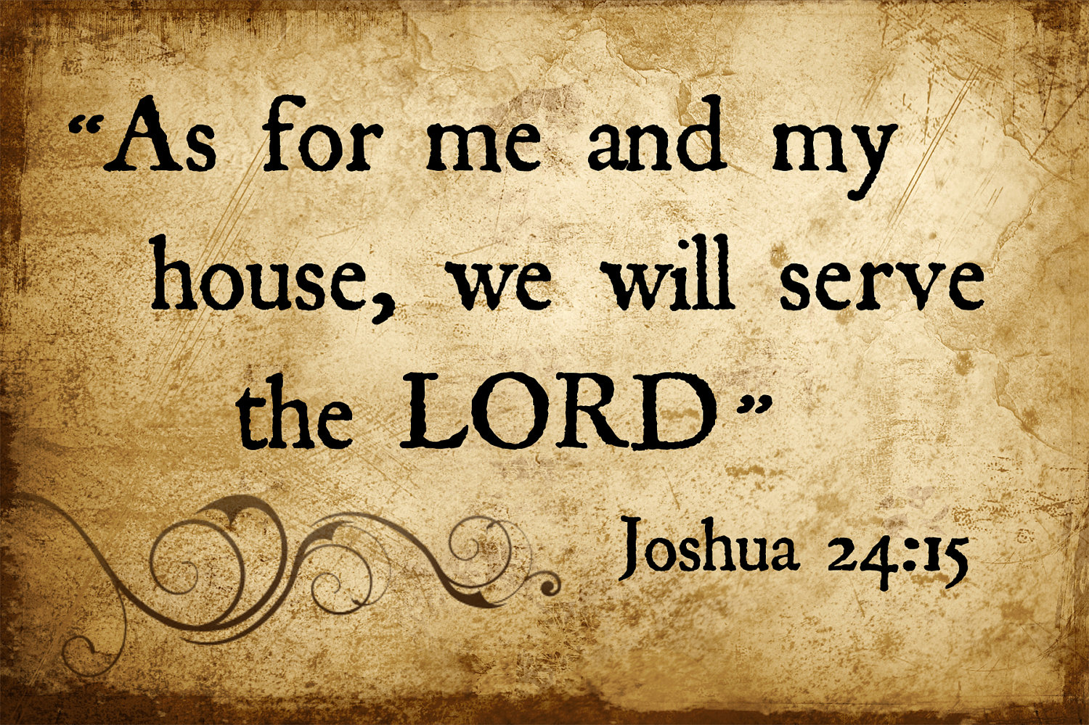

Happy Birthday!

1 Debbie Gordon
4 Gracen Bennett
4 CJ McDonald
7 JoAnn Wahala
8 Jason Myrick
11 Sarah Lucas
14 Susan Phillips
17 Geraldine Moore
18 Greg Riyevski
18 Marc Stromko
22 Carol White
22 Gavin Parker
24 Scott Tortora
26 Sawyer Dean
27 Scott McLeod
29 J.D. Monroe
31 Ina Sue Parks

Update us with church-family
birthdays anytime.
(910) 947-2924 infofpc397@gmail.com.

*****************************
GREETERS
7 Geraldine Moore
14 Bill Russell
21 JoAnn Wahala
28 The Muse Family




USHERS
Doris Russell*
Michelle Tortora
Robert Gordon
Scott Phillips
*Lead Usher


Flowers
7 Judi and Archie Kelly
14 Ann Key
21 Carol and Paul White
28 Denise and Lee Edmonds Family

To place flowers, a beautiful example of God’s creation, in church during the worship service, contact Susan Cole at 947-5764,
or see her at church.

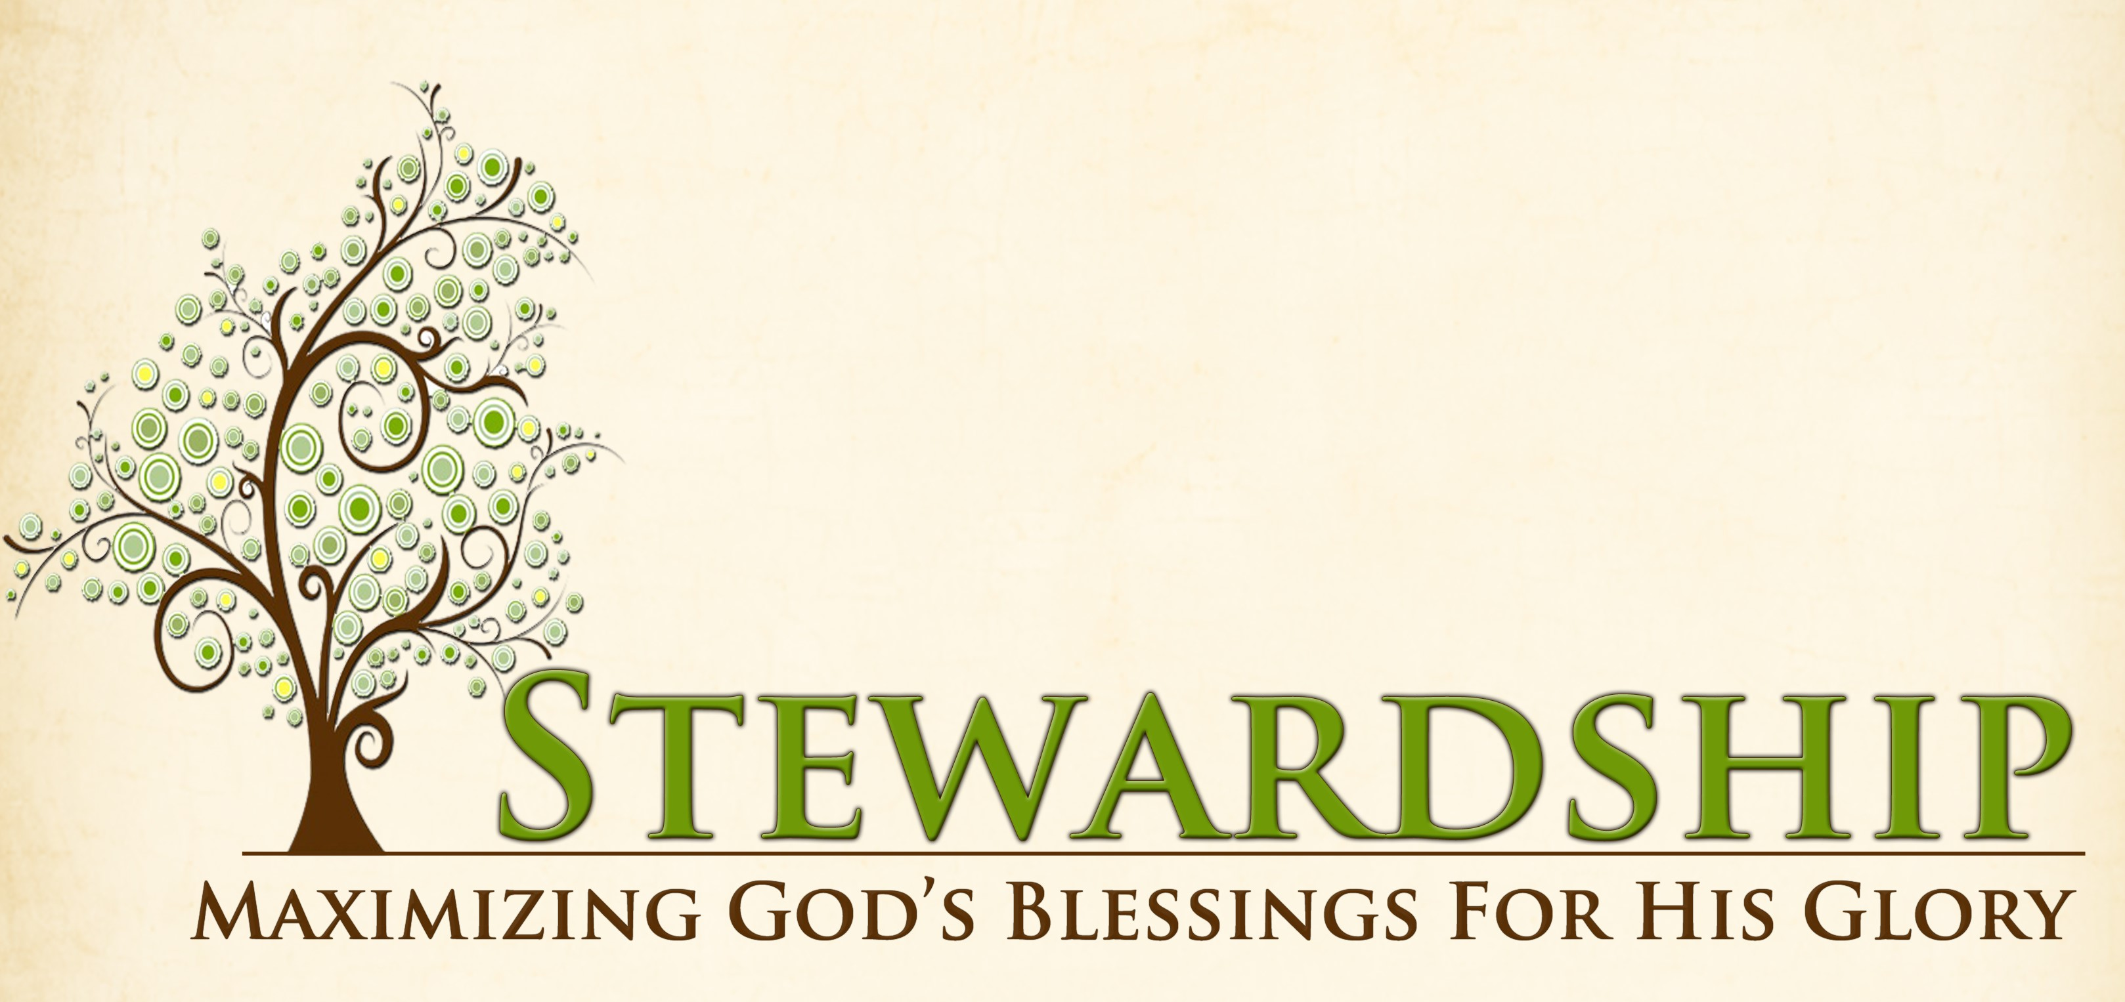 May Report
OPERATING FUNDS:
Balance in checking account as of May 1, 2019 | 60,062.36
Tithes and Offerings Received | +14,416.00
Sub-Total | 74,478.36
Expenditures | -16,935.59
Balance in checking account as of May 31, 2019 | 57,542.77
RESTRICTED FUNDS: (Funds designated for specific projects, etc.)
Restricted Funds held in checking account as of May 1, 2019  Employee FICA & w/holding taxes for May 2019  Donations/offerings received (2ȼ a Meal $122.50; Presbyterian Homes $257;  Playground equip. $100; Memorials: Reg $470; Bldg Fund $180) | 56,784.47  +536.21  +1,129.50
Sub-Total | 58,450.18
Expenditures: (VBS supplies $147.15; Frozen Meals $24.48; 2 Cents a  Meal (2 mos) $330.71; 1 Great Hour $522.14; Pres. Homes $242) | -1,266.48
Balance in Restricted Funds as of May 31, 2019 | 57,183.70
RECAP:
Operating Funds Balance | 57,542.77
Building Fund: Equipment etc 93.54 + Other 35,008.80 + 180.00 = | +35,282.34
Restricted Funds Balance | +21,901.36
 | 114,726.47
Apr & May '19 Payroll Taxes on hand (FICA 943.30; FW/H 94.94; SW/H 34.00) | -1,072.24
5/31/19 Checkbook Balance | 113,654.23
OTHER REVENUES ON HAND:
Scholarship C/D with BB&T  BB&T Investments Brokerage Acc. #JAL-059738, Estimated value (4 shs) | 23,370.20  +188.28
Total Other Revenues on hand | 23,558.48

May Attendance
 CHURCH SUNDAY SCHOOL
1st Sunday 75 38
2nd Sunday 73 36
3rd Sun 100 42
4th Sun 57 26
Average 76 36


Looking for fellowship with purpose?
First Presbyterian Church's women meet monthly to join for Ladies Lunch, Circle, Missions, and to provide community and church meals, including the annual FPC summer Salad Supper and Christmas Lunch. For more information about FPC Presbyterian Women, to receive PW email news, or, to receive a call to help in times of need, please call or text Helen at (910) 690-2463, or email her at hmcd2946gmail.com.

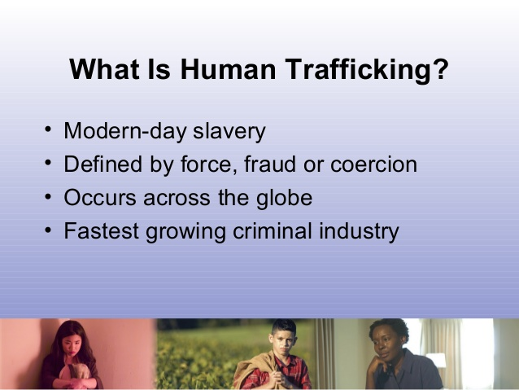
“Dare to Care: Human Trafficking Spotlight Night”
Monday, August 5th 6:00 p.m.
Families – come learn more about Human Trafficking,
how it affects our children, and what we can do
to prevent and fight this crime right here in Moore County. Our guest speaker from Carthage’s Friend to Friend
will provide relevant safety information geared for
middle school age students through adults. This Annual Salad Supper event is too important to miss. Be sure to bring your favorite salad to share for a time of fellowship that can empower us to save lives in our community.
Childcare for younger children available.


Circle is on summer break!
To order the upcoming
September Bible Study that takes a fresh look at the
Ten Commandments,
see Marie Monroe.
If you’d love to start an evening Circle like we would,
see Helen McDonald.

Pwcc Fall Gathering

Saturday, August 17th
Laurinburg Presbyterian Church
Look for info in next month’s Church Mouse.



We'll soon decorate pillowcases to send to children in Puerto Rico! Watch your Sunday Worship bulletins for info!

Ladies Lunch will not meet this month. We’ll dine again in August.

