Class of 2020
Doris Russell
Chad Thomason
Michelle Tortora
JoAnn Wahala

Class of 2021
Denise Edmonds
Robert Gordon
Lee McCaskill
Geraldine Moore

Class of 2022
Keith Hardin
Elizabeth Martindale
Helen McDonald
Marie Monroe

Non-Profit
Organization
U.S. Postage
PAID
CARTHAGE, NC
28327
Permit No. 35

FIRST PRESBYTERIAN CHURCH
POST OFFICE BOX 397
CARTHAGE, NORTH CAROLINA 28327
(910) 947-2924
fpccarthage.com (website)
infofpc397@gmail.com (email)
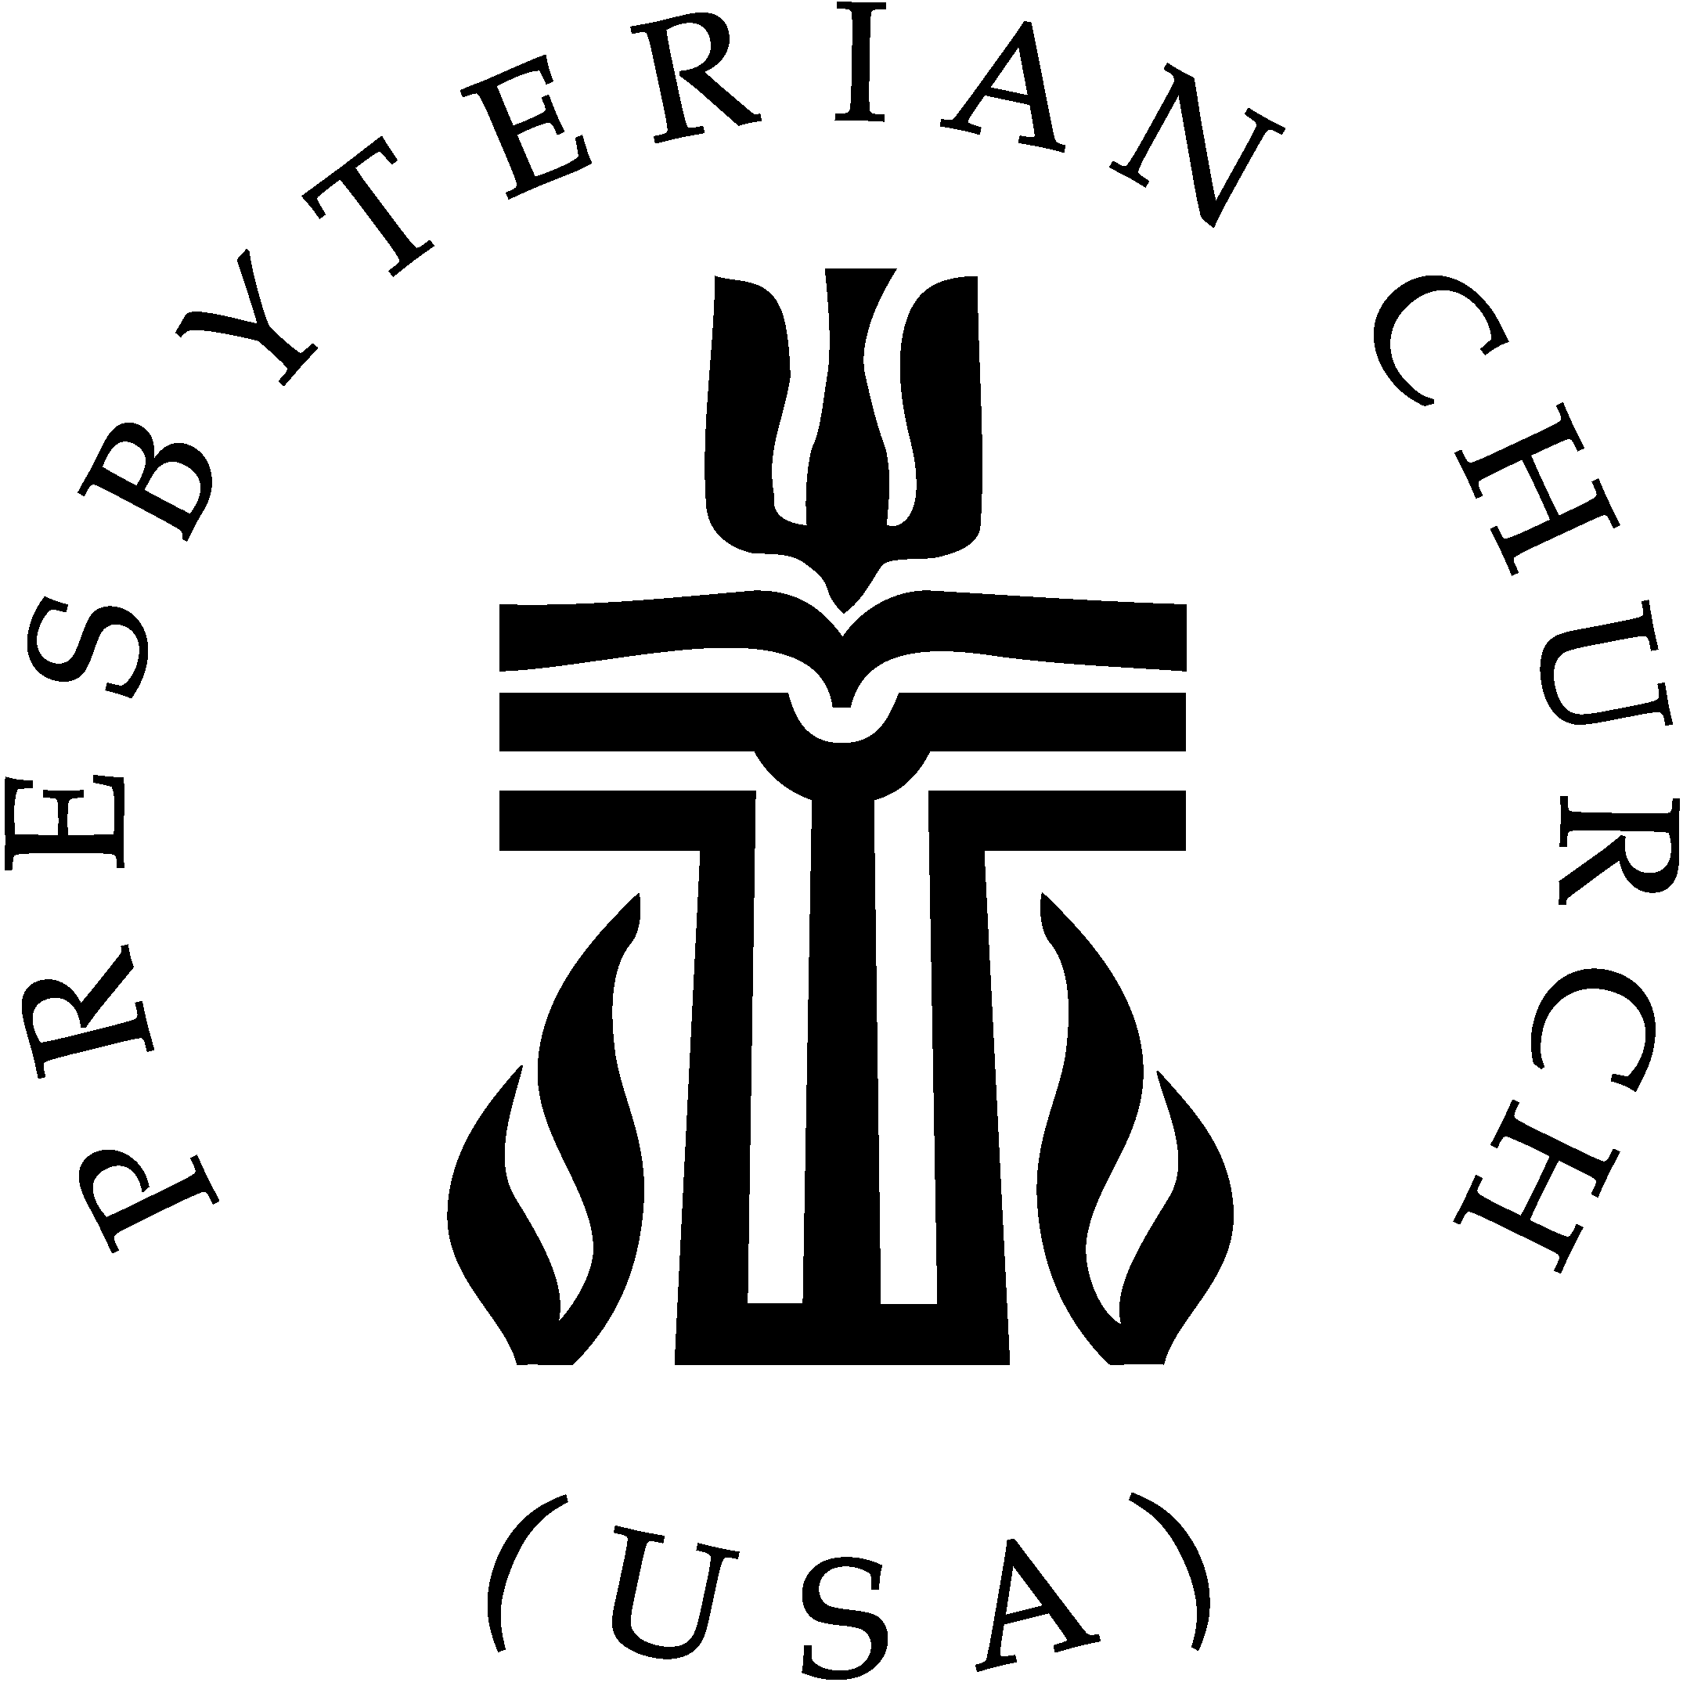
Fpc Carthage (facebook)



First Presbyterian
Church News
2020

The Reverend Rick Martindale Pastor
Ali Wadsworth Choir Director
Elizabeth Williams Organist
Shelley Hammond Administrative Assistant
Andie Hyman Nursery Attendant
Ann Key Sexton
Marie Monroe Treasurer

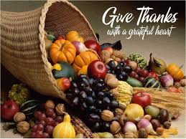

Elections Are Challenging

I was checking some recent polls and the presidential election is neck-in-neck. The senate race is about as close. The races are a statistical tie, which means in North Carolina and in our church family about half of us will be happy with the results and the other half will not. In other words, there will be lots of us unhappy very soon. I hope everyone has taken the time to vote.

Most of us are entrenched with one candidate or another. It might have to do with having a “R” or “D” beside their name. It might have something to do with global warming, larger or smaller government, the economy, COVID-19, abortion, personality, or other factors. For many people politics is almost like a religion.

But politics are not a religion. Politics are not pure. Lying and cheating are more like the norm than the exception. There are, however, good people who serve our community, state, and even nation. Sadly, there are many more who have ulterior motives. Instead of serving the people it’s about gaining power and doing one’s one will instead of what’s best for the nation.

Jesus Christ, however, is different. Jesus is without sin. He came to earth, suffered, died, and was resurrected not for His glory but for each of us. Our God loves us without exception. Our God embodies love with every action God makes. We can’t say that about politics. They only occasionally get it right. God gets it right every single time.

As the results of the 2020 election become clear, let us be reminded that Jesus Christ is the Lord and Savior of our lives. It is not the person who lives at 1600 Pennsylvania Avenue. We will probably experience some disappointment with this election. How we handle that disappointment tells a lot about the type of people we choose to be. We can show our disappointment and fear. But to belittle a supporter of the losing or winning candidate is wrong. In doing so, we are not loving our neighbor as ourselves. Jesus calls us to love one another, even those on the other side of the aisle.

This is a stressful time for us and our country, but our hope is in the One who is much more powerful than a person with the title of “president” or “senator” for example. Our strength, comes from the One who is Lord and Savior of all eternity. Looking at it from another angle, if you think it would be frightening not having your candidate win, imagine how horrible it would be without knowing Jesus Christ in your life.

May God’s Grace and Peace Be with You,

Rick
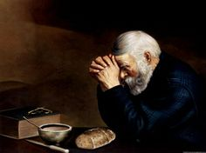
In Our Prayers

Please remember our sisters and brothers in your prayers as they face difficult times.

Debbie Albright Jean Bennett, Quail Haven Jimmy Bibey
Anna Belle Campbell John Currie, Tara Plantation Betty Elliott
Gail Hardin Keith Hardin Sheree Kelly
Margaret Leonard Carol Lucas Linda McCaskill
Nancy McKenzie Ina Sue Parks Kay Patterson
Judy Phillips Bonnie Scott Mary Thomas
Phillip Warmbrod Elizabeth Williams

Karen Bryant, friend of JoAnn Wahala Brian Casey, Lucinda and David’s son
Judy Claterbos, Mary Thomas’ sister Carl Greeson, Susan Cole’s brother
June Greeson, Susan Cole’s mother Ann Herndon, Kay Patterson’s sister
Sean Kennally, Angie Provost’s son-in-law Barbara May, friend of Debbie Gordon
Jane Medlin, Carol Lucas’ daughter Parker Megs, Union Pines student Jonah Monk, Sarah and Jonathan Monk’s son Debbie, Marlene Riyevski’s sister
Charles McNeil, Serge Riyevski’s son-in-law Louise Summers, friend of Denise Edmonds
Tommy Walton, Diane Pangborn’s brother

All of our military men and women and their families, especially the following:
Michael Abercrombie, Jonathan Baker, Kyle Bryant, Chris Mohan,
Patrick Mohan, Michael Schwartz, Will Strickland, and Quinn Wicker.

If you would like to add someone or take yourself off this list,
please call the church office at 947-2924,
or email infoFPC397@gmail.com.

SEPTEMBER 2020
FINANCIAL REPORT

CHURCH ON THE LAWN DURING THE MONTH OF SEPTEMBER, 2020 DUE TO COVID-19 VIRUS
OPERATING FUNDS:
Balance in checking account as of September 1, 2020 | 88,651.04
Tithes and Offerings Received | +13,241.00
Sub-Total | 101,892.04
Expenditures | -11,513.17
Balance in checking account as of September 30, 2020 | 90,378.87
RESTRICTED FUNDS: (Funds designated for specific projects, etc.)
Restricted Funds held in checking account as of August 1, 2020  Employee FICA & w/holding taxes for September 2020  Donations/offerings received (2ȼ a Meal $20.00; Bldg Fd $50; Memorials $125; BB&T Dividend $1.80) | 88,979.37  +562.37  +196.80
Sub-Total | 89,738.54
Expenditures: Truist Financial Corp (BB&T), Annual Brokerage Acct. fee | -19.00
Balance in Restricted Funds as of September 30, 2020 | 89,719.54
RECAP:
Operating Funds Balance | 90,378.87
Building Fund: Equip etc. 93.54 + Other 60,528.62 + $51.80-$19.00=$60,561.42 = | +60,654.96
Restricted Funds Balance | +29,064.58
 | 180,098.41
July-Sep '20 Payroll Taxes on hand (FICA 1,473.46; FW/H 159.00; SW/H 45.00 +.02) | -1,677.48
9/30/2020 Checkbook Balance | 178,420.93
OTHER REVENUES ON HAND:
Scholarship C/D with BB&T  BB&T Investments Brokerage Acc. #JAL-059738, Estimated value (4 shs) | 23,635.62  +172.84
Total Other Revenues on hand | 23,808.46

into faith

Autumn Blessings to you!
Enjoy this Kids Coloring Corner (for adults too) as we count our many blessings this season!

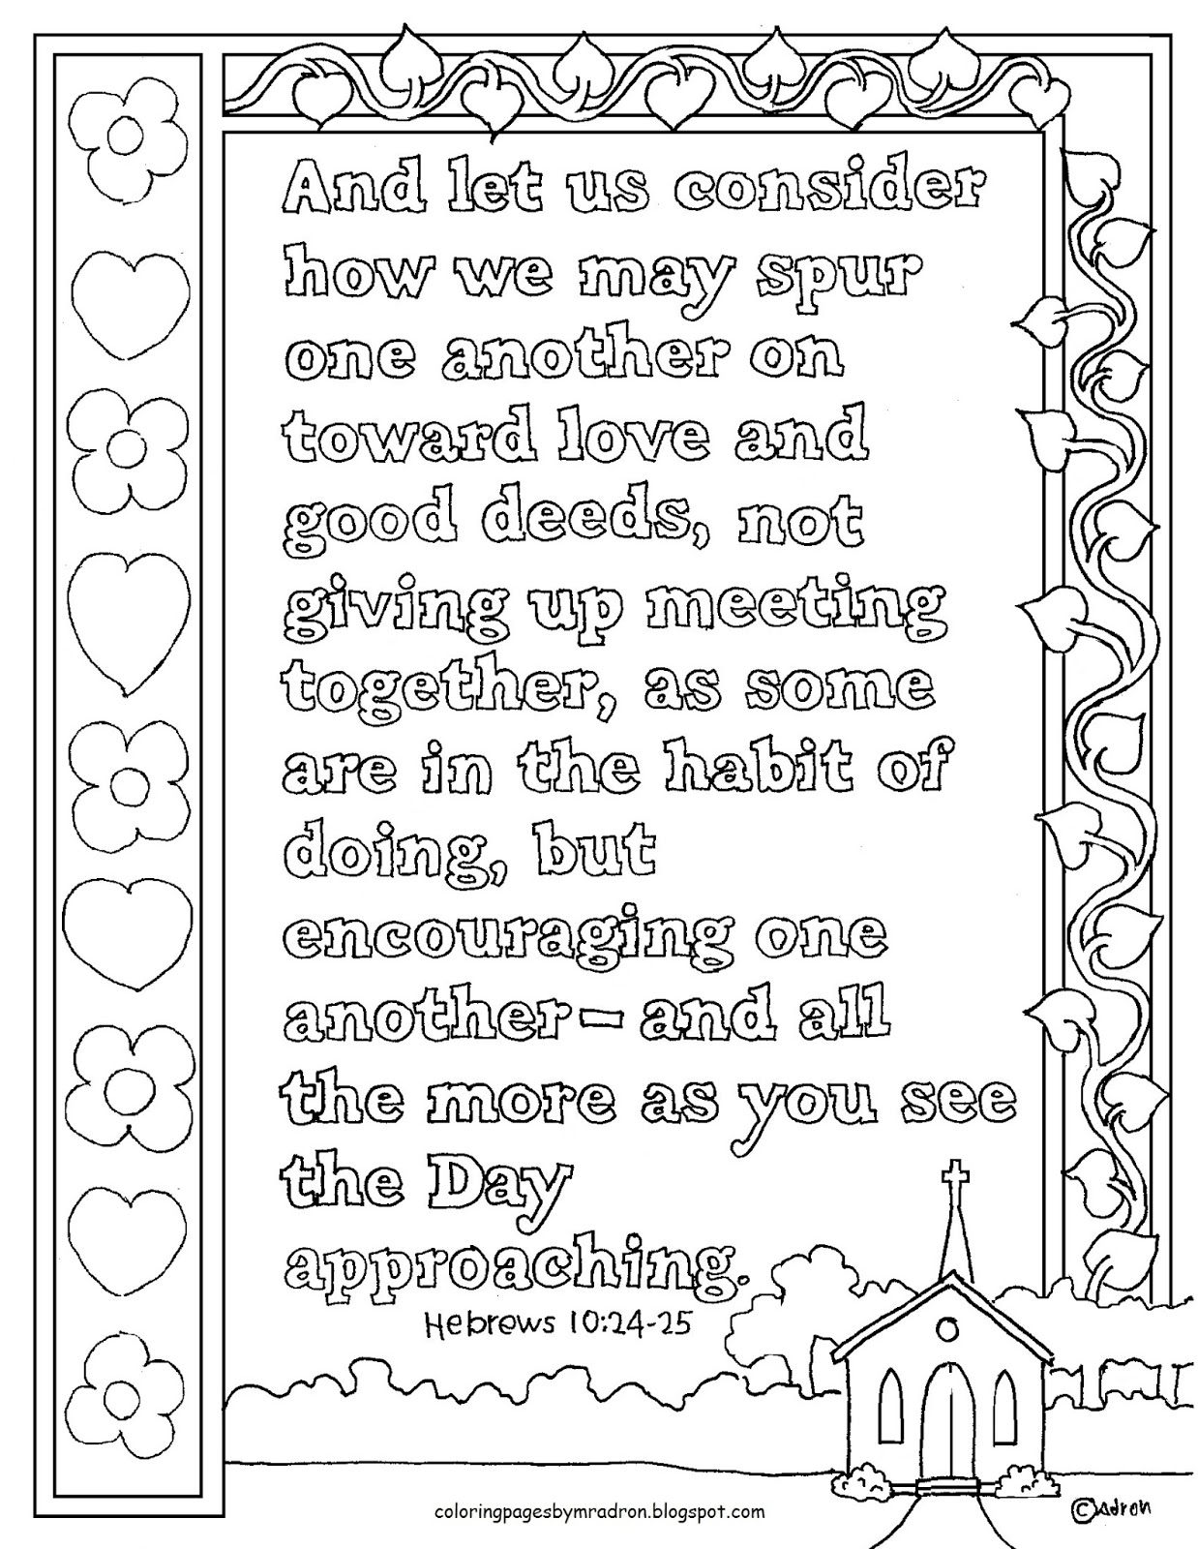
Thanks to all who helped and participated in the drive thru birthday for
Anna Belle Campbell.
You helped make her birthday very special!

THANK YOU FOR YOUR GENEROSITY!
Your recent contributions to Presbyterian Women’s October Thank Offering
are greatly appreciated, as they fund grants for projects that help women and children – both here in the USA, and internationally.
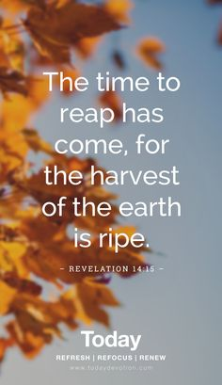
Upcoming FPC Opportunities

Sundays
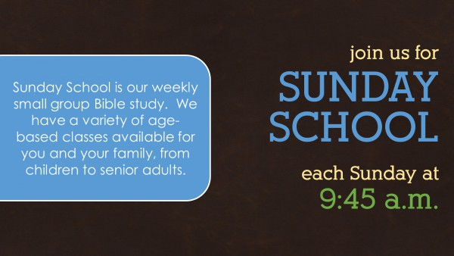
www.fpcCarthage.com/worship

10:00 a.m. Children's & Youth Sunday School
ages 3 - 12th grade
*No adult classes at this time.

10 a.m. Inside AND Virtual Worship Service
Inside our Family Life Center.
Social distancing and masks required.
Watch the service live at 10 a.m. on our
Facebook Page (Fpc Carthage),
and after the service virtually by clicking on the
FPC Video tab on our website www.fpccarthage.com.

11 a.m. Outdoor Worship Service
Outside on the FPC Lawn.
Wear your masks until seated and
bring a lawn chair.

​


Join us 7:30 a.m.
Saturday, November 7th
at Robbins’ Food Bank
of Robbins Area Christian Ministries to distribute food to local, hungry families.
Visit www.fpcCarthage.com/ways-to-serve
to find out more!


Ladies Bible Study
Thursday, November 5th, 11 a.m.
Outside, weather permitting.
Indoors in the Family Life Center otherwise.
Visit our “Women of Faith” page at www.fpcCarthage.com
for more ways to connect!


5 p.m.
wpww.fpcCarthage.com/youth

This month, FPC Youth is collecting items for
Operation Christmas Child Shoeboxes. Please drop your donations off at the Family Life Center Donation Station.



Happy Birthday!
1 Cody Adelmann
4 Anne Lucas
5 Scott Phillips
8 Jeff Medlin
9 Bill Russell
10 Steve Ingold
12 Emily Tortora
15 Megan Phillips
20 Doreen Little
21 Jane Ritter
24 Hallie Patterson
27 Cathy Campbell
29 Chad Thomason
30 Nancy McKenzie

Sunday, November 1st Daylight Savings time begins.
10:00 a.m. Children’s Sunday School, ages 3-12th grade
10:00 a.m. Indoor/Virtual Worship Service (FLC)
11:00 a.m. Outdoor Worship Service
5:00 p.m. Youth
6:00 p.m. Stewardship and Finance Committee (fellowship hall)
Monday, November 2nd Christian Faith Yoga – 2 p.m. Floor, 3:15 p.m. Chair (FLC)
Tuesday, November 3rd Election Day
6:00 p.m. Men’s Group (FLC)
Thursday, November 5th 11:00 a.m. Ladies Morning Bible Study Circle (FLC/outside)
Saturday, November 7th 7:30 a.m. Robbins’ Food Bank
Please donate double-bagged plastic bags in the FLC.
Sunday, November 8th 10:00 a.m. Children’s Sunday School, ages 3-12th grade
10:00 a.m. Indoor/Virtual Worship Service (Family Life Center)
11:00 a.m. Outdoor Worship Service (FPC lawn)
2:00 p.m. Session meeting
5:00 p.m. Youth
November Ushers Geraldine Moore (lead)
Keith Hardin
JoAnn Wahala
Chad Thomason

Monday, November 9th Christian Faith Yoga – 2 p.m. Floor, 3:15 p.m. Chair (FLC)
Wednesday, November 11th Veterans Day
Sunday, November 15th 10:00 a.m. Children’s Sunday School, ages 3-12th grade
10:00 a.m. Indoor/Virtual Communion Worship Service (FLC)
11:00 a.m. Outdoor Communion Worship Service
5:00 p.m. Youth
Monday, November 16th Christian Faith Yoga – 2 p.m. Floor, 3:15 p.m. Chair (FLC)
Tuesday, November 17th noon December Church Mouse Newsletter Deadline
6:00 p.m. Men’s Group (FLC)
Sunday, November 22nd 10:00 a.m. Children’s Sunday School, ages 3-12th grade
10:00 a.m. Indoor/Virtual Worship Service (FLC)
11:00 a.m. Outdoor Worship Service
Monday, November 23rd Christian Faith Yoga – 2 p.m. Floor, 3:15 p.m. Chair (FLC)
10:00 a.m. Decorate this Chrismon Tree
Thursday, November 26th Thanksgiving Day
Friday, November 27th Youth trip to Operation Christmas Child, Charlotte
Sunday, November 29th 10:00 a.m. Children’s Sunday School, ages 3 – 12th grade
10:00 a.m. Indoor/Virtual Worship Service (Family Life Center)
11:00 a.m. Outdoor Worship Service (FPC lawn)
Monday, November 30th 6:00 p.m. Worship Committee (FLC)


Help share the reason for the season
this Christmas with FPC’s annual
Angel Tree outreach.

Stop by Angel Tree at FPC to choose silver and gold angel gift tags for two Carthage Elementary families in need this Christmas. Wrap your new gifts, attach the angel tag on the outside of each gift, and place it under the tree now through early December. Stay tuned for updates through One Call Now and Sunday morning worship announcements.
Thank you for sharing
the love of Jesus during this
most special time of year!!

FPC Fellowship & Missions

Session Notes:
-Donated $3,600. to local organizations and ministries in our community
-Approved a second Tail-Gate Picnic for October 25th at 5 p.m.
-Approved the start of Sunday School for our children and youth
-Started a second worship service – one inside at 10 a.m. and one outside with optional
masks after sitting down at 11 a.m.
-Approved vacation time for Rev. Martindale including most Thursdays for the rest of the
year and the last week of December.
-Work on repairing the Currie/education building and the sanctuary roofs are
moving forward

