(910) 947-2924
infofpc397@gmail.com

www.FpcCarthage.com


Fpc Carthage


#fpcbethelight
First Presbyterian Church
A Community Cornerstone
for Christ since 1850.

Located in the heart of Carthage, NC
near the Post Office at 110 South Ray Street,
First Presbyterian welcomes you!

The Reverend Rick Martindale Pastor
Ali Wadsworth Choir Director
Elizabeth Williams Organist
Shelley Hammond Administrative Assistant
Andie Hyman Nursery Attendant
Ann Key Sexton
Marie Monroe Treasurer



The Reverend Rick Martindale, Pastor
Shelley Hammond, Administrative Assistant
Ann Key, Sexton
Marie Monroe, Treasurer
Robert Wilson, Choir Director and Organist

FPC Session
Session Class of 2021 Denise Edmonds, Robert Gordon, Lee McCaskill, Geraldine Moore
Session Class of 2022 Keith Hardin, Elizabeth Martindale, Helen McDonald, Marie Monroe
Session Class of 2023 Lucinda Casey, Tom Leonard, Scott Phillips, Jennifer Thomason

Non-Profit
Organization
U.S. Postage
PAID
CARTHAGE, NC
28327
Permit No. 35
First Presbyterian Church
PO Box 397
Carthage, NC 28327

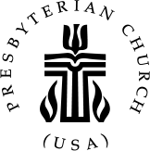

First Presbyterian Church

January 2022 Newsletter

It’s a Big Choice

Depending on the arrival of your Church Mouse, you are either preparing for one of the most exciting times of the entire year with the birth of the Christ child, or Christmas has just passed and decorations are already packed away. No matter the case, we can joyfully worship Jesus Christ every day of the year!

I recently read an article that more and more Americans are becoming secular. In other words, they are turning away from God. The numbers are not shocking. We have heard reports that Christianity is waning. We see it in the pews. More than half of Americans aren’t members of a church. Such polls might be troubling for us until we examine history. How many times did the Israelites fail to follow God’s will in the wilderness toward the promised land? How many times did the people rebel against the judges and kings of Israel? The short answer for both is… a lot! Are we any different?

God has given us the gift of Jesus. We embrace this season of love and grace. No matter if December 25th has arrived yet or not, we are still in the Christmas season. It’s that time of year when people are more generous, a little kinder, a little more understanding, and so forth. We need God in our daily lives.

As we say goodbye to this Christmas season, what will 2022 become for us? Will we continue to share God’s love and grace with one another? Will we place more of an emphasis on the secular world and less on God working in our lives? Fortunately, it’s up to us. We, like Joshua, can decide whom we will serve.

Noah did not let others influence his decision to follow God’s will. Many thought their view of God was correct until a band of followers led by a Carpenter revealed something quite different. One man thought he had all the right answers because he had studied scriptures his whole life until one day on the road to Damascus, Jesus confronted Paul and made him rethink everything.

We don’t know all the answers. We aren’t supposed to. But we know the One who does. Do we choose the secular world or God? It is our choice. As we begin a new year, may we place our trust in God’s Son, Jesus Christ.

Grace and Peace, Rick
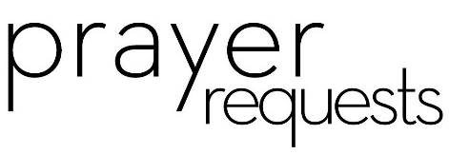
First Pres prays for you.
Remembering our brothers and sisters in Christ facing difficult times in prayer.

Debbie Albright Family of Jean Bennett
Anna Belle Campbell Benny Cole
Susan Cole and family John Currie, Tara Plantation
Family of Gail and Keith Hardin Carol Lucas
Linda McCaskill Sharon and John McDonald’s family
Nancy McKenzie and family Jeff Medlin and family
Gail Meeks Jeannie Muse and family
Ina Sue Parks Kay Patterson
Judy Phillips, Accordius, Aberdeen Family of Herman Seawell
Tom Stewart Phillip Warmbrod

Artie Barber, friend of the Monroes
Terry Barber, friend of the Monroes
Bo, friend of Geraldine Moore
Karen Bryant, friend of JoAnn Wahala
June Greeson, Susan Cole’s mother
Ann Herndon, Kay Patterson’s sister
Sean Kennally, Angie Provost’s son-in-law
Jerrod Lowry and children, family of Molly Lowry
Barbara May, friend of Debbie Gordon
Jane Medlin, Carol Lucas’ daughter
Lisa Muller, Cousin of Ina Sue Parks
Randy Scott, Ann Lynch’s brother

All of our military men and women and their families, especially the following:
Jonathan Baker, Kyle Bryant, Jack Mason, Chris Mohan,
Patrick Mohan, Greg Riyevski, Michael Schwartz, and Quinn Wicker.

If you would like to add someone, or take yourself off this list,
please call the church office at 947-2924.

FPC Stewardship & Finance
November 2021

OPERATING FUNDS:
Balance in checking account as of Nov 1, 2021 | 87,030.48
Tithes and Offerings Received | +10,894.00
Sub-Total | 97,924.48
Expenditures | -14,597.79
Balance in checking account as of Nov 30, 2021 | 83,326.69
RESTRICTED FUNDS: (Funds designated for specific projects, etc.)
Restricted Funds held in checking account as of Nov 1, 2021  Employee FICA & w/holding taxes for Nov 2021  Donations/offerings received (2ȼ a Meal $56.80; Bldg Fd $220; Presbyterian  Women Food/Meals $50 + Thank Offering $70; Memorials $425;  Shoebox Ministry $250; Honorarium $99; Cemetery Fd Memorial $50 | 45,896.72  +337.21  +1,220.80
Sub-Total | 47,454.73
Expenditures: Balance on roof repairs $9,430.43; 2 Cents a Meal $227.52 | -9,657.95
 | 37,796.78
RECAP:
Operating Funds Balance | 83,326.69
Building Fund: Equip 93.54 + Grant 265.67 + Other 17,043.89 + $220.00 (17,263.89)= | +17,623.10
Restricted Funds Balance | +20,173.68
 | 121,123.47
Oct-Nov '21 Payroll Taxes on hand (FICA 609.49; FW/H 52.00) | -661.04
11/30/2021 Checkbook Balance | 120,461.94
OTHER REVENUES ON HAND:
Scholarship C/D with BB&T  Truist Financial Corp, Estimated value (4 shs)  Total Other Revenues on hand | 23,040.37  +237.56  23,277.93
FPC Calendar January 2022 Family Life Center (FLC) Conference Room (CR)

Saturday, January 1st New Year’s Day

Sunday, January 2nd 2nd Sunday of Christmas
10:00 a.m. Sunday School
11:00 a.m. Multiple Indoor Worship Experiences / Virtual /
Special Offering for Tornado Victims
1st Sunday 2 Cents a Meal Offering
Congregational Meeting

Wednesday, January 5th 6:30 p.m. Worship Committee

Thursday, January 6th Epiphany of the Lord
11:00 a.m. Women’s Day Circle & Bible Study (FLC)

Saturday, January 8th 7:30 a.m. Robbins’ Food Bank, meet 7 a.m. at FPC to carpool

Sunday, January 9th Baptism of the Lord
10:00 a.m. Sunday School
11:00 a.m. Multiple Indoor Worship Experiences / Virtual
2:00 p.m. Session Meeting
5:00 p.m. Youth Group, grades 7-12

Sunday, January 16th 10:00 a.m. Sunday School
11:00 a.m. Multiple Indoor Worship Experiences / Virtual /
Communion

Monday, January 17th Deadline for February Church Mouse Newsletter
No School – Birthday of Martin Luther King, Jr.

Tuesday, January 18th No School

Sunday, January 23rd 10:00 a.m. Sunday School
11:00 a.m. Multiple Indoor Worship Experiences / Virtual
5:00 p.m. Youth Group, grades 7-12

Sunday, January 30th 10:00 a.m. Sunday School
11:00 a.m. Multiple Indoor Worship Experiences / Virtual
5:00 p.m. Youth Group, grades 7-12
January Birthdays
9 John Baker III
10 Alma Baker
12 Paul White
13 Hal Meeks
14 Duncan Kelly
14 Keith Hardin
16 Tom Leonard
24 Riley Medlin
25 Carson Kelly
26 Ali Smith
29 Pat Nugent

January Flowers
2nd Advent Poinsettias
9th Jennifer and Chad Thomason
16th Megan and Scott Phillips
23rd Helen and CJ McDonald
30th Denise and Lee Edmonds

Attendance Sunday School Worship
November 7th 23 39
November 14th 25 44
November 21st 17 45
November 28th 28 37
Average 22 41

Thank you for keeping church member Phillip Warmbrod, our brother in Christ, in your prayers. Phillip is currently residing in Durham. If you would like to mail him a card this new year,
please send to Phillips’ attention at the following address:
Straight Talk Support Group
1101 North Mangum Street
Durham, NC 27701
*Please do not send money. The Church is helping.




Approved the following:
-Switching optional and mandatory masks locations for worship on 12/19 and 12/24
-One service, Christmas in the Barn, on the 26th in the multi-purpose room, masks optional
-$550 donated to the Carthage Food Pantry
-Collecting Sweat Pants or joggers for the month of January (larger youth and adult sizes)
-Special offering to be collected on January 2nd for Tornado Victims
-Painting and repair work is getting ready to start in sanctuary.
Thank you!
Through uncertain times, you’ve remained steadfast in blessing our church family and friends.
Fellowship and Mission and Presbyterian Women thank you for your generous 2021 special offerings and donations of food, clothing, snacks, school supplies, Angel Tree gifts, monetary donations, and your time in support of our basket ministry and missions. You are loved!

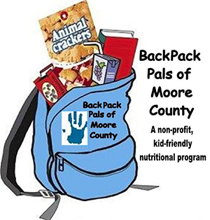

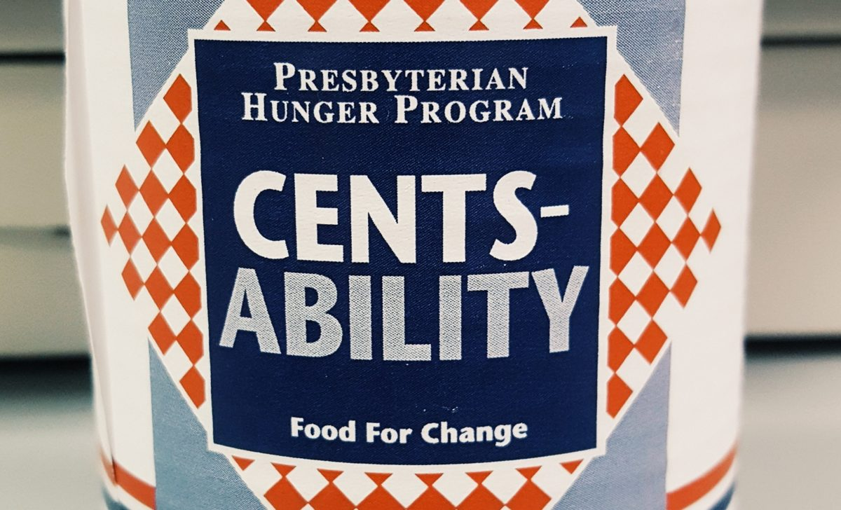

FPC’s Family Life Center serves as a collection site for our
BASKET MINISTRIES & MISSIONS. Our January focus is
BackPack Pals of Moore County and a clothing drive for Carthage Elementary.

New and gently-used sweatshirts, hoodies, and joggers/sweatpants ranging from children through adult sizes are needed (especially youth and adult sizes);
as well as after-school snacks of crackers and raisins.

Items can be dropped off in the Family Life Center baskets throughout the month.

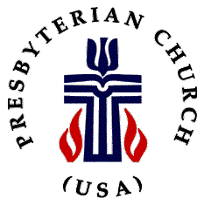

On Sunday, January 2nd, we will collect a special Presbyterian Disaster Assistance offering to help with tornado relief efforts in western Kentucky.

Celebrating Christ this Year at FPC
Looking ahead into this blessing of a new year. Let us celebrate together in Christ!

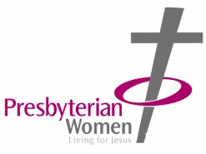

Please join us in worship, fellowship and study, and be sure to stay connected with your church family through announcements made during Sunday morning worship, our One Call Now phone tree, our Facebook page (Fpc Carthage), and through the Google Calendar and announcements pages on our church website, www.fpccarthage.

Sundays at FPC

10 a.m. Sunday School for ages 3 through adult

11 a.m. Worship
Two indoor services are provided, one in the sanctuary and one in the multipurpose room. We will rotate masks optional at service locations to provide everyone an opportunity to worship in the sanctuary. On December 24th it is masks optional in the sanctuary. On December 26th there will be only one service at 10 a.m., and masks will be optional for those worshiping in the multipurpose room. Worship can also be viewed via Facebook Live and on our website.
*1st Sundays 2 Cents a Meal Children’s Offering *3rd Sundays Communion

4-5 p.m. Sunday Funday! (1st Sundays)
Children ages four through 6th grade meet for fun and fellowship.

5 – 6:30 p.m. Youth Group
Youth in grades 7-12 meet Sunday evenings to have fun, be challenged, and explore what it means to be a Christian.

Women of Faith
Ladies Fellowship Circle & Bible Study
Ladies meet on the first Thursday of the month at 11 a.m. in the Family Life Center for fellowship and Bible Study.

Daily Devotionals
These Days devotionals are available in the lobby of the Family Life Center.

