First Presbyterian Church

Located in the heart of Carthage, NC near the Post Office at 110 South Ray Street,
First Presbyterian welcomes you!



(910) 947-2924 infofpc397@gmail.com FpcCarthage.com

The Reverend Rick Martindale, Pastor
Ali Wadsworth, Choir Director
Elizabeth Williams, Organist
Shelley Hammond, Administrative Assistant
Andie Hyman, Nursery Attendant
Ann Key, Sexton
Marie Monroe, Treasurer

Session Class of 2021 Denise Edmonds, Robert Gordon, Lee McCaskill, Geraldine Moore
Session Class of 2022 Keith Hardin, Elizabeth Martindale, Helen McDonald, Marie Monroe
Session Class of 2023 TBD

The Reverend Rick Martindale Pastor
Ali Wadsworth Choir Director
Elizabeth Williams Organist
Shelley Hammond Administrative Assistant
Andie Hyman Nursery Attendant
Ann Key Sexton
Marie Monroe Treasurer




Fpc Carthage FpcBeTheLight

Non-Profit
Organization
U.S. Postage
PAID
CARTHAGE, NC
28327
Permit No. 35
First Presbyterian Church
PO Box 397
Carthage, NC 28327

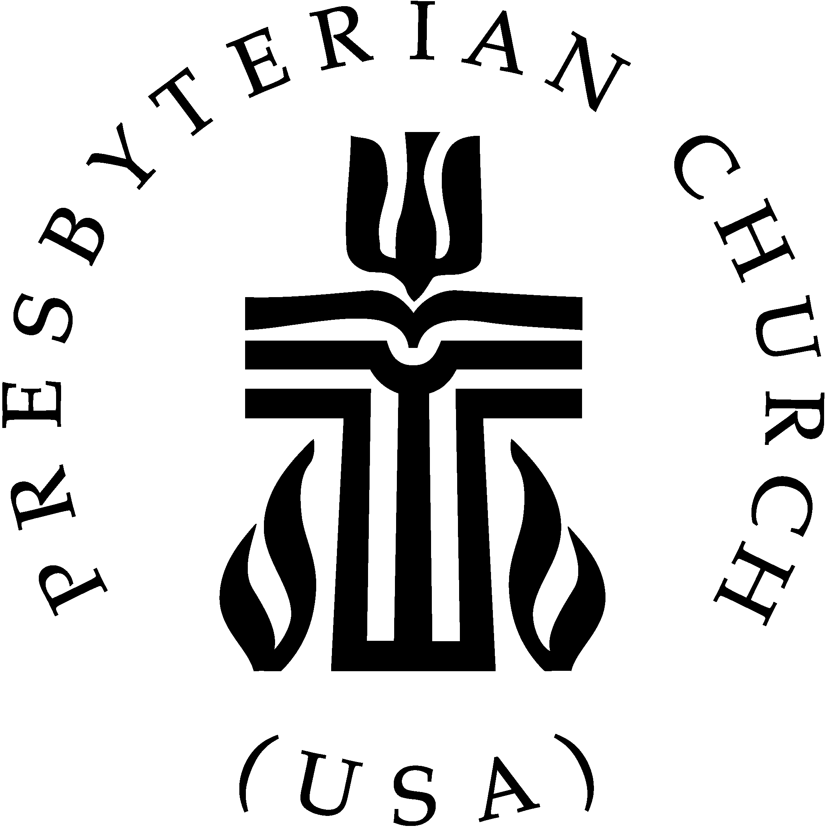


First Presbyterian Church A Cornerstone for Christ since 1850.

February 2021 Church News

Come to the Table

We have often heard the following words before Holy Communion, “Come to me, all you that are weary and are carrying heavy burdens, and I will give you rest. Take my yoke upon you, and learn from me; for I am gentle and humble in heart, and you will find rest for your souls.” (Matthew 11:28-29). This is a powerful and invigorating statement from our Lord and Savior.

There is a reason that it is often used to invite us to the Lord’s Table. Jesus gathers us together to discard our differences, sin, and acknowledge that our true strength never comes from one another, but from God.

As we sludge through the 11th month of COVID-19, we are worn out. Each of us are weary and carrying heavy burdens. Not just some of us but all of us. You are worn out. I am worn out. We want to see one another again. We want to worship together in person. We want to enjoy the fellowship of our church family. We want our children and grandchildren back in school. We want the freedom to see and be seen by others. We want physical, social, and mental well-being for everyone. Without spiritual well-being, however, we will struggle through this life.

The struggles are real for each of us, but so is the promise from God. “Come to me… and I will give you rest for your souls.” Jesus acknowledges that life will be difficult but He is ultimately worried about our souls. Our souls dictate every other part of our daily walk. God provides a sense of contentment as we journey through life.

Jesus calls the Jewish people to be free from the great burden of the Roman Empire. Jesus is calling us, who are under the great burden of COVID-19 (and all related aspects of it), to be free from it and embrace His yoke which is gentle and humble. Our spiritual life with God guides every other part of our being.

We are worn down, but the way of Christ focuses our energy. Christ helps us to look beyond sin and the challenges we face. We can discover the joy that God provides. God opens the possibilities for us. God wants us to come to God’s table. God longs for us to trust God. We get to choose which yoke, which table, we choose to make our own. Gathering at One table lifts us up. The other causes us to painfully wade through life. Each day we get to choose.

Grace and Peace,
Rick

First Pres prays
for you.

Remember our brothers and sisters in Christ through prayer and petition
as they face difficult times.

Debbie Albright Jean Bennett, Quail Haven Jimmy Bibey
Anna Belle Campbell John Currie, Tara Plantation Justin & Sarah Edmonds
Lee Edmonds Keith Hardin Margaret Leonard Carol Lucas Ina Sue Parks Kay Patterson
Otis Patterson Bonnie Scott Phillip Warmbrod

Karen Bryant, friend of JoAnn Wahala Brian Casey, Lucinda and David’s son
Judy Claterbos, Mary Thomas’ sister Jack Denniston, Lucinda and David’s daughter-in-law’s father
The family of Betty Elliott Carl Greeson, Susan Cole’s brother
June Greeson, Susan Cole’s mother Ann Herndon, Kay Patterson’s sister
Sean Kennally, Angie Provost’s son-in-law Barbara May, friend of Debbie Gordon
Jane Medlin, Carol Lucas’ daughter Tommy Walton, Diane Pangborn’s brother

All of our military men and women and their families, especially the following:
Michael Abercrombie, Jonathan Baker, Kyle Bryant, Chris Mohan,
Patrick Mohan, Michael Schwartz, Will Strickland, and Quinn Wicker.

Stay connected!
If you would like to add someone or take yourself off our Prayer List,
please contact the church office at 947-2924, or email us at infofpc397@gmail.com.

FPC Stewardship & Finance
December 2020

OPERATING FUNDS:
Balance in checking account as of December 1, 2020 | 96,558.70
Tithes and Offerings Received | +19,963.00
Sub-Total | 116,521.70
Expenditures | -27,367.18
Balance in checking account as of December 31, 2020 | 89,154.52
RESTRICTED FUNDS: (Funds designated for specific projects, etc.)
Restricted Funds held in checking account as of December 1, 2020  Employee FICA & w/holding taxes for December 2020  Donations/offerings received (2ȼ a Meal $0.00; Bldg Fd $25,000; Memorials $125; PW 2020 Thank Offering $25; Carthage Food Pantry $480; Cemetery $300; Stock div $1.80; Technology Grant $500; Ins pmt, roof damage $16,217.20) | 89,964.28  + 623.57  +42,649.00
Sub-Total | 133,236.85
Expenditures: 2 Cents a Meal to Presbytery | -5.00
Balance in Restricted Funds as of December 31, 2020 | 133,231.85
RECAP:
Operating Funds Balance | 89,154.52
Building Fund: Equip etc 93.54 + Other 60,961.42 + $41,219.00 = | +102,273.96
Restricted Funds Balance | +30,957.89
 | 222,386.37
Oct-Dec '20 Payroll Taxes on hand (FICA 1,526.77; FW/H 159.00; SW/H 45.00) | -1,730.77
12/31/2020 Checkbook Balance | 220,655.60
OTHER REVENUES ON HAND:
Scholarship C/D with BB&T  BB&T Investments Brokerage Acc. #JAL-059738, Estimated value (4 shs) | 23,635.62  +202.60
Total Other Revenues on hand | 23,838.22

FPC Calendar February 2021
Family Life Center (FLC) Conference Room (CR) Outdoor Worship held at 40 degrees+

Monday, February 1st Online Lent Devotionals available at www.fpccarthage.com
2:00 p.m. YogaFaith floor class (FLC)
3:15 p.m. YogaFaith chair class (FLC)
Wednesday, Feb. 3rd Homebound Valentine Basket donations begin through Feb. 7th
Saturday, February 6th 7:30 a.m. Robbins’ Food Bank, meet 7 a.m. at FPC to carpool
Sunday, February 7th Souper Bowl of Caring
Last day to donate items for Homebound Valentine Baskets
10:00 a.m. Children’s Sunday School, classes for ages 3-12th grade
10:00 a.m. Indoor/Virtual Worship (FLC)
10:45 a.m. Congregational Meeting (FLC & Virtual) – No Outdoor Worship
6:00 p.m. Youth Group (note change in time – Super Bowl Party)
Monday, February 8th 2:00 p.m. YogaFaith floor class (FLC)
3:15 p.m. YogaFaith chair class (FLC)
6:30 p.m. Worship Committee (FLC)
Sunday, February 14th Valentine’s Day
10:00 a.m. Children’s Sunday School, classes for ages 3-12th grade
10:00 a.m. Indoor/Virtual Worship (FLC)
11:00 a.m. Outdoor Worship, weather-permitting
2:00 p.m. Session Meeting (FLC and virtual)
5:00 p.m. Youth Group
Monday, February 15th Deadline for March Church Mouse Newsletter
2:00 p.m. YogaFaith floor class (FLC)
3:15 p.m. YogaFaith chair class (FLC)
Wednesday, February 17th Ash Wednesday
Sunday, February 21st 1st Sunday in Lent/Communion Sunday
10:00 a.m. Children’s Sunday School, classes for ages 3-12th grade
10:00 a.m. Indoor/Virtual Worship (FLC)
11:00 a.m. Outdoor Worship, weather-permitting
5:00 p.m. Youth Group
Monday, February 22nd 2:00 p.m. YogaFaith floor class (FLC)
3:15 p.m. YogaFaith chair class (FLC)
Sunday, February 28th 2nd Sunday in Lent
10:00 a.m. Children’s Sunday School, ages 3-12th grade
10:00 a.m. Indoor/Virtual Worship (FLC)
11:00 a.m. Outdoor Worship, weather-permitting
5:00 p.m. Youth Group

LENTEN SEASON
Stay tuned for FPC’s Lenten schedule via One Call Now, Sunday announcements, and the church website.
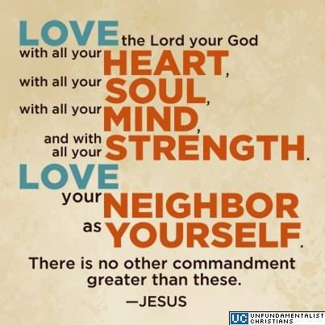
FIRST PRESBYTERIAN. A cornerstone for Christ in the Carthage community since 1850.

Led by God and sustained by the Holy Spirit, FPC supports God’s children as they grow
in their faith, strengthen their relationship with Jesus Christ,
and are challenged to be God’s servants and disciples.

10 a.m. Children’s & Youth 10 a.m. Worship 11 a.m. Worship
Sunday School Indoor Outdoor
12/6 13 17 --
12/13 10 25 10
12/20 16 19 6
12/27 8 12 8
Average 12 18 8

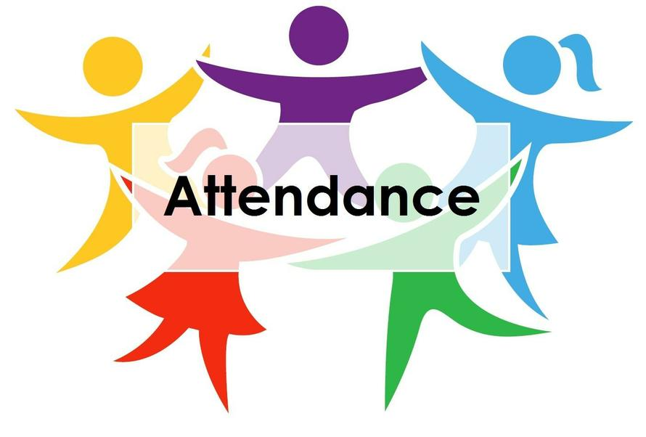


Valentine Baskets will soon be delivered to our Homebound church family!
From February 3rd – 7th Presbyterian Women are collecting individually-wrapped candies, cookies, and crackers for the baskets in a designated donation box in the kitchen of the Family Life Center.
February Birthdays

2 Nicholas Baker
2 Emma Leonard
5 Taylor Allred
5 Robert Gordon
7 Jennifer Thomason
11 Archie Kelly
13 Pat Jackson
13 Dell Wahala
15 Elizabeth Williams
28 Ellie Mae Collins

Connecting in Christ in 2021

Being a Christian, doing God’s will and not our own, challenges us each and every day. The wonderful difference as we journey through this life is that God is with us. We are never alone. We do not have to endure the challenges of this life without Christ. God wants us to give our burdens over to Him. We praise Him for this promise to us. As we press forward into this new year, stay connected in Christ through 2021 in worship, in fellowship, and in service.

Lent Connect. 2021
Take a journey discerning God’s movement in your life and in the world around us during this prayerful season of Lent.

Beginning February 1st on our website you’ll find daily scripture to guide you in prayer under the
Lent Devotional tab at www.fpccarthage.com.

The devotions are downloadable sets of weekly PDFs starting with the first Sunday of Lent taking you in prayer and scripture through Holy Week.

They can be shared via email to church friends and family.

Share the Lenten journey!
Email the 2021 Lent Devotional to church family and friends for individual and/or small group study.
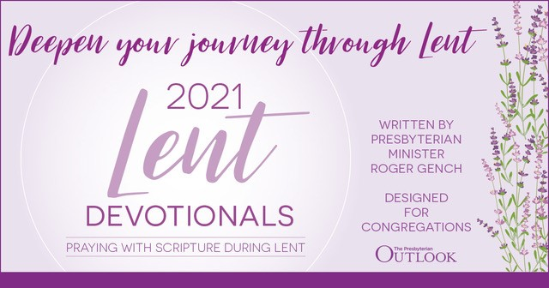

Worship Connect. 2021
But the hour is coming, and is now here, when the true worshipers will worship the Father
in Spirit and in truth, for the Father wants such people to worship him. John 4:23

Meaningful to our faith, worship is a time for us to praise and worship Jesus Christ, our Lord and Savior.
​​​​​
Children's Sunday School 10 a.m. Sundays Classes for ages 3 through 12th grade.
​
​Inside AND Virtual Worship Service 10 a.m. Sundays
Worship inside our Family Life Center, with social distancing seating and masks.
To worship virtually, watch the service live at 10 a.m. on our Fpc Carthage Facebook Page.
​You may also view the service afterward any time by clicking on the Facebook Live link on our website’s
Worship & Fellowship in 2021 tab at www.fpccarthage.com, or on our Fpc Carthage Facebook Page.

​Outdoor Worship Service 11 a.m. Sundays
Worship outside on the FPC Lawn, weather-permitting (40-degrees or higher).
Please wear a mask, until seated and bring a lawn chair for social-distance seating.

Serve Connect. 2021
For I was hungry and you gave me food, I was thirsty and you gave me something to drink,
I was a stranger and you welcomed me, I was naked and you gave me clothing,
I was sick and you took care of me, I was in prison and you visited me. Matthew 25:35-36

Meaningful to our brothers and sisters in Christ and to the larger community, service allows us the opportunity to be the hands and feet of Jesus. Learn more ways to simply serve by visiting our
Serve tab at www.fpccarthage.com.

Fellowship Connect. February 2021
For where two or three are gathered in my name, I am there among them. Matthew 18:20

Meaningful to the nourishment off the soul, fellowship is a time for us to come together as family
in Christ to encourage and lift one another up in our journey of faith.
​​​​
Youth Group 5 p.m. Sundays
During the school year, FPC’s Youth Group for grades 7-12 meets Sunday evenings to have fun,
be challenged, and explore what it means to be a Christian. Youth does not meet on weeks with school holidays or breaks. Check out the Family Life & Youth page under our Worship & Fellowship tab at www.fpccarthage.com.
​
YogaFaith "Strengthening Your Core in Faith and in Body" All ages and beginners welcome.
Classes led by Lynda Lea Goodall, a certified Christian Yoga Instructor recognized by the Yoga Alliance, are held in the Family Life Center weekly on Mondays. Mat Floor Class, 2-3 p.m., $5 Chair Class, 3:15-4:15 p.m., $5. ​​Visit our YogaFaith page under our Worship & Fellowship tab at www.fpccarthage.com.​​

Daily Inspiration
Available in the lobby of First Presbyterian’s Family Life Center, “These Days” offers daily meditations and devotions of hope and comfort. Also During Lent, use the Lenten Devotionals.

#FpcBeTheLight. 2021
I am the light of the world.
Whoever follows me will never walk in darkness but will have the light of life. John 8:12
Live the Love of Christ all year long. 2021 Social Media Outreach
When Christ was born, a star led the way to the Light of the World.
We invite you to share the light of Christ in the lives of others by connecting friends, family, and our
wider community to FPC’s social media outlets.
Throughout the year we’ll share hope-based scripture, praises, testimony, songs, and worship on our FpcCarthage Facebook page and through our new #FpcBeTheLight Instagram account.
Like us on FB and follow us on Instagram, and begin sharing the good news!

