Class of 2020
Doris Russell
Chad Thomason
Michelle Tortora
JoAnn Wahala

Class of 2021
Denise Edmonds
Robert Gordon
Lee McCaskill
Geraldine Moore

Class of 2022
Keith Hardin
Elizabeth Martindale
Helen McDonald
Marie Monroe

The Reverend Rick Martindale Pastor
Ali Wadsworth Choir Director
Elizabeth Williams Organist
Shelley Hammond Administrative Assistant
Andie Hyman Nursery Attendant
Ann Key Sexton
Marie Monroe Treasurer



Non-Profit
Organization
U.S. Postage
PAID
CARTHAGE, NC
28327
Permit No. 35

FIRST PRESBYTERIAN CHURCH
POST OFFICE BOX 397
CARTHAGE, NORTH CAROLINA 28327
(910) 947-2924
fpccarthage.com (website)
infofpc397@gmail.com (email)



First Presbyterian Church News February 2020

Looking for God

“You show me the path of life. In your presence there is fullness of joy; in your right hand are pleasures forevermore” (Psalm 16:11). This is what we hope for in life. We believe God is with us, but our faith often falters. Trusting in God is not for the weak of heart. It requires everything we have… and then some. On our own, we do not have what it takes to follow the path of God. On our own, we will struggle to find joy, we will probably more readily discover fear and doubt. On our own, we struggle to grasp the pleasures that God has in store for us. We see instead all the bills piling up, the broken relationships, our broken spirits and bodies. Trusting in God takes more than we can offer, it requires God’s participation to do what we can’t. His gift to us is faith – the ability to walk and trust that God is with us. Accept the gift of faith God offers us!

In Philippians 4:4-7, we are urged by Paul to rejoice. He tells us twice to rejoice. Even when things are difficult, we are to rejoice. Paul knew the challenges that the early church faced. Yet he reminded the people and us today, to not give in to fear and doubt. “Do not worry about anything… (Philippians 4:6). Easier said than down. We have a tendency to worry a lot. It’s not surprising that we worry so frequently because we don’t see God working in our midst (even though God is). It goes back to having faith in God, the One who is leading us.

Isaiah 40:29-32 gives us words of hope, “He gives power to the faint, and strengthens the powerless. Even youths will faint and be weary, and the young will fall exhausted; but those who wait for the Lord shall renew their strength, they shall mount up with wings like eagles, they shall run and not be weary, they shall walk and not faint.”

 If you are looking for encouragement, read your Bible and discover an app with encouraging Bible verses. Then go out into the world and put the Word of God into practice. In the Gospel of John as Jesus begins calling His disciples to join Him, Nathanael becomes excited because Jesus tells him about seeing him sitting under a fig tree. Nathanael calls Him the Son of God! Jesus responds by saying, “You will see greater things than these.” Open your eyes and spirit so you may see God working in your life and the lives of others.

Grace and Peace,

Rick

In Our Prayers
Remembering our sisters and brothers
as they face difficult times.

Jean Bennett – Quail Haven
Jimmy Bibey
Anna Belle Campbell
Benny Cole
John Currie – Tara Plantation
Betty Elliott
Keith Hardin
Sheree Kelly
Margaret Leonard
Carol Lucas
Jim Lucas
Nancy McKenzie
Marie Monroe
Pat Nugent
Regena Nugent
Dennis Parks
Ina Sue Parks
Kay Patterson
Nicole and Jordan Phillips
Scott Rives
Bonnie Scott
Phillip Warmbrod

Our military men and women
and their families including:
Michael Abercrombie
Jonathan Baker
Kyle Bryant
Chris Mohan
Patrick Mohan
Gregory Riyevski
Michael Schwartz
Will Strickland
Quinn Wicker

To add someone
or to remove your name,
please call the church office at 947-2924.

Donnie Albright
Tony Bibey, Jimmy Bibey’s son
Mary Brewer
Anna Bristow, Debbie Albright’s sister
Karen Bryant, friend of JoAnn Wahala
Olivia Bryant, Karen Bryant’s granddaughter
Dean Cameron
Wife of Larry Cockman, friend of Benny Cole
Robert Davis
Christopher Freeman, Maria Bigger’s grandson
Carl Greeson, Susan Cole’s brother
June Greeson, Susan Cole’s mother
Ann Herndon, Kay Patterson’s sister
Mary Hussey
Aaron Ladmin
Rexine Lloyd, Kelly Martindale’s mother
Vince Mann, friend of the Leonards
Jane Medlin, Carol Lucas’ daughter
Garin Parker, Barbara Danley’s nephew
Kimberly Sanders and Family
Hunter Smith
William Stutts, Bonnie Scott’s brother-in-law
JoAnne Thompson, Keith Hardin’s mother
Skip Vann, Judy Phillip’s brother-in-law
Tommy Walton, Diane Pangborn’s brother

Welcome! You are important to God and to First Presbyterian Church!
Led by God and sustained by the Holy Spirit, we are a church where you will be supported as you grow
in your faith, strengthen your relationship with Jesus Christ, and are challenged to be God's servants
and disciples. Come as you are, and bring your gifts, imperfections, and hopes. We will!

SUNDAY SCHOOL CHURCH
12/1 29 91
12/8 43 71
12/15 49 103
12/22 41 73
12/29 22 60
Average 37 80



DECEMBER 2019 FINANCIAL REPORT
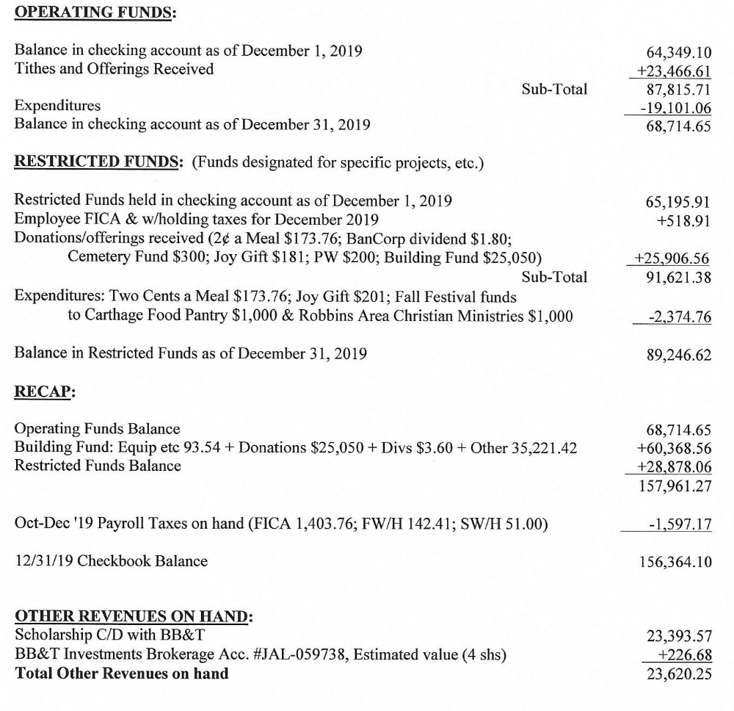

JOIN US SUNDAYS @ FPC! 9:45 a.m. Sunday School for all ages 11 a.m. Worship


February
2 Nicholas Baker 11 Archie Kelly
2 Emma Leonard 13 Pat Jackson
5 Taylor Allred 13 Dell Wahala
5 Robert Gordon 15 Elizabeth Williams
7 Jennifer Thomason 28 Ellie Mae Collins



FEBRUARY USHERS GREETERS FLOWERS
JoAnn Wahala (lead) 2/2 Judi & Archie Kelly Nancy Carter
Keith Hardin 2/9 Tom Stewart Tom Stewart
Chad Thomason 2/16 Ann Lynch Lucinda & David Casey
Geraldine Moore 2/23 Bill Russell Marie & J.D. Monroe


OFFICERS

Administrative Lee McCaskill and JoAnn Wahala
Building and Grounds Keith Hardin and Chad Thomason
Christian Education Elizabeth Martindale and Michelle Tortora
Fellowship and Mission Geraldine Moore and Doris Russell
Stewardship and Finance Robert Gordon and Marie Monroe
Worship Denise Edmonds and Helen McDonald



Drop off donations for Carthage Elementary students in need,
now through mid-February, at the FPC Family Life Center Donation Station,
or in the upper and lower sanctuary narthexes.

Glue Sticks Ink Pens Composition Books Wide-Ruled Paper
#2 Pencils Kleenex Hand Sanitizer Clorox Wipes



Paint a Bowl. Visit the pottery painting studio named the “9th of September” at 214 NW Broad St. in downtown Southern Pines to paint a bowl for the Empty Bowls Sandhills/Moore County Coalition for Human Care fundraiser. For $17 you can paint and fire a bowl for the event! Be sure to call the pottery studio ahead at 695-9063 to ensure they have plenty of bowls available to paint.
Fill a Bowl. Help provide food, clothing, utilities, etc. for local folks in need by filling your bowl with delicious soups made by local chefs. Purchase your tickets for the Coalition’s March 1st Empty Bowls fundraiser at Whispering Pines Country Club by calling 693-1600 ext. 5, or online at www.sandhillscoalition.org.

RUARY @ FPC
Wednesday, 1st New Year’s Day – Church Office closed
Thursday, 2nd 11:00 a.m. Morning Women’s Fellowship & Bible Study, conference room
6:00 p.m. Praise Team practice
Saturday, 4th 7:30 a.m. Robbins’ Food Bank, meet at FPC to carpool
Sunday, 5th 9:00 a.m. Fellowship and Mission Committee, conference room
9:45 a.m. Sunday School
11:00 a.m. Contemporary Family Worship, Family Life Center
Monday, 6th Epiphany
YogaFaith Classes – 8:45 a.m. floor / 10:15 a.m. chair
Tuesday, 7th 2:00 p.m. CHS High School Reunion Committee, conference room
6:00 p.m. Men’s Group, conference room
Wednesday, 8th YogaFaith Classes – 8:45 a.m. floor / 10:15 a.m. chair
5:30 p.m. What’s Up Wednesday, ages 4-6th grade
7:00 p.m. Choir practice
Thursday, 9th 6:30 p.m. Evening Women’s Fellowship & Bible Study, conference room
Sunday, 12th 9:00 a.m. Worship Committee, conference room
9:45 a.m. Sunday School, all ages
11:00 a.m. Worship/ Installation of New Elders
2:00 p.m. Session meeting, conference room
5:00 p.m. Youth Group, 7th-12th grades
Monday, 13th YogaFaith Classes – 8:45 a.m. floor / 10:15 a.m. chair
Wednesday, 15th YogaFaith Classes – 8:45 a.m. floor / 10:15 a.m. chair
5:30 p.m. What’s Up Wednesday, ages 4-6th grade
7:00 p.m. Choir practice
Thursday, 16th 12:00 p.m. Ladies Lunch, Aroma Café & Bakery
6:00 p.m. Praise Team practice
Saturday, 18th 10:00 a.m. “When Only Faith Remains” women’s gathering, Community Pres.
Sunday, 19th 9:45 a.m. Sunday School, all ages
11:00 a.m. Worship Service with Communion
Monday, 20th YogaFaith Classes – 8:45 a.m. floor / 10:15 a.m. chair
Tuesday, 21st 6:00 p.m. Men’s Group, conference room
Wednesday, 22nd YogaFaith Classes – 8:45 a.m. floor / 10:15 a.m. chair
5:30 p.m. What’s Up Wednesday, ages 4-6th grade
7:00 p.m. Choir practice
Thursday, 23rd 8:30 a.m. West Community Presbytery Meeting, FPC
6:00 p.m. Praise Team practice
Sunday, 26th 9:45 a.m. Sunday School, all ages
11:00 a.m. Worship/Baptism
5:00 p.m. Youth Group, 7th-12th grades
Monday, 27th YogaFaith Classes – 8:45 a.m. floor / 10:15 a.m. chair
Wednesday, 29th YogaFaith Classes – 8:45 a.m. floor / 10:15 a.m. chair
5:30 p.m. What’s Up Wednesday, ages 4-6th grade
7:00 p.m. Choir practice
Thursday, 29th 6:00 p.m. Praise Team practice

