Class of 2020
Doris Russell
Chad Thomason
Michelle Tortora
JoAnn Wahala

Class of 2021
Denise Edmonds
Robert Gordon
Lee McCaskill
Geraldine Moore

Class of 2022
Keith Hardin
Elizabeth Martindale
Helen McDonald
Marie Monroe

The Reverend Rick Martindale Pastor
Ali Wadsworth Choir Director
Elizabeth Williams Organist
Shelley Hammond Administrative Assistant
Andie Hyman Nursery Attendant
Ann Key Sexton
Marie Monroe Treasurer
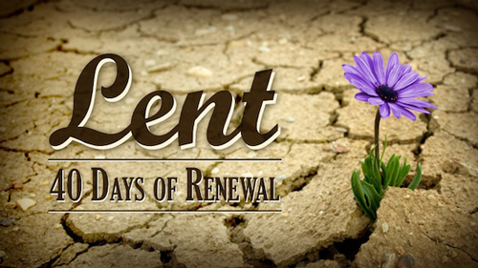

Non-Profit
Organization
U.S. Postage
PAID
CARTHAGE, NC
28327
Permit No. 35

FIRST PRESBYTERIAN CHURCH
POST OFFICE BOX 397
CARTHAGE, NORTH CAROLINA 28327
(910) 947-2924
fpccarthage.com (website)
infofpc397@gmail.com (email)



 First Presbyterian Church News
MARCH
Combining Two of My Favorite Things

We are getting ready to enter one of my favorite times of year, actually two of my favorite times of year – Lent and March Madness. Lent is a time of personal reflection. It is a time when we are very intentional about our faith. We add something during Lent and/or we give up something. Whatever we do or don’t do, we focus on our personal relationship with our Lord and Savior. We want to grow in our faith and in our relationship with God. Lent provides an excellent opportunity to begin new spiritual habits, or discard bad ones.

Later this month, March Madness begins! It is the NCAA basketball tournament to determine the national champion for 2020. The first “real” round will include 32 games in two days! The next round will include 16 games in the next two days. Within four days, the tournament is narrowed down to 16 teams – the Sweet Sixteen! Within the couple of weeks following, it will narrow down to the championship game. If you love college basketball, this is an awesome time!

For 2020, I want FPC to combine Lent and March Madness. It sounds like a crazy combination, but I think this will be an exciting venture if you like both feeding the hungry and college basketball.

Starting on Sunday, March 15th, FPC will begin collecting canned food items for the Carthage and Robbins Food Banks. As you turn in your canned food, please designate your favorite college teams like UNC, NC State, Duke, App State, Clemson, Indiana, or whoever you want… including UNI, by clearly marking them on both the top and bottom of your cans.

A group of us will keep a running total so that you know how your team is doing. On the 29th we will stop collecting cans and one team will be crowned as college champion – even if their team doesn’t make it to the Sweet Sixteen! Start collecting cans now, marking them with your favorite team, and be ready to drop them off at FPC starting Sunday, March 15th.

May we celebrate the joy and passion of life given by God in the countless opportunities presented to us. May we also never forget those less fortunate than ourselves whether it is for those who hunger for food, good health, purpose, or being loved. What are your plans for Lent? It’s time to begin.

Grace and Peace,

Rick
Donnie Albright Tony Bibey, Jimmy Bibey’s son
Mary Brewer
Anna Bristow, Debbie Albright’s sister
Karen Bryant, friend of JoAnn Wahala
Olivia Bryant, Karen Bryant’s granddaughter
Dean Cameron
Wife of Larry Cockman, friend of Benny Cole
Robert Davis Christopher Freeman, Maria Bigger’s grandson
Carl Greeson, Susan Cole’s brother
June Greeson, Susan Cole’s mother
Ann Herndon, Kay Patterson’s sister Mary Hussey
Aaron Ladmin
Vince Mann, friend of the Leonards
Jane Medlin, Carol Lucas’ daughter
Garin Parker, Barbara Danley’s nephew Kimberly Sanders and Family
Wilton Seawell’s Family, Herman’s brother
Hunter Smith William Stutts, Bonnie Scott’s brother-in-law
JoAnne Thompson, Keith Hardin’s mother Skip Vann, Judy Phillip’s brother-in-law
Tommy Walton, Diane Pangborn’s brother


Remembering our sisters and brothers in prayer as they face difficult times.
To add a Prayer Request, or to take yourself off our prayer list, please call FPC at 947-2924.
Debbie Albright
Jean Bennett, Quail Haven Jimmy Bibey Anna Belle Campbell
Benny Cole John Currie, Tara Plantation Betty Elliott Keith Hardin Sheree Kelly Margaret Leonard
Carol Lucas
Jim Lucas Linda McCaskill, First Health
Nancy McKenzie Marie Monroe Pat Nugent Regena Nugent Dennis Parks Ina Sue Parks Kay Patterson Nicole and Jordan Phillips Scott Rives Bonnie Scott Phillip Warmbrod

Donnie Albright Tony Bibey, Jimmy Bibey’s son
Mary Brewer
Anna Bristow, Debbie Albright’s sister
Karen Bryant, friend of JoAnn Wahala
Olivia Bryant, Karen Bryant’s granddaughter
Dean Cameron
Wife of Larry Cockman, friend of Benny Cole
Robert Davis Christopher Freeman, Maria Bigger’s grandson
Carl Greeson, Susan Cole’s brother
June Greeson, Susan Cole’s mother
Ann Herndon, Kay Patterson’s sister Mary Hussey
Aaron Ladmin Rexine Lloyd, Kelly Martindale’s mother
Vince Mann, friend of the Leonards
Linda McCaskill
Jane Medlin, Carol Lucas’ daughter
Garin Parker, Barbara Danley’s nephew Kimberly Sanders and Family
Hunter Smith William Stutts, Bonnie Scott’s brother-in-law
JoAnne Thompson, Keith Hardin’s mother Skip Vann, Judy Phillip’s brother-in-law
Tommy Walton, Diane Pangborn’s brother

Our military and their families:
Michael Abercrombie, Jonathan Baker, Kyle Bryant, Chris Mohan, Patrick Mohan,
Gregory Riyevski, Michael Schwartz, Will Strickland, and Quinn Wicker

Our military men and women, and their families:
Michael Abercrombie, Jonathan Baker, Kyle Bryant, Chris Mohan, Patrick Mohan,
Gregory Riyevski, Michael Schwartz, Will Strickland, and Quinn Wicker

Our military and their families:
Michael Abercrombie, Jonathan Baker, Kyle Bryant, Chris Mohan, Patrick Mohan,
Gregory Riyevski, Michael Schwartz, Will Strickland, and Quinn Wicker




Sunday School Worship
1/5 43 82
1/12 45 103
1/19 43 66
1/26 38 84
Average 42 84

JANUARY 2020 FINANCIAL REPORT
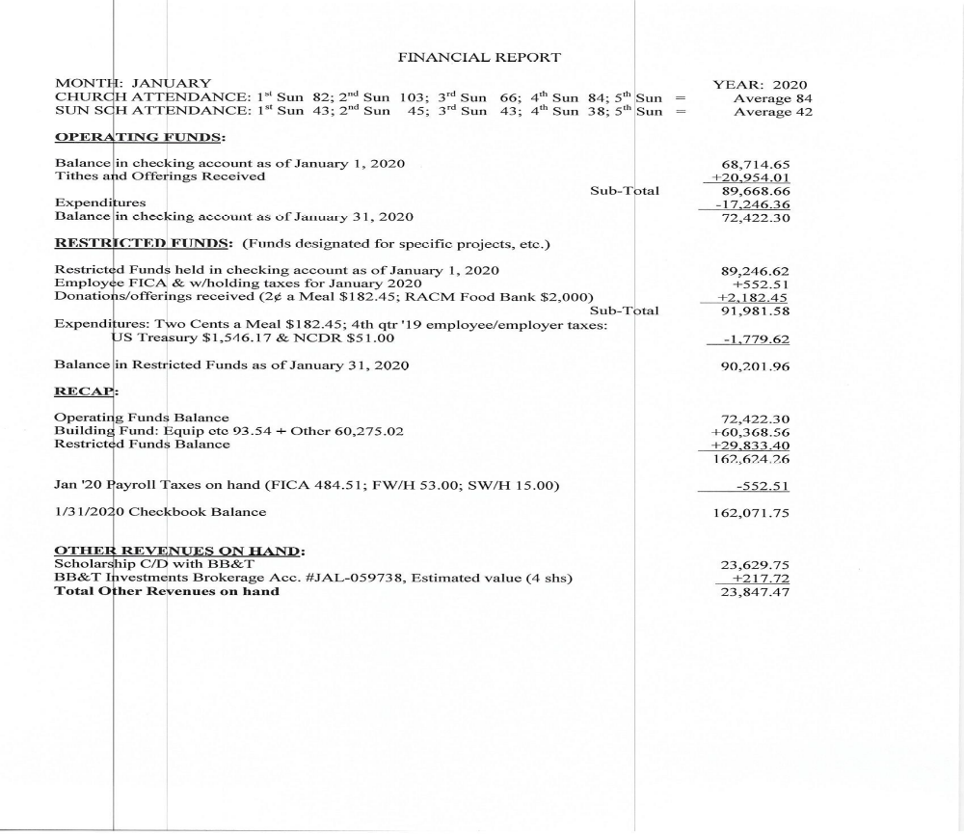

JOIN US SUNDAYS @ FPC! 9:45 a.m. Sunday School for all ages 11 a.m. Worship



Tie-Dye Night! March 22nd 5 p.m.

Let’s get messy designing colorful
table-cloths for FPC’s
1st Sunday Contemporary Services!
Wear clothes and shoes that can get messy!

Approved:
* Several groups to use our Family Life Center in the coming months. * April 26th PW Birthday Offering
and August 3rd PW Salad Supper.
* Continuing the Contemporary Worship Service.
* June 7th as the last day for children & youth
Sunday School until the August 9th kick-off.
* July 10th-12th VBS


A special thank you for helping with our Soup Lunch! Money collected benefits PW 2020 projects.

Penny for a Prayer 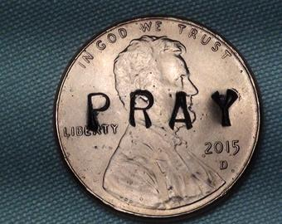 The Fellowship of the Least Coin
If you would like to participate in the Fellowship of the Least Coin, pickup information and a devotional book in the lower vestibule. Just a penny for each prayer goes a long way in helping impoverished women and children around the world.


Sunday, April 19th 2 p.m.
Brownson Memorial Presbyterian
330 S. May Street, Southern Pines

Our local Hospice is very appreciative of your generosity!
Kleenex, Gripper Socks, and Dollar Store Large-Print Word Searches
are needed, in addition to toiletries, snacks, calendars and writing pens.

Blessings Bags
For patients and their families


Palm Sunday 4/5
11 a.m. Worship
Maundy Thursday 4/9
Mourning the tragic events of Christ’s death.
7 p.m. Tenebrae Service
Easter Sunday 4/12
FPC Community Sunrise Service
& Breakfast, 7 a.m.
Breakfast helpers needed.
Please see Tracy Thomas to sign up to help.
Sanctuary Worship Service, 11 a.m.

April 5th-12th

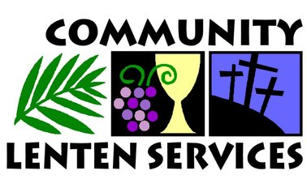

Having taken place for many years, the Community Lenten Series is a wonderful opportunity of worship and fellowship with our brothers and sisters in Christ.

3/4 First Missionary Baptist Church, 576 Needmore Road
3/11 John Hall Presbyterian Church, 518 Dowd St.
3/18 First Presbyterian Church, 110 S. Ray St.
*To help FPC PW with lunch, contact Helen at 690-2463.
3/25 Mt. Olive AME Zion Church, 440 Bethlehem Church Rd.
4/1 ​First Baptist Church, 108 S. McNeill St.

Noontime Worship Service & Lunch

Wednesdays during Lent

February 26th to April 1st

On Easter Sunday,
white lilies are placed
in worship to commemorate the promise of new life through the resurrection of
Jesus Christ.


To place an Easter Lily in the sanctuary on
4/12
in honor of,
or in memory
of someone special, email or call the church office by
April 7th.

infofpc397@gmail.com
947-2924

3 Jimmy Bibey 17 Mike Kelly
3 Ken Fara 19 Tom Currie
4 Joe Lynch 21 Margaret Leonard
5 Emily Muse 22 Ann Lynch
6 Otis Patterson 23 Maria Bigger
8 Joey Tortora 26 Susan Cole
10 Bonnie Scott 27 Barbara Kelly
12 Johnny Scott 28 Lucinda Casey
13 Angie Medlin 29 Connor Lucas
14 Jordan Smith 31 Dennis Parks
15 Peter Little 31 Christopher Phillips

Keep us updated! To add or correct a birthday, contact FPC @ (910) 947-2924 or infofpc397@gmail.com.



MARCH USHERS GREETERS FLOWERS
Denise Edmonds (lead) 3/1 Geraldine Moore Jeannie & Max Muse
Elizabeth Martindale 3/8 Herman Seawell Bonnie Scott
Lee McCaskill 3/15 Otis Patterson Barbara Danley
Michelle Tortora 3/22 Ann & Tom Currie Doris & Bill Russell
3/29 Ruby Ingold Pat Jackson

To place flowers in the church this year, please contact Helen at 690-2463 or hmcd2946@gmail.com.

