First Presbyterian Church

Located in the heart of Carthage, NC
near the Post Office at 110 South Ray Street,
First Presbyterian welcomes you!
(910) 947-2924
infofpc397@gmail.com

www.FpcCarthage.com


Fpc Carthage


#fpcbethelight

The Reverend Rick Martindale Pastor
Ali Wadsworth Choir Director
Elizabeth Williams Organist
Shelley Hammond Administrative Assistant
Andie Hyman Nursery Attendant
Ann Key Sexton
Marie Monroe Treasurer



The Reverend Rick Martindale, Pastor
Shelley Hammond, Administrative Assistant
Ann Key, Sexton
Marie Monroe, Treasurer
Ali Wadsworth, Choir Director
Robert Wilson, Organist

FPC Session
Session Class of 2021 Denise Edmonds, Robert Gordon, Lee McCaskill, Geraldine Moore
Session Class of 2022 Keith Hardin, Elizabeth Martindale, Helen McDonald, Marie Monroe
Session Class of 2023 Lucinda Casey, Tom Leonard, Scott Phillips, Jennifer Thomason

Non-Profit
Organization
U.S. Postage
PAID
CARTHAGE, NC
28327
Permit No. 35
First Presbyterian Church
PO Box 397
Carthage, NC 28327




First Presbyterian Church
A Cornerstone for Christ since 1850.

August 2021 Church News

Happiness

Happiness is a state of mind. In a world where we are we are still enduring the challenges of COVID-19 after 16 months; it might be argued that happiness has been hard to locate or acquire.

Some will argue happiness is about the events or things that happen in one’s life. The birth of a child or grandchild ushers in happiness. A promotion at work or acing a test brings happiness. Events like these may bring happiness or joy but for some, even wonderful events bring with them new worries or concerns. Such as, how do I keep my child or grandchild safe? With a promotion, comes new worries and expectations.

Happiness comes back to a state of mind for me. My happiness is not based on what others think or other exterior events that happen in my life. My happiness is an eternal way of life that is completely contingent upon me and me alone. As I write this, I know that even this is not accurate either.

I find my happiness not based upon “events” that take place, or even my state of mind, but in the realization of my relationship with God. “But let all who take refuge in You rejoice; let them ever sing for joy…” Psalm 5:11a. God challenges us to a happiness that is grounded in something much greater than the fleeting praises or finite things of the world around us.

“Blessed are those who trust in the Lord, whose trust is the Lord. They shall be like a tree planted by water, sending out its roots by the stream. It shall not fear when heat comes, and its leaves shall stay green; in the year of the drought it is not anxious, and it does not cease to bear fruit.” Jeremiah 17:7-8.

Our happiness comes from God. We come to understand that God is fuller and richer than the world around us. Our happiness should be grounded in Someone much greater than a new I-Phone or a gracious compliment given by another. Our happiness comes from knowing God and being in relationship with God. God’s love is greater than ALL creation. God provides a joy that is eternal.

Grace and Peace,
Rick


First Pres prays for you.

Remember
our brothers and sisters
in Christ through prayer
as they face difficult times.
Debbie Albright Jean Bennett, Quail Haven
Anna Belle Campbell Benny Cole John Currie, Tara Plantation Margaret Leonard Carol Lucas Linda McCaskill Nancy McKenzie Gail Meeks
Max Muse Linda Myrick and family
Ina Sue Parks Kay Patterson Herman Seawell Tom Stewart
Phillip Warmbrod

Artie Barber, friend of the Monroes
Terry Barber, friend of the Monroes
Bo, friend of Geraldine Moore
Karen Bryant, friend of JoAnn Wahala
Brian Casey, Lucinda and David Casey’s son
Judy Claterbos, Mary Thomas’ sister
Jack Denniston, Lucinda and David’s daughter-in-law’s father
Carl Greeson, Susan Cole’s brother
June Greeson, Susan Cole’s mother
Ann Herndon, Kay Patterson’s sister
Sean Kennally, Angie Provost’s son-in-law
Barbara May, friend of Debbie Gordon
Noah Mathews, Kayla Carter’s brother
Jane Medlin, Carol Lucas’ daughter
Lisa Muller, Cousin of Ina Sue Parks
Tommy Walton, Diane Pangborn’s brother

All of our military men and women and their families, especially the following:
Michael Abercrombie, Jonathan Baker, Kyle Bryant, Chris Mohan,
Patrick Mohan, Greg Riyevski, Michael Schwartz, Will Strickland, and Quinn Wicker.

FPC Stewardship & Finance
June 2021
OPERATING FUNDS:
Balance in checking account as of June 1, 2021 | 88,927.37
Tithes and Offerings Received | +10,260.25
Sub-Total | 99,187.62
Expenditures | -11,429.72
Balance in checking account as of June 30, 2021 | 87,757.90
RESTRICTED FUNDS: (Funds designated for specific projects, etc.)
Restricted Funds held in checking account as of June 1, 2021  Employee FICA & w/holding taxes for June 2021  Donations/offerings received (2ȼ a Meal $40; Bldg Fd $80; Truist dividend $1.80;  Cemetery Fund $100; Presbyterian Women $65; Honorarium $100 | 103,989.63 +252.15  +386.80
Sub-Total | 104,628.58
Expenditures: Habitat for Humanity, donations received $120; 2 Cents a  Meal $80.69; Pentecost, 60% of offering the Presbytery $126.60;  (Pentecost, 40% of offering transferred to Youth Ministry $84.40) | -327.29
Balance in Restricted Funds as of June 30, 2021 | 104,301.29
RECAP:
Operating Funds Balance | 87,757.90
Building Fund: Equip 93.54 + Grant 500.00 + Other 76,801.17 + 81,80= | +77,476.51
Restricted Funds Balance | +26,824.78
 | 192,059.19
Apr-June '21 Payroll Taxes on hand (FICA 775.34; FW/H 37.00 + .04 excess) | -812.38
6/30/2021 Checkbook Balance | 191,246.81
OTHER REVENUES ON HAND:
Scholarship C/D with BB&T  Truist Financial Corp, Estimated value (4 sharess)  Total Other Revenues on hand | 23,639.20  +225.20  23,864.40

FPC Calendar August 2021 Family Life Center (FLC) Conference Room (CR)

Sunday, August 1st 10:00 a.m. Multiple Indoor Worship Experiences / Virtual
and Children’s Church
2 Cents a Meal Offering
Place in regular offering basket in envelope
with amount, marked “Special Offering.”
Baby gifts due for Ali Wadsworth Carthage Elementary Supply Drive Begins

Monday, August 2nd 6:30 p.m. 2021-22 Women’s Bible Study Kick-Off (FLC)

Tuesday, August 3rd 6:30 p.m. Fellowship and Mission Committee (CR)

Sunday, August 8th 10:00 a.m. Multiple Indoor Worship Experiences / Virtual
and Children’s Church

Monday, August 9th 6:30 p.m. Worship Committee

Saturday, August 14th 7:30 a.m. Robbins’ Food Bank, meet 7 a.m. at FPC to carpool

Sunday, August 15th 10:00 a.m. Multiple Indoor Worship Experiences / Virtual
Communion and Children’s Church
11:00 a.m. Congregational Meeting to elect Nominating
Committee immediately after worship
2:00 p.m. Session Meeting

Thursday, August 19th 4:00 p.m. Presbytery Meeting

Sunday, August 22nd 10:00 a.m. Multiple Indoor Worship Experiences / Virtual
and Children’s Church

Monday, August 23rd First day of the 2021-2022 school year!
Deadline for September Church Mouse Newsletter

Sunday, August 29th 10:00 a.m. Multiple Indoor Worship Experiences / Virtual
and Children’s Church

____ ____ FPC Connect News & Announcements_______


You made the
2021 VBS
“Wilderness Escape:
Where God Guides & Provides”
wildly fantastic!!!!

******************************************************************************************************************************************************************************************
All ladies are invited to join us
as we kick off our 2021-22 year
on Monday, August 2nd at 6:30 p.m.
in the FLC with an awesome guest speaker,
Gracie Williams, of Sanford’s
Blandonia Presbyterian Church.
Enjoy door prizes and to-go desserts!
For a copy of this year’s study book,
What My Grandmothers Taught Me,
call Helen at 690-2463.
Study books are $10.



Day Circle begins Thursday, September 2nd at 11 a.m. in the conference room.
If interested in participating in a night group, please email Helen at
hmcd29426@gmail.com ASAP to coordinate details that work best for the group.

******************************************************************************************************************************************************************************************
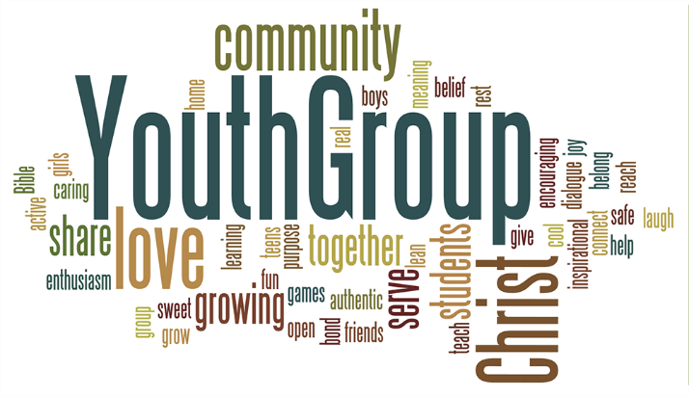
Children ages 4 – 6th grade may join us Wednesdays starting September 8th at 5:30 p.m.,
and youth 7th – 12th grade on Sundays starting September 12th at 5 p.m.

FPC Basket Ministries & Mission

August’s Focus:
CARTHAGE ELEMENTARY STUDENTS IN-NEED



We are currently collecting the following items throughout the year:
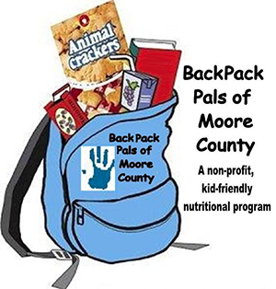


Instant potatoes non-perishable food plastic grocery bags

Please donate items to show God’s love, light and hope!
Items may be dropped off in the
FPC Family Life Center Donation Station baskets.
to serve our neighbors in need.

Pencils
Washable Markers
Glue Sticks
Dry Erase Markers
Loose Leaf Notebook Paper
Clorox Wipes
Lysol Wipes
Baby Wipes
Kleenex/Tissues

Crackers and raisins

FIRST PRESBYTERIAN.
A cornerstone for Christ in the Carthage community since 1850.
Summer Schedule began June 6th with Children’s Church.
No Sunday School in the summer.

10 a.m. Indoor Worship
6/6 34
6/13 41
6/20 31
6/27 47
Average 38

puzzles, word searches, crosswords, adult coloring books, pens, colored pencils, crayons and Little Debbie Cakes,
Lance crackers, etc.

Happy Birthday!
3 Ruth Tyson
5 Aubrey Tortora
6 John McDonald
6 Tom Stewart
7 Marie Monroe
9 Ruby Ingold
9 Ashley Bibey
11 Sheree Kelly
11 Gail Meeks
15 Carl Nunnery
16 Jeff Key
17 Will Thomason
21 Ty White
22 Meredith Marshburn
22 Linda McCaskill
25 Denise Edmonds
27 Rick Martindale
29 Alex Thomason

Sanctuary Flowers given
to the glory of God!



August 1st Denise and Lee Edmonds
August 8th JoAnn and Dell Wahala
August 15th Carol and Paul White
August 22nd Jennifer and Chad Thomason
August 29th Debbie and Robert Gordon

If you would like to place flowers in the sanctuary in October or November
please contact Helen McDonald
at 690-2463 or hmcd2946@gmail.com.



Mark your calendars!

We’re kicking off our new
2021-2022
Ladies Bible Study
“What My Grandmothers Taught Me”
… with a guest speaker!

Monday, August 2nd
6:30 p.m.

Look for more details later this month!

For a study book please
call or email Helen McDonald at
690-2463 or hmcd2946@gmail.com.



